Use these links to rapidly review the document

Table of Contents

Table of Contents

UNITED STATES

SECURITIES AND EXCHANGE COMMISSION

Washington, D.C. 20549

SCHEDULE 14A

Proxy Statement Pursuant to Section 14(a) of

the Securities Exchange Act of 1934 (Amendment No.

)

Filed by the Registrant ☒

Filed by a Party other than the Registrant

Check the appropriate box:

Preliminary Proxy Statement

Confidential, for Use of the Commission Only (as permitted by Rule 14a-6(e)(2))

- Definitive Proxy Statement

Definitive Additional Materials

Soliciting Material under §240.14a-12

(Name of Registrant as Specified In Its Charter)

N/A

(Name of Person(s) Filing Proxy Statement, if other than the Registrant)

Payment of Filing Fee (Check the appropriate box):

- No fee required.

Fee computed on table below per Exchange Act Rules 14a-6(i)(1) and 0-11.

  - Title of each class of securities to which transaction applies:

  - Aggregate number of securities to which transaction applies:

  - Per unit price or other underlying value of transaction computed pursuant to Exchange Act Rule 0-11 (set forth the amount on which the filing fee is calculated and state how it was determined):

  - Proposed maximum aggregate value of transaction:

  - Total fee paid:

Fee paid previously with preliminary materials.

Check box if any part of the fee is offset as provided by Exchange Act Rule 0-11(a)(2) and identify the filing for which the offsetting fee was paid previously. Identify the previous filing by registration statement number, or the Form or Schedule and the date of its filing.

  - Amount Previously Paid:

  - Form, Schedule or Registration Statement No.:

  - Filing Party:

  - Date Filed:



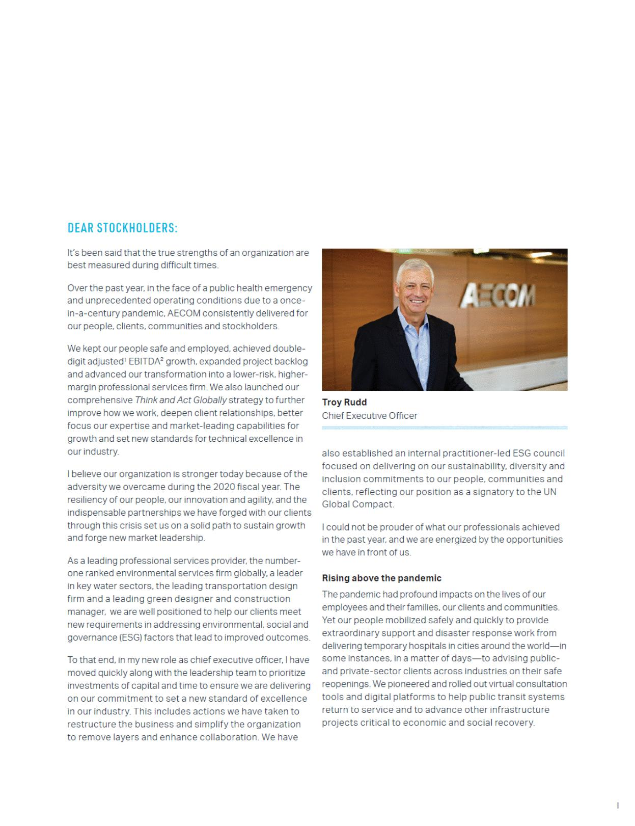

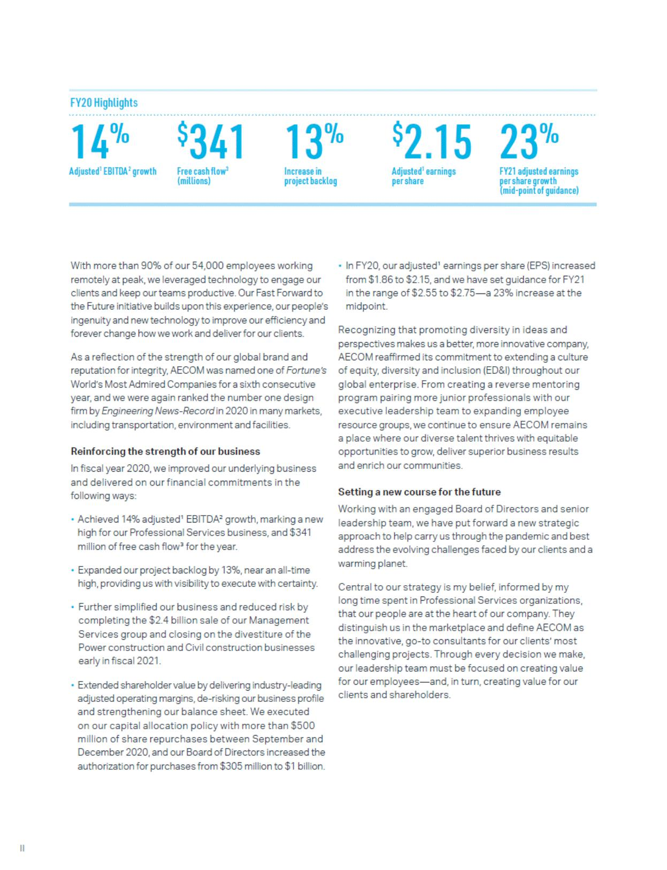

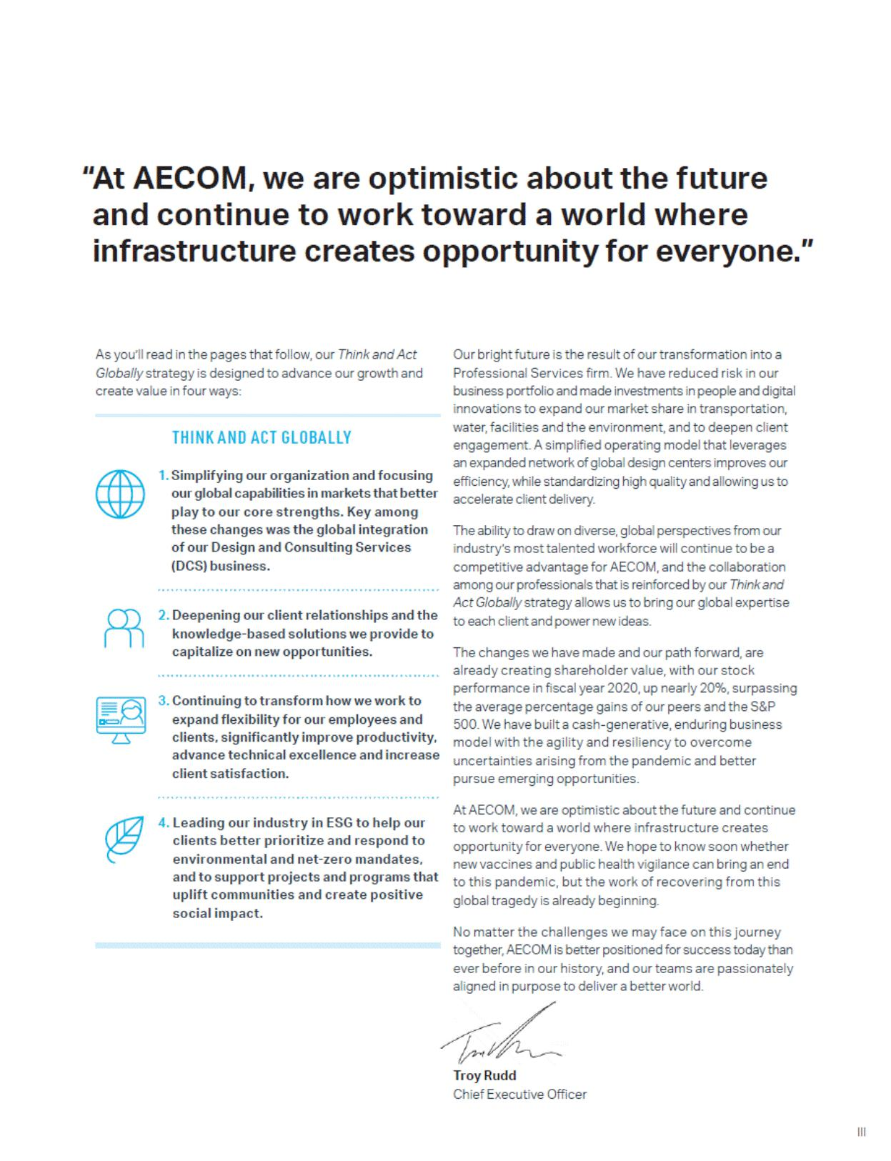



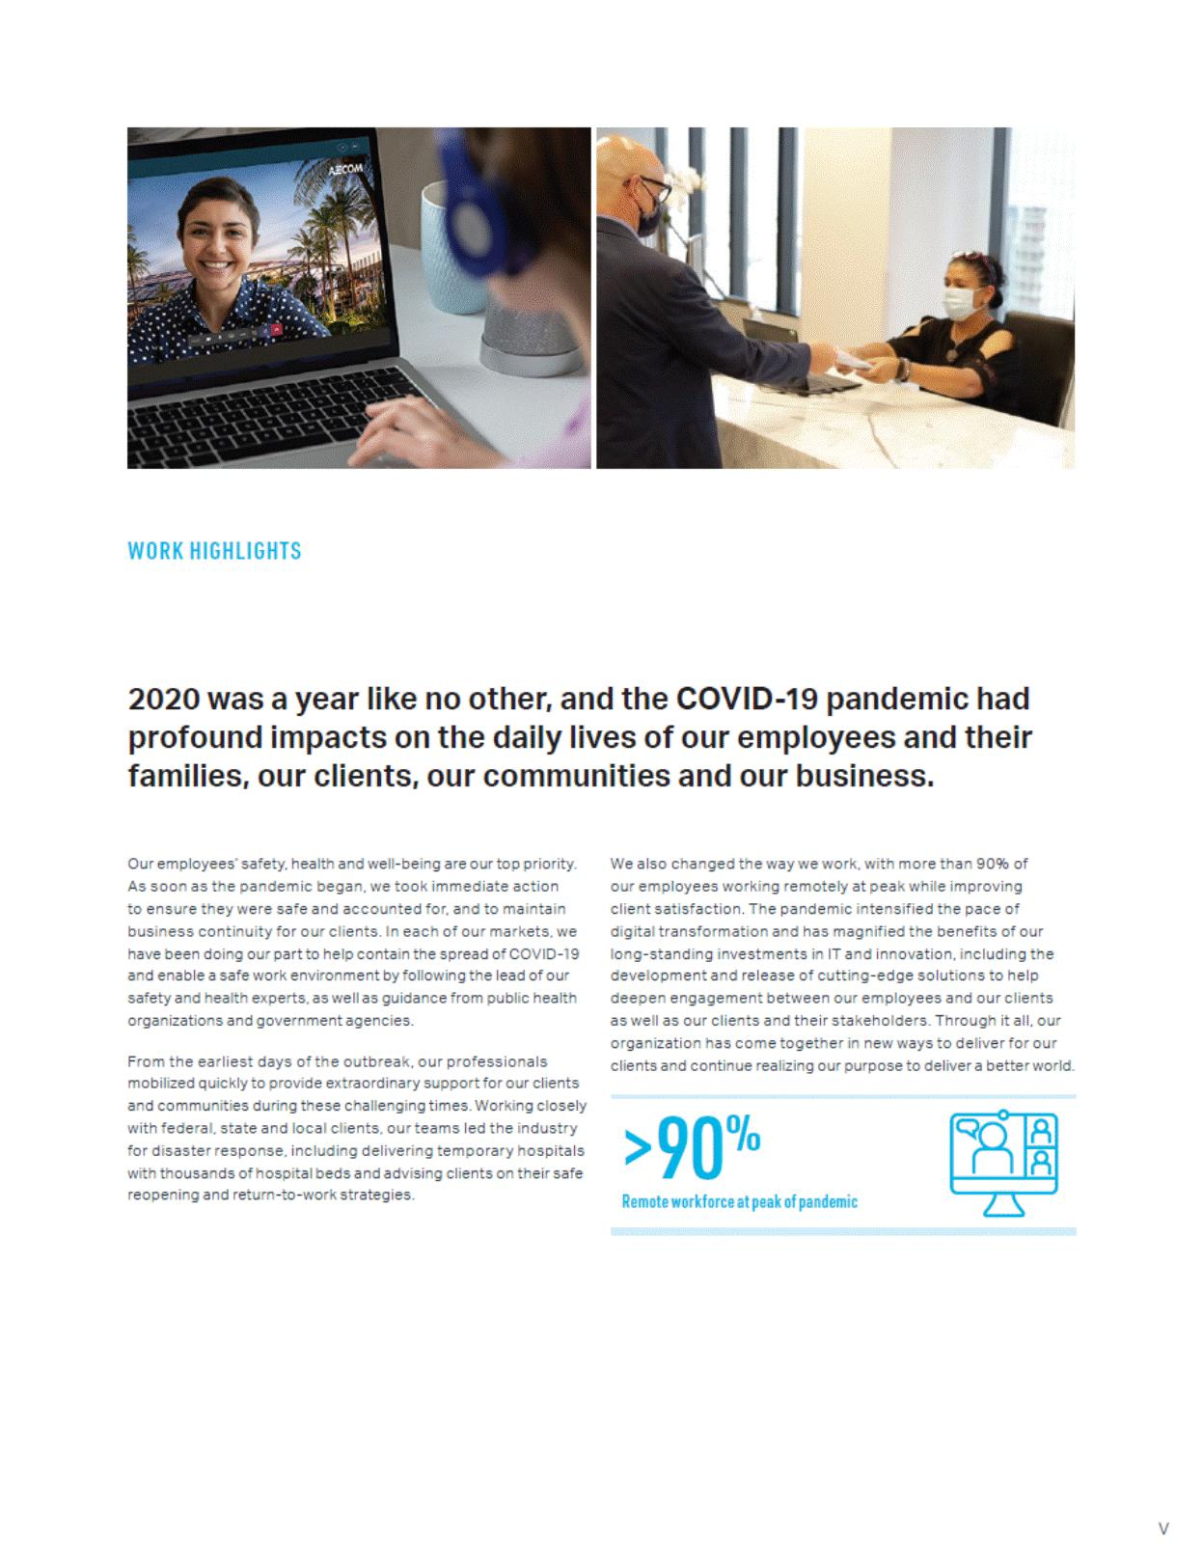

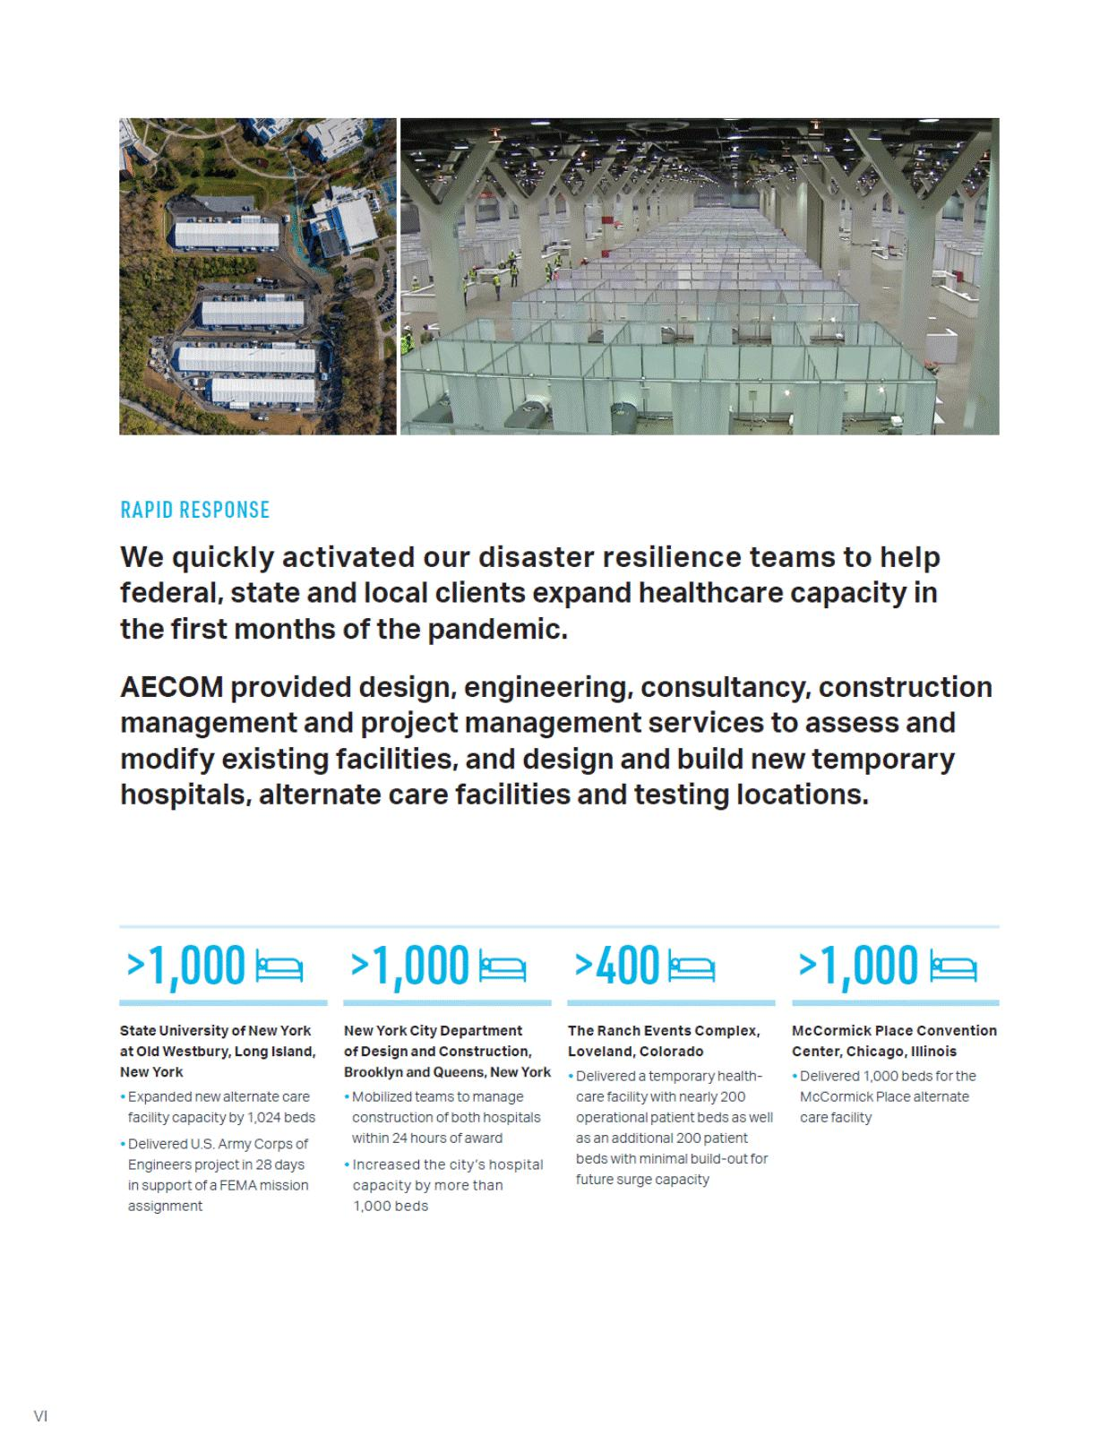

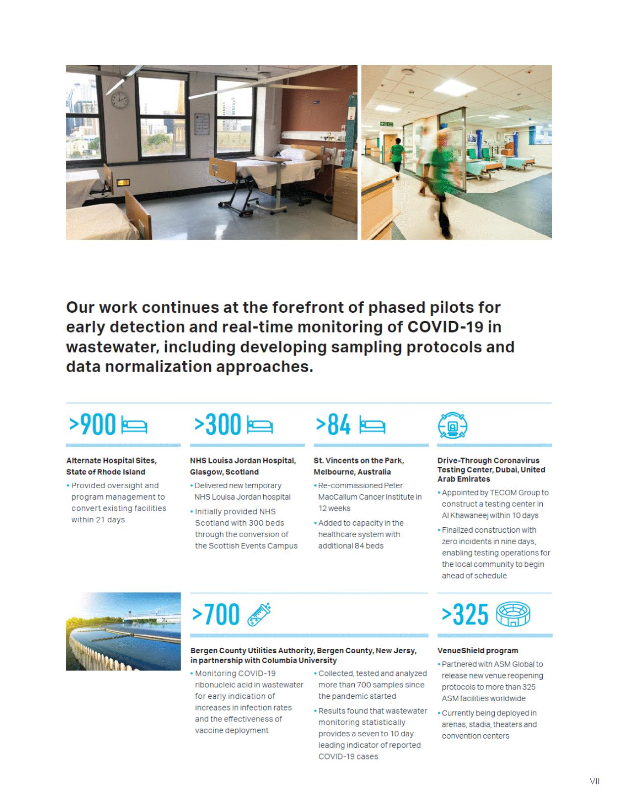



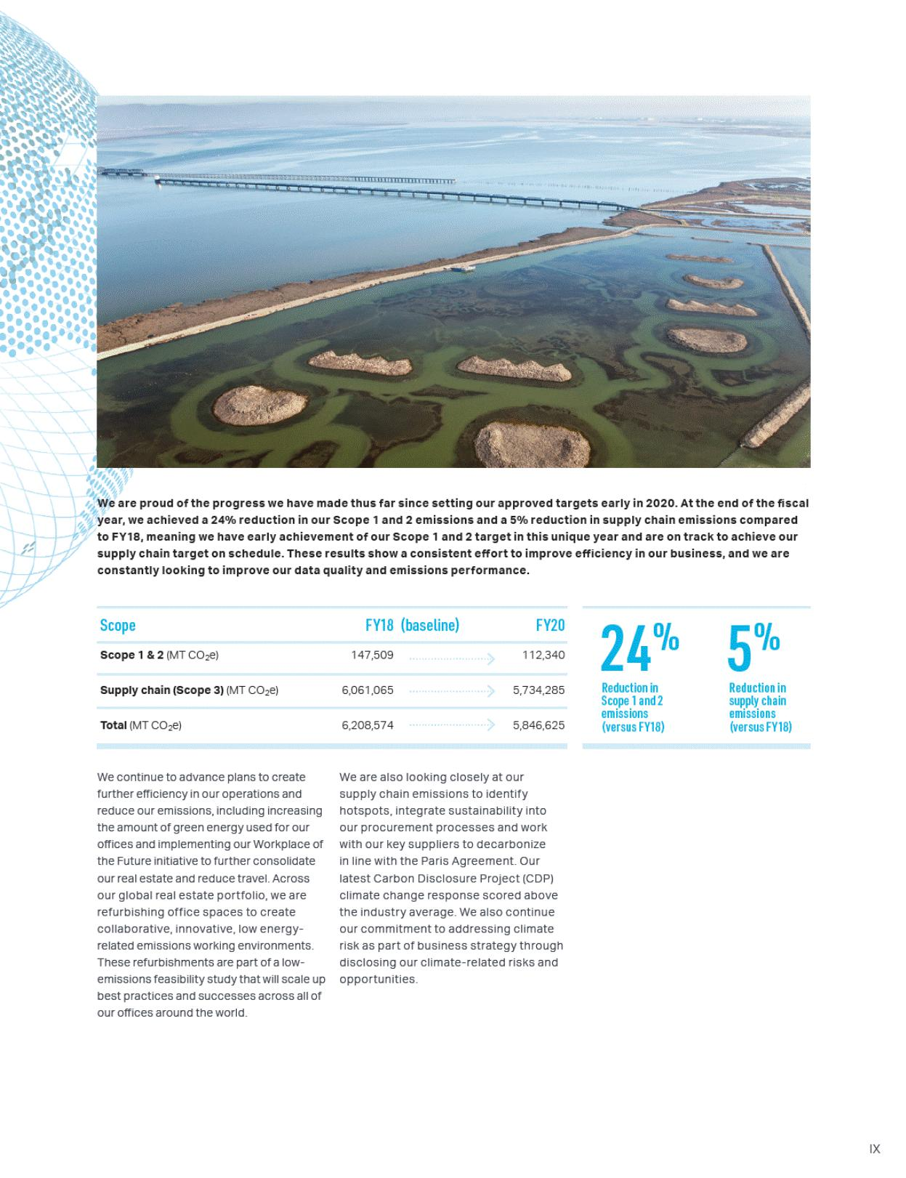





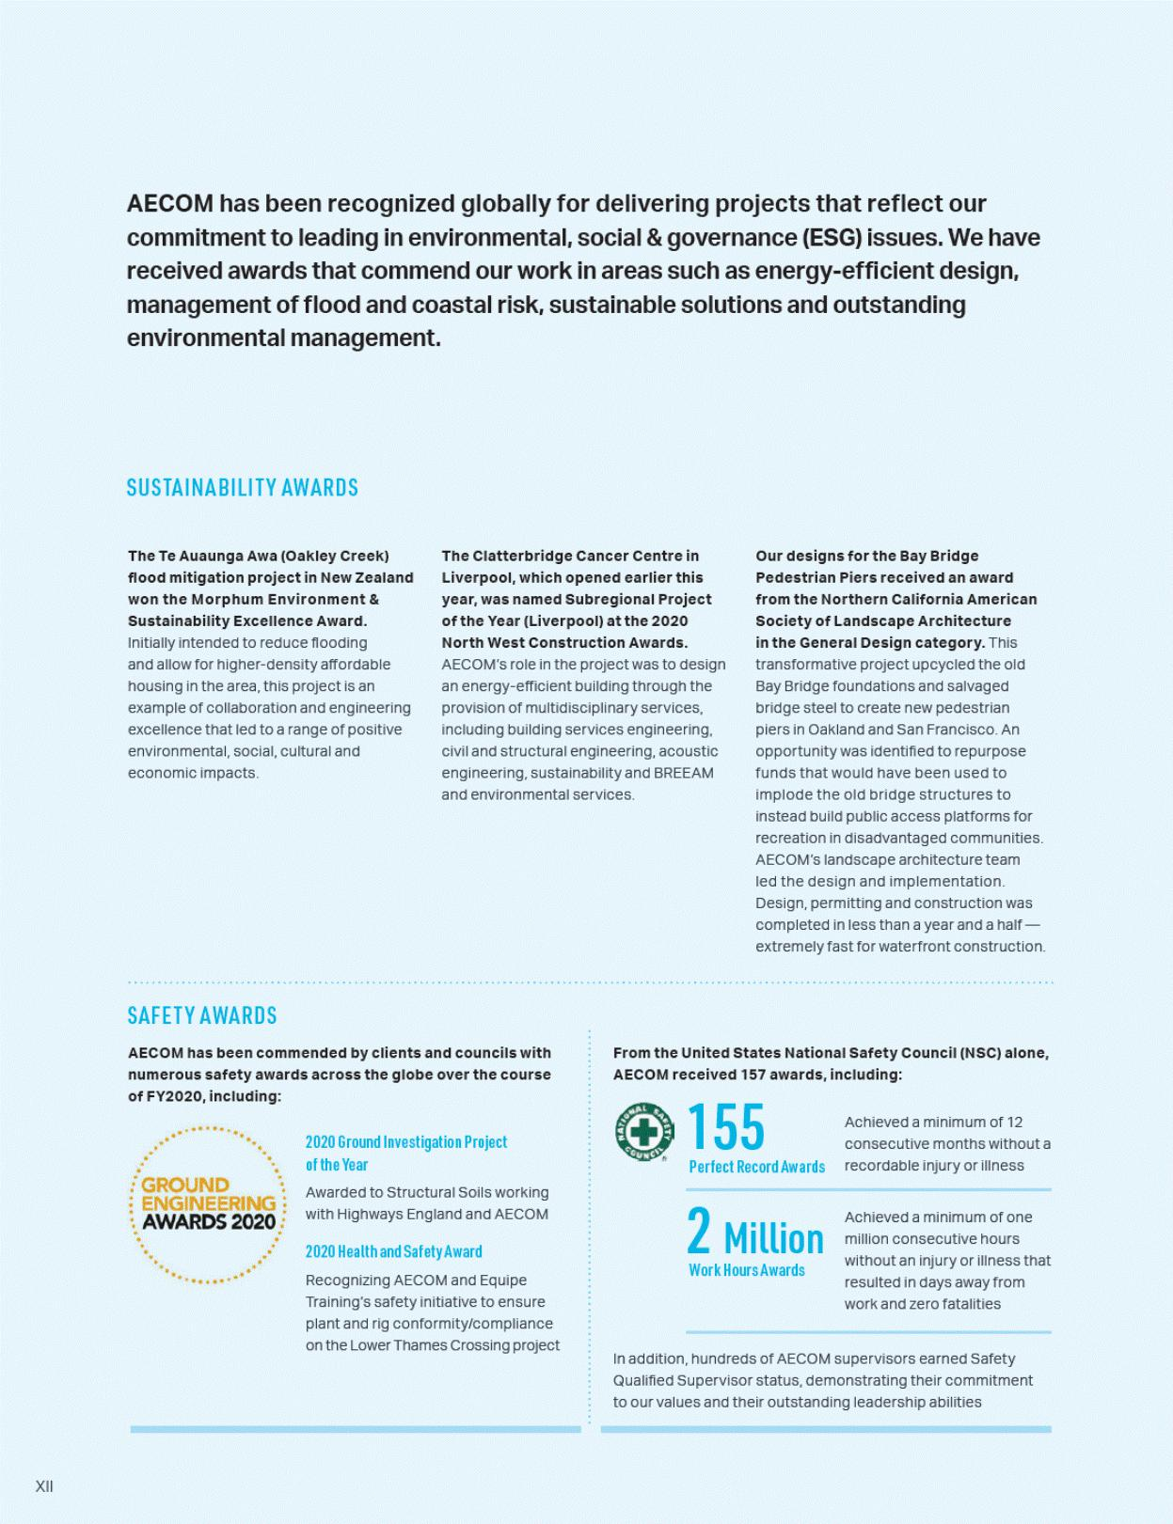

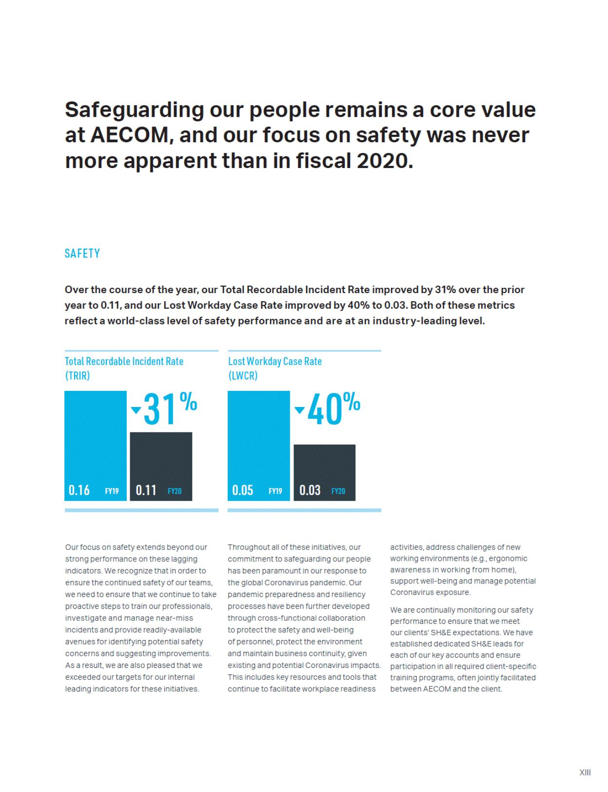



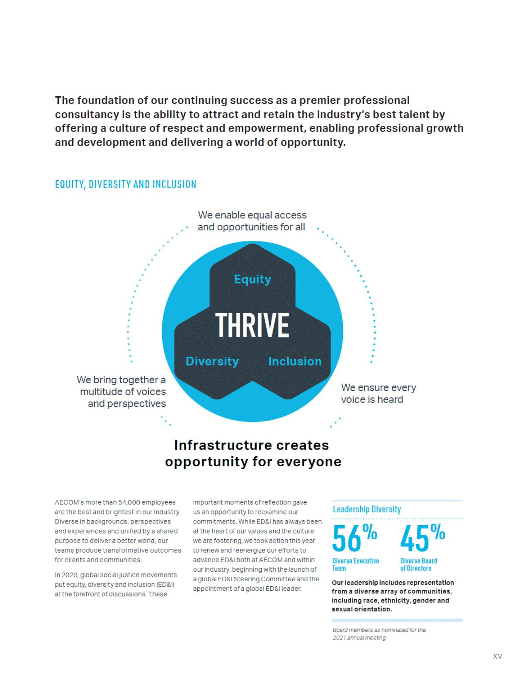

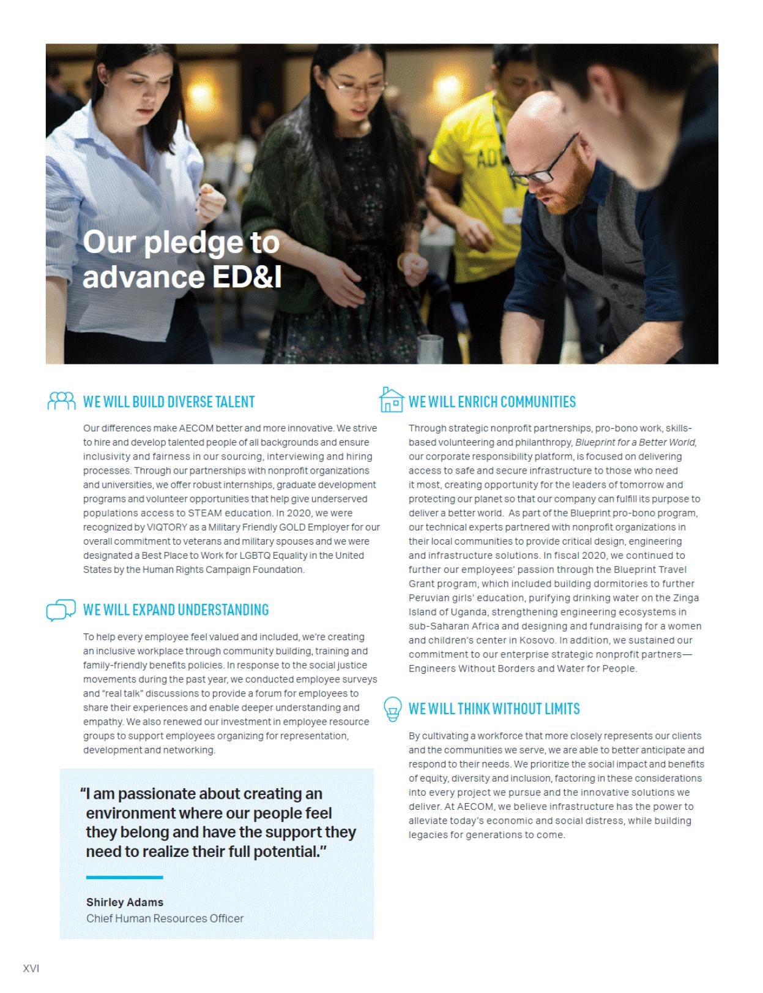



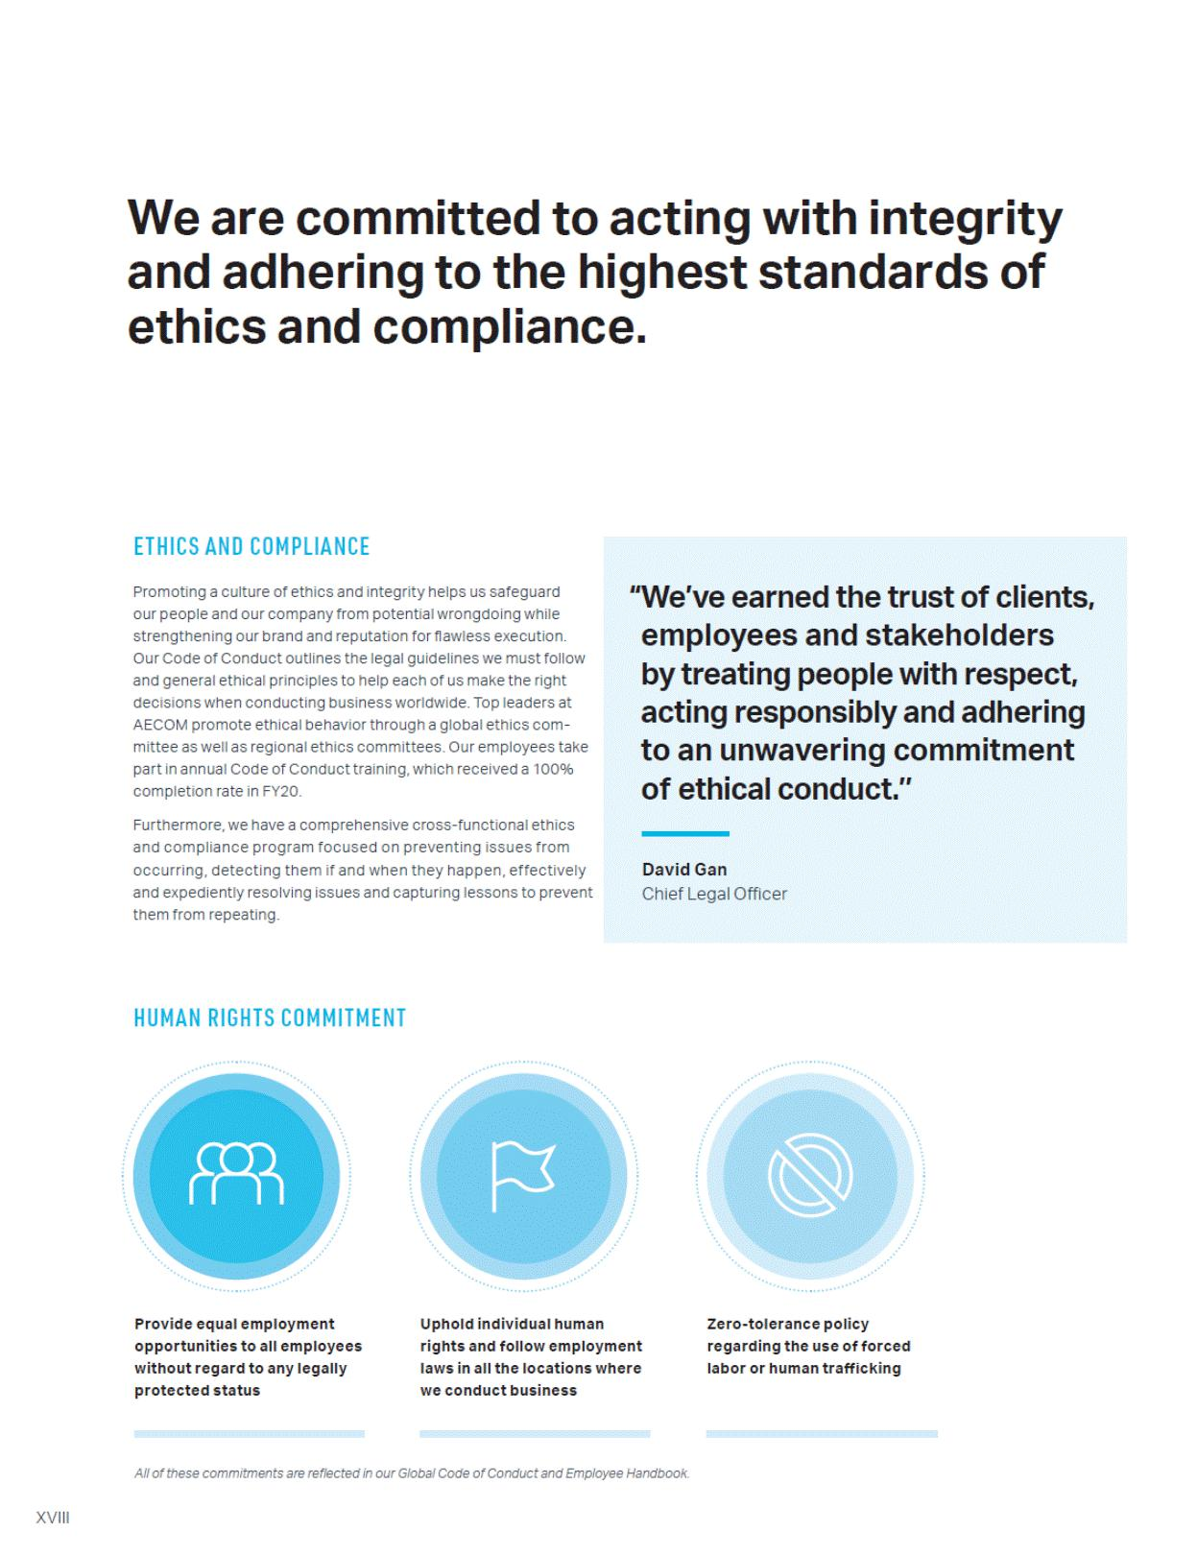

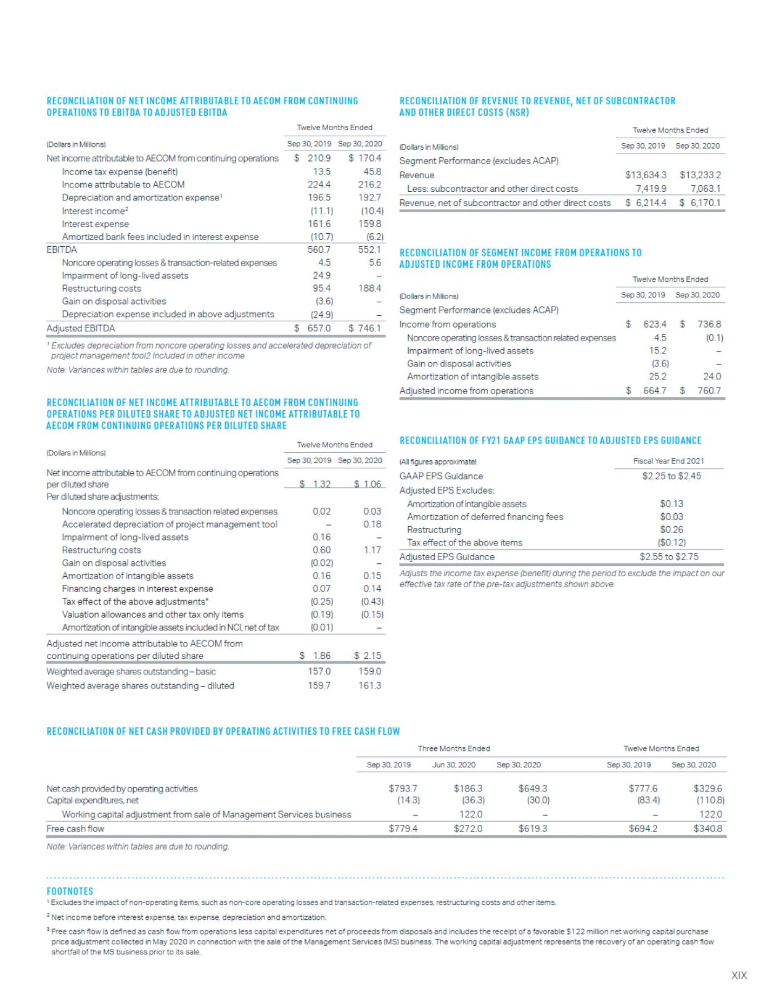

Table of Contents

300 SOUTH GRAND AVENUE, 9TH FLOOR

LOS ANGELES, CALIFORNIA 90071

Dear AECOM Stockholder:

You are cordially invited to attend the 2021 Annual Meeting of Stockholders (the "2021 Annual Meeting") of AECOM, which will be held on Wednesday, February 24, 2021, at 8:00 a.m. Pacific Time. The 2021 Annual Meeting will be a completely virtual meeting, conducted via live webcast, as a health precaution in light of the global COVID-19 pandemic. The virtual meeting format allows all of our stockholders the opportunity to participate in the annual meeting no matter where they are located. You will be able to attend the annual meeting, vote, and submit questions during the meeting by visiting www.meetingcenter.io/276990237. Further information regarding attendance, including how to access the virtual meeting, is set forth in the "Attending the Virtual Annual Meeting" section of the attached Proxy Statement.

Details of the business to be conducted at the 2021 Annual Meeting are given in the attached Notice of Annual Meeting of Stockholders and the attached Proxy Statement.

Whether or not you plan to attend the 2021 Annual Meeting, it is important that your shares be represented. The attached Proxy Statement contains details about how you may vote your shares.

Sincerely,
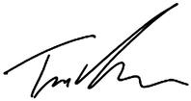

W. Troy Rudd

Chief Executive Officer

Table of Contents

300 SOUTH GRAND AVENUE, 9TH FLOOR

LOS ANGELES, CALIFORNIA 90071

NOTICE OF ANNUAL MEETING OF STOCKHOLDERS

TO BE HELD ON FEBRUARY 24, 2021

The 2021 Annual Meeting of Stockholders (the "2021 Annual Meeting") of AECOM (the "Company," "our" or "we") will be held on Wednesday, February 24, 2021, at 8:00 a.m. Pacific Time, virtually by live webcast.

You will be able to attend the annual meeting, vote, and submit questions during the meeting by visiting www.meetingcenter.io/276990237. At the 2021 Annual Meeting, you will be asked to:

- Elect each of the 11 director nominees named in the Proxy Statement accompanying this notice to the Company's Board of Directors to serve until the Company's 2022 Annual Meeting of Stockholders.

The Board of Directors recommends that you vote FOR each of the director nominees.

- Ratify the selection of Ernst & Young LLP as our independent registered public accounting firm for Fiscal Year 2021.

The Board of Directors recommends that you vote FOR the ratification of the selection of Ernst & Young LLP.

- Vote to approve the Company's executive compensation, on an advisory basis.

The Board of Directors recommends that you vote FOR the Company's executive compensation on an advisory basis.

- To consider and act upon a stockholder proposal regarding lobbying disclosure.

The Board of Directors recommends that you vote AGAINST the stockholder proposal.

We will also attend to any other business properly presented at the 2021 Annual Meeting and any adjournment or postponement thereof. The foregoing items of business are more fully described in the Proxy Statement that is attached to, and a part of, this notice.

Only common stockholders of record at the close of business on January 11, 2021 can vote at the 2021 Annual Meeting or any adjournment or postponement thereof.

By order of the Board of Directors,
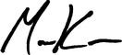

Manav Kumar

Corporate Secretary

Los Angeles, California

January 15, 2021

Table of Contents

Table of Contents

Proxy Statement Summary | 1
Introduction | 10
Annual Meeting Information | 11
Proposal 1: Election of Directors | 14
Proposal 2: Ratification of Selection of Independent Registered Public Accounting Firm | 24
Proposal 3: Advisory Resolution to Approve Executive Compensation | 26
Proposal 4: Stockholder Proposal | 27
Proposal 4: Board of Directors' Statement in Opposition to the Stockholder Proposal | 29
Corporate Governance | 31
Executive Officers | 40
Compensation Discussion and Analysis | 42
Report of the Compensation and Organization Committee of the Board of Directors | 61
Executive Compensation Tables | 62
CEO Pay Ratio | 71
Directors' Compensation | 72
Compensation Committee Interlocks and Insider Participation | 74
Report of the Audit Committee of the Board of Directors | 75
Audit Fees | 77
Security Ownership of Certain Beneficial Owners and Management | 78
Other Information | 80
Annex A — Reconciliation of Non-GAAP Items | A-1

Table of Contents

Proxy Statement Summary

Meeting Information

Record January 11, 2021

Date:
Meeting February 24, 2021, 8:00 a.m. (Pacific Time)
Date:
Location: Virtual live webcast. You will be able to attend the annual meeting, vote, and submit questions during the meeting by visiting
www.meetingcenter.io/276990237. Further information regarding attendance, including how to access the virtual meeting, is set forth in the "Attending the Virtual
Annual Meeting" section of the Proxy Statement

This summary highlights information contained elsewhere in our Proxy Statement and does not contain all of the information that you should consider. We encourage you to read the entire Proxy Statement carefully before voting. We made this Proxy Statement first available to stockholders on January 15, 2021.

Stockholder Voting Matters

 | Proposal |  | Board's Voting | Page
 | Number | Description | Recommendation | Reference
 | 1 | Elect directors to serve until our 2022 Annual Meeting of Stockholders. | FOR EACH | 14
 | 2 | Ratify the selection of Ernst & Young LLP as our independent registered public accounting firm for Fiscal Year 2021. | FOR | 24
 | 3 | Advisory vote to approve our executive compensation. | FOR | 26
 | 4 | Stockholder proposal regarding lobbying disclosure. | AGAINST | 27
How to Vote

Vote Online | Vote by Phone | Vote by Mail
You can vote your shares online by following the instructions on | You can vote your shares by phone by following the instructions on | You can vote your shares by mail by requesting a printed copy of
your proxy card | your proxy card (1-800-652-8683)—or scan the QR code: | the proxy materials and signing, dating and mailing the enclosed
(www.envisionreports.com/ACM). |  | proxy card to:

AECOM
300 South Grand Avenue, 9th Floor
Los Angeles, CA 90071
Attn: Corporate Secretary

Your Vote is Important

Whether or not you plan to attend the 2021 Annual Meeting, we request that you vote (a) by Internet, (b) by telephone or (c) by requesting a printed copy of the proxy materials and using the proxy card or voting instruction card enclosed therein as promptly as possible in order to ensure your representation at the 2021 Annual Meeting.

You may revoke your proxy at any time before it is exercised by giving our Corporate Secretary written notice of revocation, submitting a later-dated proxy by Internet, telephone or mail or by attending the 2021 Annual Meeting and voting.

Please note, however, that if your shares are held of record by a broker, bank or other nominee and you wish to vote at the 2021 Annual Meeting, you must obtain from the record holder a proxy issued in your name.

1

Table of Contents

Our Current Board of Directors

 |  |  | Director |  |  | Committee
Name |  | Age | Since | Primary (or Former) Occupation | Independent | Memberships
Bradley W. Buss |  | 57 | 2020 | Former Chief Financial Officer of SolarCity Corporation and former Chief Financial Officer of | Yes | CO, NG
 |  |  |  | Cypress Semiconductor Corporation
 | Robert G. Card | 67 | 2019 | President, The Card Group LLC; Former President and Chief Executive Officer of SNC-Lavalin | Yes | A, NG
Jacqueline C. Hinman |  | 59 | 2019 | Former Chairman, President and Chief Executive Officer of CH2M HILL Companies, Ltd. | Yes | CO, SRS
Steven A. Kandarian¹ |  | 68 | 2019 | Former Chairman and Chief Executive Officer of MetLife Inc. | Yes | A, CO*
Lydia H. Kennard |  | 66 | 2020 | Founder and Chief Executive Officer of KDG Construction Consulting | No | SRS
Dr. Robert J. Routs¹ |  | 74 | 2010 | Former Executive Director U.S. Downstream Operations, Royal Dutch Shell plc | Yes | CO, SRS*
W. Troy Rudd |  | 56 | 2020 | Chief Executive Officer, AECOM | No | None
Clarence T. Schmitz |  | 72 | 2014 | Co-Founder and Former Chief Executive Officer, Outsource Partners International Inc. | Yes | A*, CO
Douglas W. Stotlar† |  | 60 | 2014 | Former President and Chief Executive Officer, Con-way Inc. | Yes | A, NG*
Daniel R. Tishman |  | 65 | 2010 | Chairman and Executive Vice President of Tishman Holdings Corporation | No | SRS
General Janet C. |  | 62 | 2015 | General (Retired), United States Air Force | Yes | NG, SRS
Wolfenbarger

- Mr. Kandarian and Dr. Routs will not stand for re-election at the 2021 Annual Meeting

A = Audit Committee

CO = Compensation and Organization Committee

NG = Nominating and Governance Committee

SRS = Safety, Risk and Sustainability Committee

* = Committee Chair
† = Chairman of the Board

Recent Corporate Governance Actions

AECOM prioritizes direct engagement between management and the Board with our stockholders. As a result, several significant corporate governance actions have been implemented over the last several years. These actions include separating the roles of Chairman and CEO in August 2020, strengthening commitments to Board diversity and Environmental, Social and Governance (ESG) initiatives, adopting majority voting in uncontested director elections, adopting proxy access, providing stockholders with a right to call a special meeting, and removing

2

Table of Contents

supermajority provisions to approve business combinations. These actions safeguard and promote the long-term interests of AECOM and all stockholders.

Separation of Chairman and | 2020 | ✔ The roles of Chairman and Chief Executive Officer were separated in August 2020 upon the appointment of W. Troy Rudd as Chief Executive Officer
Chief Executive Officer Roles | 2020 |  | and Douglas W. Stotlar as Chairman of the Board
 |  | ✔ | The Corporate Governance Guidelines were amended in November 2020 to state that the Board should encompass individuals with diverse
Strengthened Commitment to |  |  | backgrounds and perspectives and should include representation of individuals from underrepresented communities, including people of different
Strengthened Commitment to | 2020 |  | genders, experiences, ages, races and ethnic backgrounds.
Board Diversity | 2020
Board Diversity |  | ✔ Five out of the 11 nominees for election as directors at the 2021 Annual Meeting are diverse, consisting of four women, including one African American
 |  |  | woman, and one director who self-identifies as LGBTQ+.
Strengthened Commitment to |  | ✔ Refocused the scope of responsibility of the Board's Strategy, Risk and Safety Committee in November 2020 to include oversight of sustainability
Strengthened Commitment to | 2020 |  | matters and renamed it the Safety, Risk and Sustainability Committee
ESG | 2020
ESG |  | ✔ Formed an internal Global ESG Council led by Company President Lara Poloni to elevate commitment to ESG throughout the Company
Adopted Majority Voting | 2018 | ✔ | Adopted majority voting in uncontested elections of directors
 |  | ✔ Stock ownership threshold of 3%
Adopted Proxy Access for | 2017 | ✔ Holding period of 3 years
Director Nominations | 2017 | ✔ May submit nominees consisting of up to 20% of our Board or two directors
 |  | ✔ Up to 20 stockholders may group together to reach 3% stock ownership threshold
Adopted Right to Call a Special | 2017 | ✔ Stockholders owning 25% or more of our shares may request a special meeting of stockholders
Meeting of Stockholders | 2017
Removed Supermajority |  | ✔ Supermajority provision to approve business combinations was eliminated
Provision to Approve Business | 2017
Combinations
 |  |  | 3

Table of Contents

Corporate Governance Information
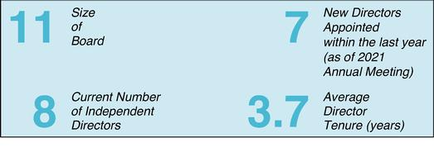

Criteria | Detail
Audit, Compensation and Organization, and Nominating and Governance Committees Consist Entirely of Independent Directors | Yes
Annual Election of All Directors | Yes
Annual Advisory Say-on-Pay Vote | Yes
All Directors Attended More Than 75% of Meetings Held | Yes
Independent Directors Meet Regularly in Executive Session | Yes
Annual Board and Committee Self Evaluations | Yes
Code of Business Conduct and Ethics | Yes
Corporate Governance Guidelines | Yes
Stock Ownership Guidelines for Directors and Executive Officers | Yes
Stockholder Rights Plan (Poison Pill) | No
Proxy Access | Yes
Stockholder Right to Call a Special Meeting | Yes
Supermajority Provision to Approve Business Combinations | No
Adopted Majority Voting in Uncontested Director Elections | Yes
Separation of CEO and Chairman Roles | Yes
4

Table of Contents

Executive Compensation Practices

Our executive pay program provides competitive pay packages that attract, motivate, reward and retain key talent critical to achieving long-term strategic objectives, our ongoing commitment to sustainability, diversity, and inclusion, and the creation of leading shareholder value. Our executive pay program is strongly aligned with stakeholder value and promotes AECOM's ESG (Environmental, Social and Governance) and EDI (Equity, Diversity and Inclusion) initiatives.

What We Do:

- Pay-for-Performance — We condition a majority of performance compensation for our Named Executive Officers (NEOs) on the achievement of earnings, cash flow, Return On Invested Capital ("ROIC") targets, and Relative Total Shareholder Return ("TSR").

- Rigorous Goal Setting — We undergo a detailed process of analyzing and reviewing a number of factors including but not limited to our short- and long-term financial plan; investor input, feedback and expectations; industry and peer performance; benchmarking; and overall achievability.

- Stockholder Engagement — We engage with stockholders throughout the year, including direct outreach to stockholders that represent the ownership of more than 50% of our stock.

- Stock Ownership Guidelines — We have stock ownership guidelines that require NEOs to maintain a significant equity stake in the Company. The CEO ownership guideline is six times base salary and the guideline for other NEOs is three times base salary.

- Independent Consultant — We utilize the services of an independent compensation consultant who does not provide any other services to the Company.

- Clawback Policy — We maintain a clawback policy that allows us to recoup a portion of the short-term cash and long-term equity incentive-based compensation awards paid to current and former officers who are subject to reporting under Section 16 of the Exchange Act (referred to below as Section 16 officers) during the three fiscal years before an accounting restatement due to material noncompliance with any financial reporting requirement under the securities laws.

- Risk Assessment — Our compensation consultant performs an independent risk assessment of compensation programs.

- Competitive Analysis — We annually seek to understand labor market trends pertaining to the amount and form of executive pay delivery through comprehensive competitive analyses.

- Annual Say-on-Pay Vote — We have a policy to hold an advisory vote to approve the Company's executive compensation on an annual basis.

What We Don't Do:

- Stock Option Repricing — Our stock plan prohibits re-pricing underwater stock options or stock appreciation rights without stockholder approval.

- Single Trigger Equity Acceleration — We do not maintain plans or agreements that provide for automatic "single-trigger" equity acceleration or bonus payments in connection with a change in control (rather, any payment of benefit requires a qualifying termination of employment in connection with a change in control known as "double trigger").

- Tax Gross-Ups — We do not provide tax gross-ups to NEOs on change in control payments.

- Hedging and Pledging — We prohibit hedging transactions involving AECOM common stock and do not allow trading in puts, calls, options or other similar transactions. In addition, we prohibit the pledging of AECOM common stock except in certain limited circumstances subject to Company approval and demonstration of the ability to repay the applicable loan without selling such securities.

5

Table of Contents

Environmental, Social and Governance Matters

We are committed to being a leader in environmental sustainability, social responsibility, and corporate governance.

We embrace sustainability by striving to make a positive, lasting impact on society and the environment. Sustainability and resilience in the world's built and natural environments are at the core of what we do and how we operate — focusing on the environmental, social and governance impacts of our business. Through our projects and our operations, we have both a significant opportunity and a responsibility to protect, enhance and restore the world's natural and social systems.

We are committed to addressing the effects of climate change as a key priority for our sustainability program by improving resilience and working to advance ambitious greenhouse gas emissions reduction targets. Having achieved our previous emissions reduction targets ahead of schedule, we have set new science-based targets for 2025 that are in alignment with the Paris Agreement's goals to limit the worst effects of climate change: a 20% reduction in Scope 1 and 2 emissions and a 10% reduction in supply chain emissions from our 2018 baseline. Our new targets have been independently validated by the Science Based Targets initiative (SBTi) and, at the time of validation, AECOM was the first and only US-based company in the engineering and construction sector to have set SBTi targets.
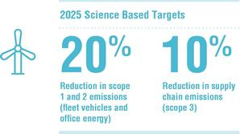

In addition, we continue to invest in proprietary innovations and solutions to combat globally pervasive emerging contaminants, such as our patented DE-FLUOROTM water treatment solution to destroy per- and polyfluoroalkyl substances (PFAS) on-site.

We have established an internal Global ESG Council to coordinate and drive our ESG initiatives across AECOM worldwide. The Council's functions include: (i) assessing the impact of the Company's services and operations and advising on how the Company may enhance its ESG performance; (ii) advising on appropriate global ESG goals, commitments and targets; (iii) shaping the Company's ESG messaging and disclosure; and (iv) assessing the potential impact of climate change on the Company's services and operations and providing a global forum to share ideas on how the Company's unique offerings and solutions can enable mitigation, adaptation and resilience to climate change that will develop and support buildings, infrastructure assets and communities; and (v) providing a framework for evaluating client opportunities to ensure that they align with our ESG goals. The Council is composed of employees with relevant professional expertise and experience including strategic and end market leadership; consulting expertise; operations; procurement, real estate and facilities management and other corporate functions. Our Board, including through its Safety, Risk and Sustainability Committee, has oversight over ESG matters. Additional information regarding our ESG initiatives is located on the investor relations section of our website, at https://investors.aecom.com/esg.

Commitment to Our People (Human Capital Management)

We have made key advances in the past year in our transformation into a professional services firm and continue to set new standards for excellence in our industry. The foundation of our continuing success as a premier professional services enterprise is the ability to attract and retain the industry's best, diverse talent by providing a culture of equity, diversity, inclusion, development, opportunity and empowerment. This understanding informs our approach to supporting our people.

Our principal asset is our employees, and large percentages of our employees have technical and professional backgrounds and undergraduate and/or advanced degrees. At the end of our fiscal 2020, we employed

6

Table of Contents

approximately 54,000 persons including engineers, architects, environmental scientists, project managers and other project professionals. We believe that the quality and level of service that our professionals deliver are among the highest in our industry.

We are committed to enhancing our position as a leading employer in our industry. Our culture and reputation as a leader in the engineering and construction sector enables us to recruit and retain some of the best available talent in the countries we operate in. We believe in a culture of equity, diversity and inclusion, and we are committed to advancing safe and respectful work environments where our employees are invited to bring their talents, backgrounds and expertise to bear on some of the world's most complex problems and where every person has the opportunity to thrive personally and professionally.

We are committed to engaging our employees globally to understand regional inclusion and diversity opportunities, building leadership accountability and expanding recruitment efforts to foster a workforce reflective of our communities. To continue attracting and retaining some of the most talented employees in our industry, we ensure employees have the tools and resources they need to hone their skills, develop strong leadership behaviors and advance their careers. Our human capital objectives and initiatives are overseen by our Board as per our Corporate Governance Guidelines.

Health and Safety. Core to our corporate values is safeguarding our people and fostering a culture of caring that promotes the wellbeing of our employees, contractors and business partners. We safeguard our people, projects and reputation by striving for zero employee injuries and illnesses, while operating and delivering our work responsibly and sustainably. We maintain our industry's best-in-class lost workday case and recordable incident rates, and our safety performance is consistently recognized by key clients across the regions where we work as well as by recognized safety organizations.

From the United States National Safety Council (NSC) alone, AECOM received 157 awards, including:


- Perfect Record Awards (155): Achieved a minimum of 12 consecutive months without a recordable injury or illness.

- Million Work Hour Awards (2): Achieved a minimum of one million consecutive hours without an injury or illness that resulted in days away from work and zero fatalities. In addition, hundreds of AECOM supervisors earned Safety Qualified Supervisor status, demonstrating commitment to our values and outstanding leadership abilities.

Equity, diversity and inclusion. While ED&I has always been a part of our culture, we continue to advance efforts globally to integrate our principles into all aspects of our work and measure results. We are focused on four key areas: 1) Building diverse talent through our recruitment efforts, as well as offering internships (including virtual internships during the Covid-19 pandemic) and partnering with nonprofit organizations and universities, 2) Enriching communities through pro-bono work, volunteerism, philanthropy and strategic partnerships, 3) Expanding understanding and empathy among employees through community-building, training and family-friendly benefit

7

Table of Contents

policies, and 4) Prioritizing the social impact and benefits of ED&I into every project we pursue and the innovative solutions we deliver.
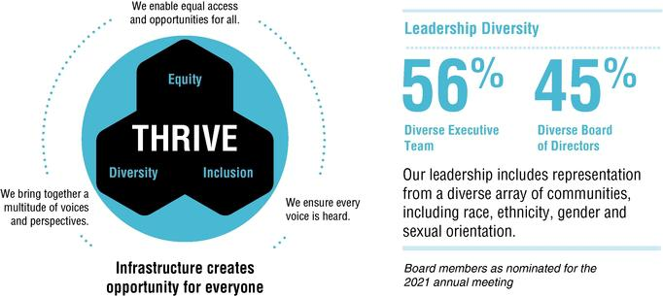

Employee experience. We continue to enhance our employee programs, workplace culture and digital technologies to support employees and managers in more effective and efficient ways to execute their work and meaningfully engage with clients. These efforts include employee wellness and wellbeing programs to better support employees while working remotely during the Covid-19 pandemic and beyond, expanding access and technical training programs through our online education portal, AECOM University, delivering new digital tools to boost connectivity among employees, and advancing frontline leadership programs.

Workplace of the Future Initiative. Drawing upon the experiences of our professionals, who have remained highly productive while working remotely during the Covid-19 pandemic, we have invited their input and ideas to begin to shape the future ways of working at AECOM. In particular, through a global competition, we challenged our professionals to consider how new workspaces can support health, collaboration and camaraderie, how technology and tools can be leveraged to ensure continuing productivity and client engagement, and what they need to be well and engaged. Many of the resulting ideas are being implemented regionally and globally. Our initiatives in this area include a continued drive toward digital delivery of our work product and enhanced client engagement, hybrid work environments, and a repurposed and overall reduced global real estate footprint.

Community responsibility. Through strategic nonprofit partnerships, pro-bono work, skills-based volunteering and philanthropy, Blueprint for a Better World, our corporate responsibility platform, is focused on delivering access to safe and secure infrastructure to those who need it most, creating opportunity for the leaders of tomorrow and protecting our planet so that our company can fulfill its purpose to deliver a better world. As part of the Blueprint pro-bono program, our technical experts partnered with nonprofit organizations in their local communities to provide critical design, engineering and infrastructure solutions. In fiscal 2020, we continued to further our employees' passion through the Blueprint Travel Grant program, which included building dormitories to further Peruvian girls' education, purifying drinking water on the Zinga Islands of Uganda, strengthening engineering ecosystems in Sub-Saharan Africa, and designing and fundraising for a women and children's center in Kosovo. In addition, we sustained our commitment to our enterprise strategic nonprofit partners — Engineers Without Borders and Water for People.

8

Table of Contents

Blueprint for a Better World


Workplace Accolades:


9

Table of Contents

300 SOUTH GRAND AVENUE, 9TH FLOOR

LOS ANGELES, CALIFORNIA 90071

PROXY STATEMENT

ANNUAL MEETING OF STOCKHOLDERS
TO BE HELD
FEBRUARY 24, 2021

INTRODUCTION

This Proxy Statement is furnished in connection with the solicitation of proxies, on behalf of the Board of Directors of AECOM, a Delaware corporation ("we," "our," the "Company" or "AECOM"), for use at our 2021 Annual Meeting of Stockholders ("2021 Annual Meeting") to be held on February 24, 2021, at 8:00 a.m. Pacific Time, or at any adjournment or postponement thereof. At the 2021 Annual Meeting, you will be asked to consider and vote on the matters described in this Proxy Statement and in the accompanying notice. The 2021 Annual Meeting will be held virtually on the Internet. You will be able to attend the annual meeting, vote, and submit questions during the meeting by visiting www.meetingcenter.io/276990237. Only common stockholders of record at the close of business on January 11, 2021, which is the record date for the 2021 Annual Meeting, are permitted to vote at the 2021 Annual Meeting and any adjournment or postponement thereof.

The Company's Board of Directors (the "Board of Directors" or "Board") is soliciting your vote to:

- Elect each of the 11 director nominees named in this Proxy Statement to the Company's Board of Directors to serve until the Company's 2022 Annual Meeting of Stockholders.

- Ratify the selection of Ernst & Young LLP as our independent registered public accounting firm for Fiscal Year 2021.

- Approve the Company's executive compensation, on an advisory basis.

- Consider and act upon a stockholder proposal regarding lobbying disclosure.

We utilize the U.S. Securities and Exchange Commission rule allowing companies to furnish proxy materials to their stockholders over the Internet. We believe that this e-proxy process expedites stockholders' receipt of proxy materials while also lowering the costs and reducing the environmental impact of our annual meeting. On January 15, 2021, we began mailing a Notice of Internet Availability of Proxy Materials (the "Notice") to all stockholders of record as of January 11, 2021, and posted our proxy materials on the website referenced in the Notice. As more fully described in the Notice, all stockholders may choose to access our proxy materials on the website referred to in the Notice or may request a printed set of our proxy materials. In addition, the Notice and website provide information regarding how you may request proxy materials in printed form by mail or electronically by e-mail on an ongoing basis.

The Notice of Internet Availability of Proxy Materials, Proxy Statement and our Annual Report on Form 10-K are available at investors.aecom.com.

10

Table of Contents

ANNUAL MEETING INFORMATION

Proxies

You may vote your shares at the 2021 Annual Meeting or by proxy if you are a record holder. There are three ways to vote by proxy: (1) on the Internet by following the instructions on the Notice or proxy card, (2) by telephone by calling 1-800-652-8683 and following the instructions on the Notice or proxy card or (3) by requesting a printed copy of the proxy materials and signing, dating and mailing the enclosed proxy card to our Corporate Secretary at the address below. If your shares are held in the name of a bank, broker or another holder of record, you will receive instructions from the holder of record. You must follow the instructions of the holder of record in order for your shares to be voted. Internet and telephone voting will also be offered to stockholders owning shares through certain banks and brokers.

You may revoke your proxy at any time before it is exercised at the 2021 Annual Meeting by (1) giving our Corporate Secretary written notice of revocation, (2) delivering to us a signed proxy card with a later date,

- granting a subsequent proxy through the Internet or telephone or (4) attending the 2021 Annual Meeting and voting. Written notices of revocation and other communications with respect to the revocation of proxies should be addressed to AECOM, 300 South Grand Avenue, 9th Floor, Los Angeles, California 90071, Attention: Corporate Secretary.

All shares represented by valid proxies received and not revoked before they are exercised will be voted in the manner specified in the proxy. Other than with respect to certain trustees who hold our shares in trust, if you submit proxy voting instructions but do not direct how to vote on each item, the persons named as proxies will vote in accordance with the Board recommendations for the proposals. Our Board is unaware of any matters other than those described in this Proxy Statement that may be presented for action at our 2021 Annual Meeting. If other matters do properly come before our 2021 Annual Meeting, however, it is intended that shares represented by proxies will be voted in the discretion of the proxy holders.

If you are a beneficial owner and hold your shares in the name of a bank, broker or another holder of record and do not return the voting instruction card, the broker or another nominee may vote your shares on each matter at the 2021 Annual Meeting for which he or she has the requisite discretionary authority. Under applicable rules, brokers have the discretion to vote on routine matters, which include the ratification of the selection of the independent registered public accounting firm. Brokers will not have the discretion to vote on any of the other proposals presented at the 2021 Annual Meeting.

Solicitation of Proxies

We will pay the entire cost of soliciting proxies. In addition to soliciting proxies by mail and by the Internet, we will request banks, brokers and other record holders to send proxies and proxy materials to the beneficial owners of our common stock and to secure their voting instructions, if necessary. We will reimburse record holders for their reasonable expenses in performing these tasks. We have agreed to pay Innisfree M&A Incorporated $25,000 plus reasonable expenses, costs and disbursements for various proxy solicitation services associated with the 2021 Annual Meeting. If necessary, we may use our regular employees, who will not be specially compensated, to solicit proxies from stockholders, whether personally or by telephone, letter or other means.

11

Table of Contents

Record Date and Voting Rights

Our Board has fixed January 11, 2021 as the record date for determining the stockholders who are entitled to notice of, and to vote at, our 2021 Annual Meeting. Only common stockholders of record at the close of business on the record date will receive notice of, and be able to vote at, our 2021 Annual Meeting. As of the record date, there were 147,774,517 shares of our common stock outstanding held by 1,808 record holders. A majority of the stock issued and outstanding and entitled to vote must be present at our 2021 Annual Meeting, either in person or by proxy, in order for there to be a quorum at the meeting. Each share of our outstanding common stock entitles its holder to one vote. Shares of our common stock with respect to which the holders are present at our 2021 Annual Meeting but not voting, and shares for which we have received proxies but with respect to which holders of the shares have abstained, will be counted as present at our 2021 Annual Meeting for the purpose of determining whether or not a quorum exists. "Broker non-votes" will also be counted as present for the purpose of determining whether a quorum exists. Broker non-votes are shares of common stock held by brokers or nominees over which the broker or nominee lacks discretionary power to vote and for which the broker or nominee has not received specific voting instructions from the beneficial owner.

Our Board urges you to vote promptly by either (1) electronically submitting a proxy or voting instruction card over the Internet, (2) by telephone or (3) by delivering to us or to your broker, as applicable, a signed and dated proxy card.

Votes will be tabulated by the inspector of election appointed for the 2021 Annual Meeting, who will separately tabulate affirmative and negative votes, abstentions and broker non-votes.

Attending the Virtual Annual Meeting

Stockholders of record at the close of business on January 11, 2021 will be able to attend the annual meeting, vote, and submit questions during the 2021 Annual Meeting by visiting www.meetingcenter.io/276990237 at the meeting date and time. You should ensure that you have a strong Wi-Fi connection wherever you intend to participate in the meeting. You should also give yourself enough time to log in and ensure that you can hear streaming audio prior to the start of the meeting. We encourage you to access the 2021 Annual Meeting prior to the start time; online access will begin at 7:00 a.m., Pacific Time. The two items of information needed to access the virtual annual meeting from the website are as follows:

- Control number: the 15-digit control number located in the shaded bar on the Notice, proxy card, or email notification you have received

- Password: ACM2021

Have the Notice or proxy card in hand when you access the website and then follow the instructions. If you are a stockholder of record, you are already registered for the virtual meeting. If you hold your shares beneficially in street name, you must register in advance to attend the virtual meeting, vote, and submit questions. To register in advance you must obtain a legal proxy from the broker, bank, or other nominee that holds your shares giving you the right to vote the shares. You must forward a copy of the legal proxy along with your email address to Computershare. Requests for registration should be sent by email to legalproxy@computershare.com or by mail to:

Computershare

AECOM Legal Proxy
P.O. Box 43001
Providence, RI 02940-3001

Requests for registration must be labeled as "Legal Proxy" and be received no later than 5:00 p.m., Eastern Time, on February 19, 2021.

Stockholders of record and beneficial owners who duly registered to attend the 2021 Annual Meeting will be able to vote their shares and submit questions at any time during the virtual meeting by following the instructions on the website referenced above. You will be able to vote your shares electronically while attending the 2021 Annual Meeting via the virtual meeting platform by following the instructions on the website. You may also submit questions in advance of the 2021 Annual Meeting beginning approximately two weeks prior to the meeting by logging into www.meetingcenter.io/276990237 and following the instructions on the website.

12

Table of Contents

Our aim is to offer shareholders rights and participation opportunities during our virtual annual meeting that are comparable to those that have been provided at our past in-person annual meetings of shareholders, using online tools to facilitate shareholder access and participation. We will answer questions that comply with the meeting rules of conduct during the annual meeting of stockholders, subject to time constraints. If we receive substantially similar questions, we will group such questions together. Questions relevant to meeting matters that we do not have time to answer during the meeting will be posted to our website following the meeting. Questions regarding personal matters or matters not relevant to meeting matters will not be answered.

If you have technical difficulties or trouble accessing the virtual meeting at any time after online access commences at 8:00 a.m., Pacific Time, on the date of the annual meeting, please access the support link provided on the website referenced above.

Year End Reporting Convention

We report our results of operations based on 52- or 53-week periods ending on the Friday nearest September 30. For clarity of presentation, all periods are presented as if the fiscal year ended on September 30.

Fiscal 2020 consisted of a 53-week period.

Majority Voting; Director Resignation Policy

In uncontested elections, directors will be elected by a majority of the votes cast, which means that the number of shares voted "for" a director must exceed the number of shares voted "against" that director. In uncontested elections, any director who is not elected by a majority of the votes is expected to tender his or her resignation to the Nominating and Governance Committee ("Nominating Committee"). The Nominating Committee will recommend to the Board whether to accept or reject the resignation offer, or whether other action should be taken. The Board will act on the Nominating Committee's recommendation within 90 days following certification of the election results.

13

Table of Contents

PROPOSAL 1

ELECTION OF DIRECTORS

We are nominating 11 directors for election to our Board, 9 of whom are current members of our Board that are standing for re-election at the 2021 Annual Meeting. Directors elected at the 2021 Annual Meeting will serve until the 2022 Annual Meeting of Stockholders and until their successors are duly elected and qualified. If a quorum is present at our 2021 Annual Meeting, the directors will be elected by a majority of the votes cast, which means that the number of shares voted "for" a director must exceed the number of shares voted "against" that director, with any director who is not elected by a majority of the votes case being expected to tender his or her resignation to the Nominating Committee. The Nominating Committee will recommend to the Board whether to accept or reject the resignation offer, or whether other action should be taken. The Board will act on the Nominating Committee's recommendation within 90 days following certification of the election results.

Shares represented by proxies will be voted, if authority to do so is not withheld, for the election of each of the director nominees named in this Proxy Statement. The size of our Board is currently 11 directors, and we are nominating 11 director nominees. Proxies cannot be voted for a greater number of persons than the number of nominees named. Each of the nominees has consented to serve as a director if elected, and management has no reason to believe that any nominee will be unable or unwilling to serve if elected as a director, except as set forth in the remainder of this paragraph. In the event that any nominee is unavailable for re-election as a result of an unexpected occurrence, shares will be voted for the election of such substitute nominee as our Board may propose.

Director Qualifications

The Board believes that, as a whole, Board members should possess a combination of the skills, professional experience and diversity of backgrounds necessary to oversee the Company's business. The Nominating Committee is responsible for developing and recommending Board membership criteria to the full Board for approval. The criteria, which are set forth in the Company's Corporate Governance Guidelines, include the highest professional and personal ethics and values, commitment to enhancing stockholder value with sufficient time to effectively carry out his or her duties and business acumen. In considering director candidates, the Nominating Committee looks for business experience and skills, judgment, integrity, an understanding of such areas as finance, marketing, regulation and public policy and the absence of potential conflicts with the Company's interests. In particular, the Nominating Committee seeks candidates that have skills/experience in the following areas, each of which it is views as particularly important: senior leadership experience, industry experience, public company experience, financial expertise, government/regulatory expertise and international expertise. The Nominating Committee believes that it is essential that Board members represent diverse viewpoints and backgrounds.

The Nominating Committee periodically reviews the appropriate skills and characteristics required of Board members in the context of the current composition of the Board, the operating requirements of the Company and the long-term interests of the Company's stockholders. In conducting this assessment, the Nominating Committee considers diversity, skills and such other factors as it deems appropriate to maintain a balance of knowledge, experience and capabilities. This periodic assessment enables the Board to update the skills and experience it seeks in the Board, as a whole and in individual directors, as the Company's needs evolve over time and to assess the effectiveness of efforts at pursuing diversity. From time to time, while identifying director candidates, the Nominating Committee may establish specific skills and experience that it believes the Company should seek in order to constitute a balanced and effective Board.

14

Table of Contents

Board Skills and Experience

Board members should possess a combination of the skills, professional experience and diversity of backgrounds necessary to oversee AECOM's business. The following sections summarize the specific skills, professional experience and background information of each director nominee that led the Board of Directors to conclude that each such person should serve on the Board of Directors.
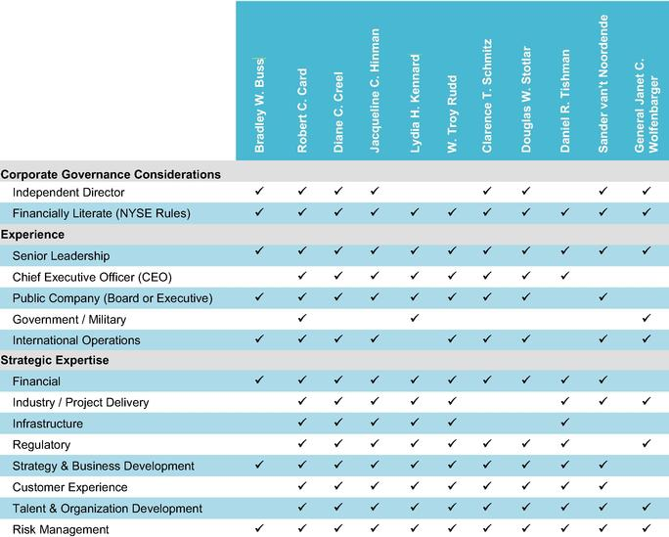

15

Table of Contents

Key Skills and Experience

SENIOR LEADERSHIP EXPERIENCE

Directors who have served in senior leadership positions are important to us, as they have the experience and perspective to analyze, shape, and oversee the execution of important operational and policy issues.

INDUSTRY / PROJECT DELIVERY EXPERTISE

Directors with industry experience are a key asset to the Company as their industry experience and knowledge provides valuable oversight and direction in managing, growing and improving our business.

PUBLIC COMPANY EXPERIENCE

Directors with public company Board or executive experience understand the dynamics and operation of a corporate Board, the relationship of a Board to the CEO and other management personnel, the importance of particular agenda and oversight issues, and how to oversee a changing mix of strategic, operational and compliance-related matters.

REGULATORY EXPERTISE

Directors with experience in addressing regulatory matters or who have served in government positions provide valuable insights that help us work constructively with governments and regulatory bodies around the world and address significant public policy issues.

FINANCIAL EXPERTISE

Knowledge of financial markets, financing and funding operations, and financial and accounting reporting processes is also important. This experience assists our Directors in understanding, advising on, and overseeing our capital structure, finance and investing activities, and our financial reporting and internal controls.

INTERNATIONAL EXPERTISE

Directors with international experience can provide valuable business and cultural perspectives regarding many important aspects of AECOM's business given AECOM's vast global reach.

Board Age and Tenure

Current Board
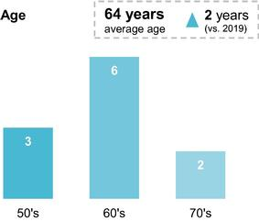
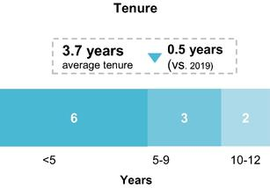

16

Table of Contents

Nominees for Election at the 2021 Annual Meeting
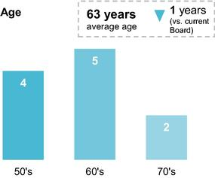
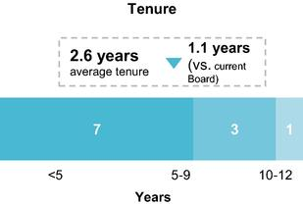

Nominees for Directors

The following section sets forth certain background information on the 11 nominees for election as directors as well as each individual's specific experience, qualifications and skills that led our Board to conclude that each such director nominee should serve on our Board. On December 8, 2020 we announced changes to our Board in collaboration with a significant stockholder, Starboard Value LP ("Starboard"), including the nomination of Diane C. Creel and Sander van't Noordende as directors and the renomination of Bradley W. Buss, Robert G. Card and Jacqueline C. Hinman, the three directors previously appointed pursuant to a November 2019 agreement with Starboard (the "Starboard Agreement"). As previously announced, Steven A. Kandarian and Dr. Robert J. Routs will not stand for re-election at the 2021 Annual Meeting.

Board Diversity

As part of our efforts to promote diversity on our Board, five out of the 11 nominees for election as directors at the 2021 Annual Meeting are diverse, consisting of four women, including one African American woman, and one director who self-identifies as LGBTQ+.
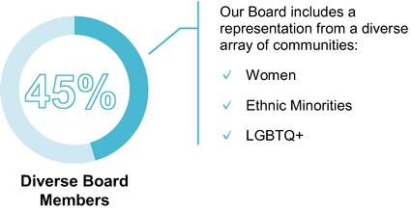

17

Table of Contents

Bradley W. Buss


Age: 57

Director Since: 2020

Board Committees:

- Compensation and Organization
- Nominating and Governance

Robert G. Card


Age: 67

Director Since: 2019

Board Committee:

- Audit
- Nominating and Governance

Mr. Buss brings to our Board executive experience and extensive financial and accounting expertise with both public and private technology-focused companies in diverse industries.

Mr. Buss' prior experience as the Chief Financial Officer of publicly-traded companies and his prior and current service on public company boards enable him to provide valuable insight to our

Board on issues that impact public companies.

Business Experience

SolarCity Corporation

• Chief Financial Officer (2014 - 2016)

Cypress Semiconductor Corporation

• Chief Financial Officer (2005 to 2014)

Public Boards

QuantumScape Corporation (2020 - Present)
Marvell Technology Group Ltd. (2018 - Present)
Advance Auto Parts, Inc. (2016 - Present)
Cavium, Inc. (2016 - 2018)
Tesla, Inc. (2009 - 2019)
Café Press (2007 - 2016)

Private Boards and Community Service

Diamond Foundry (2018 - Present)
TuSimple (2020 - Present)

Education

Bachelor of Arts, Economics (McMaster University)
Business Administration Degree, Majoring in Finance and Accounting (University of Windsor)

Mr. Card brings to our Board strong expertise in the architecture, engineering and construction industry through his leadership of infrastructure firms in Canada and the United States.

Mr. Card's public sector background adds valuable perspective in light of AECOM's extensive work with government clients paired with substantial corporate board experience.

Business Experience

The Card Group LLC

• President (2015 - Present)

SNC-Lavalin Group Inc.

•President and Chief Executive Officer (2012 - 2015)

CH2M HILL Companies, Ltd.

•President, Energy, Water and Facilities Divisions (2004 - 2012)

Public Service

U.S. Department of Energy

•Under Secretary of Energy (2001 - 2004)

Public Boards

Amec Foster Wheeler plc (2017)

SNC-Lavalin Group Inc. (2012 - 2015)

Private Boards and Community Service

Westinghouse Electric Company LLC (2018 - Present)

Longenecker & Associates LLC (2016 - Present)
CH2M Hill Companies, Ltd. (2005 - 2012)

Education

Bachelor of Science, Civil Engineering (University of Washington)
Master of Science, Civil and Environmental Engineering (Stanford University)

18

Table of Contents


Diane C. Creel

Age: 72

Director Nominee

Ms. Creel brings to our Board decades of experience in architecture and engineering. Her management experience includes operations, finance, marketing, international expansion and mergers and acquisitions.

Business Experience

Ecovation

•Chairman and Chief Executive Officer (2003 - 2008)

Earth Tech, Inc.

•Chairman and Chief Executive Officer (1992 - 2003)

•Chief Operating Officer (1988 - 1992)

•Vice President (1984 - 1988)

CH2M Hill

•Director of Business Development (1978 - 1984)

Public Boards

TimkenSteel Corporation (2012 - Present)
EnPro Industries (2010 - Present)
Allegheny Technologies Incorporated (1998 - Present)
URS Corporation (2014)
Foster Wheeler Ltd. (2004 - 2008)
Teledyne Corporation (1999 - 2005)
Goodrich Corporation (1997 - 2012)

Private Boards and Community Service

Lipscomb University Board of Trustees (2017 - Present)
Canyon Creek Foundation (2008 - Present)
H.W. Lochner, Inc. (2009 - February 2021)

Education

Bachelor of Arts, Journalism (University of South Carolina)
Master's Degree, Communications (University of South Carolina)

19

Table of Contents


Jacqueline C.

Hinman

Age: 59

Director Since: 2019

Board Committee:

- Compensation and Organization
- Safety, Risk and Sustainability

Ms. Hinman brings to our Board strong knowledge, management and operational experience in the engineering and construction management industry. Due to her prior experience as the Chief Executive Officer of a large engineering firm and her current service on public company boards, Ms. Hinman brings corporate governance and corporate strategy expertise.

Business Experience

CH2M Hill Companies, Ltd.

•Chairman, President, Chief Executive Officer and Director (2014 - 2017)

•President, International and Infrastructure (2005 to 2013)

•Senior Vice President and Project Manager (1988 - 1996)

Earth Tech, Inc.

•Senior Vice President, Government, Facilities and Infrastructure Division (2001 - 2003)

Talisman Partners

•Founder and Chief Executive Officer (1997 - 2001)

Public Boards

Dow Chemical Company (2019 - Present)

International Paper Company (2017 - Present)

Lydia H.
Kennard

Age: 66

Director Since: 2020

Board Committee:

- Safety, Risk and Sustainability

Private Boards and Community Service

CH2M Hill Companies, Ltd. (2008 - 2017)

Education

Bachelor of Science, Civil Engineering (Pennsylvania State University)

Ms. Kennard brings to our Board more than 40 years of executive and operational experience in real estate development and construction management. From her service on multiple public company boards, she adds important insights into operational requirements and challenges faced by public companies.

Business Experience

KDG Construction Consulting

•Founder and Chief Executive Officer (1980 - 1994 and 2007 - Present)

Airport Property Ventures, LLC

•Principal (2007 - Present)

Los Angeles World Airports

•Executive Director (1999 - 2003 and 2005 - 2007)

Public Boards

Healthpeak Properties, Inc. (2018 - Present)

Prologis, Inc. (2004 - Present)
Freeport-McMoRan Inc. (2013 - Present)
URS Corporation (2007 - 2014)

Private Boards and Community Service

The University of Southern California, Life Trustee

California Air Resources Board (2004 - 2011)

Education

Bachelor of Science, Urban Planning and Management (Stanford University)
Master's Degree, City Planning (Massachusetts Institute of Technology)
Juris Doctorate (Harvard Law School)

20

Table of Contents


W. Troy Rudd

Age: 56

Director Since: 2020

Mr. Rudd brings to our Board a critical vantagepoint as Chief Executive Officer of the Company and, accordingly, the director closest to the Company's day-to-day operations. Mr. Rudd has extensive executive experience in the professional services sector, finance, public company matters, international business, strategic planning, and mergers and acquisitions.

Business Experience

AECOM

•Chief Executive Officer and Director (2020 - Present)

•Chief Financial Officer (2015 - 2020)

•Chief Operating Officer, Design Consulting Services ("DCS") Americas and Chief Financial Officer, DCS Global (2014 to 2015)

•Senior Vice President, Corporate Finance and Treasurer (2012 - 2015)

•Vice President, Financial Planning and Analysis (2009 - 2012)

KPMG LLP (1998-2009)

•Partner

Public Boards

Clarence T.

Schmitz

Age: 72

Director Since: 2014

Board Committee:

- Audit (Chair)
- Compensation and Organization

AECOM (2020 - Present)

Education

Bachelor of Science (University of British Columbia)
Master of Science, Taxation (Golden Gate University)

Mr. Schmitz brings to our Board an extensive career in the professional services industry that spans four decades, with significant financial and global experience as an executive and board member, including service as National Managing Partner of KPMG LLP.

Business Experience

Outsource Partners International Inc.

•Chairman, Co-Founder and Chief Executive Officer (2000 - 2011)

Jefferies Group Inc.

•Executive Vice President and Chief Financial Officer (1995 - 2000)

KPMG LLP

•National Managing Partner (1970 - 1995)

Private Boards and Community Service

KPMG LLP, Board of Directors (1990 - 1994)

CureSearch for Children's Cancer, Chairman of Board of Trustees
The City of Hope, Board of Trustees

Education

Bachelor of Science, Accounting (Case Western Reserve University)

21

Table of Contents


Douglas W.

Stotlar

Age: 60

Mr. Stotlar brings to our Board substantial knowledge of the transportation sector. As a former Chief Executive Officer of a public company, Mr. Stotlar contributes valuable experience with corporate governance practices, labor and stockholder relations matters, as well as current legal and regulatory requirements and trends.

Business Experience

Director Since: 2014 | Con-way Inc.
Board Committee: | •President, Chief Executive Officer and Director (2005 - 2015)
• Nominating and | Con-way Transportation Services Inc.
Governance (Chair)
• Audit | •President and Chief Executive Officer (2004 - 2005)
 | •Executive Vice President and Chief Operating Officer (2002 - 2004)
 | •Executive Vice President of Operations (1997 - 2002)
 | Public Boards
 | Reliance Steel & Aluminum Co. (2016 - Present)
 | LSC Communications, Inc. (2016 - Present)
 | URS Corporation (2007 - 2014)

Daniel R.

Tishman

Age: 65

Director Since: 2010

Board Committee:

- Safety, Risk and Sustainability

Private Board and Community Service

Grieve Well (2009 - Present)

Mauser Packaging Solutions (2017 - Present)

Education

Bachelor of Science, Business (The Ohio State University)

Mr. Tishman brings to our Board extensive knowledge, management, business and operational experience in the construction management industry and on large-scale development projects such as the rebuilding of the World Trade Center site in New York City and other major projects.

Business Experience

Tishman Holdings Corporation

•Chairman and Executive Vice President (1997 - Present)

Tishman Construction Corporation

•Chairman of the Board and Chief Executive Officer (1991 - 2010)

AECOM

•Vice-Chairman (2010 - 2018)

Private Boards and Community Service

NexWave Capital Partners LLC (2008 - Present)
Montefiore Medicine, Chairman of the Board of Trustees
Real Estate Board of New York
Natural Resources Defense Council
National September 11 Memorial & Museum

Education

Bachelor of Science, Environmental and Biological Science (Evergreen State College)
Master of Science, Environmental Education (Lesley College)

22

Table of Contents


Sander van't Noordende

Age: 57

Director Nominee

Mr. van't Noordende brings to our Board deep leadership experience in the professional services sector, having served on Accenture's global management committee for 13 years.

Business Experience

Accenture

•Products Operating Group, Group Chief Executive (2013 - 2020)

•Management Consulting, Group Chief Executive (2011 - 2013)

•Resources Operating Group, Group Chief Executive (2006 - 2011)

•Various leadership roles (1987 - 2006)

Public Boards

Micro Focus (2020 - Present)

Gen. Janet C.

Wolfenbarger,
USAF Retired

Age: 62

Director Since: 2015

Board Committee:

- Nominating and Governance
- Safety, Risk and Sustainability

Private Board and Community Service

Out & Equal (2016 - Present)

Education

Master's Degree, Industrial Engineering and Management Science (Eindhoven University of Technology, Netherlands)

General Wolfenbarger brings to our Board a distinguished career as a senior leader in the military, including serving as the Air Force's first female four-star general. In addition to significant international experience, these qualifications provide our Board with valuable government-related expertise supportive of the company's global business operations and public-sector client roster.

Public Service

Air Force Materiel Command, Wright-Patterson Air Force Base

•Commander, Air Force Materiel Command (2012 - 2015)

•Commander, C-17 Systems Group for the Aeronautical Systems Center (2002 - 2005)

•Director, B-2 System Program Office (2000 - 2002)

Pentagon

•Military Deputy to the Assistant Secretary of the Air Force for Acquisition (2011 - 2012)

•Service's Director of the Acquisition Center of Excellence (2005 - 2006)

Private Boards and Community Service

KPMG LLP, Independent Director (2018 - Present)

Defense Advisory Committee on Women in the Services, Chair (2016 - Present)
Massachusetts Institute of Technology Corporation, Member (2020 - Present) Falcon Foundation, Trustee (2016 - Present)

Education

Bachelor of Science, Engineering Sciences (U.S. Air Force Academy)

Master of Science, Aeronautics and Astronautics (Massachusetts Institute of Technology)
Master of Science, National Resource Strategy (National Defense University)

Vote Required and Recommendation of the Board of Directors

Directors are elected by a majority of the votes cast for and against by holders of shares entitled to vote at the 2021 Annual Meeting. This means that for each director the number of votes cast "FOR" the director must exceed the number of votes cast "AGAINST" the director. Abstentions and broker non-votes will not be considered votes cast.

The Board of Directors recommends that you vote FOR the election of each nominee for director.

23

Table of Contents

PROPOSAL 2

RATIFICATION OF SELECTION OF INDEPENDENT

REGISTERED PUBLIC ACCOUNTING FIRM

The Audit Committee of our Board has retained Ernst & Young LLP to serve as our independent registered public accounting firm for the fiscal year ending September 30, 2021. Ernst & Young LLP has served as the Company's independent registered public accounting firm since 1990. A representative of Ernst & Young LLP is expected to be present at the 2021 Annual Meeting and will have an opportunity to make a statement if the representative so desires, and will be available to respond to appropriate questions.

Reasons for the Proposal

The selection of our independent registered public accounting firm is not required to be submitted for stockholder approval, but the Audit Committee of our Board is seeking ratification of its selection of Ernst & Young LLP from our stockholders as a matter of good corporate practice. If stockholders do not ratify this selection, the Audit Committee of our Board will reconsider its selection of Ernst & Young LLP and will, in its sole discretion, either continue to retain this firm or appoint a new independent registered public accounting firm. Even if the selection is ratified, the Audit Committee may, in its discretion, appoint a different independent registered public accounting firm at any time during the fiscal year if it determines that such a change would be in the Company's best interests and the best interests of our stockholders.

Reasons for Recommendation to Appoint Ernst & Young as the Company's Independent Registered Public Accounting Firm

As with previous years, the Audit Committee undertook a review of Ernst & Young LLP in determining whether to select Ernst & Young LLP as the Company's independent registered public accounting firm for fiscal year 2020 and to recommend ratification of its selection to the Company's stockholders. In that review, the Audit Committee considered a number of factors including:

- continued independence of Ernst & Young LLP;

- length of time Ernst & Young LLP has been engaged by the Company;

- senior management's assessment of Ernst & Young LLP's performance;

- audit and non-audit fees;

- capacity to appropriately staff the audit;

- geographic and subject matter coverage;

- lead audit engagement partner performance;

- overall performance;

- qualifications and quality control procedures; and

- whether retaining Ernst & Young LLP is in the best interests of the Company and its stockholders.

Based upon this review, the Audit Committee believes that Ernst & Young LLP is independent and that it is in the best interests of the Company and our stockholders to retain Ernst & Young LLP to serve as our independent registered public accounting firm for Fiscal Year 2021.

In accordance with the Sarbanes-Oxley Act and the related SEC rules, the Audit Committee limits the number of consecutive years an individual partner may serve as the lead audit engagement partner to the Company. The

24

Table of Contents

maximum number of consecutive years of service in that capacity is five years. The current lead audit engagement partner is in his fourth year in that role.

Vote Required and Recommendation of the Board of Directors

The ratification of our independent registered public accounting firm requires the affirmative vote of the holders of a majority of the shares of common stock present or represented by proxy and entitled to vote on the proposal at the 2021 Annual Meeting. Abstentions will be counted as present and will have the effect of a vote against the proposal. Brokers have discretion to vote on the ratification of our independent registered public accounting firm and, as such, no votes on this proposal will be considered broker non-votes.

The Board of Directors recommends that you vote FOR the ratification of Ernst & Young LLP.

25

Table of Contents

PROPOSAL 3

ADVISORY RESOLUTION TO APPROVE EXECUTIVE COMPENSATION

In accordance with Section 14A of the Exchange Act, we are asking our stockholders to approve, on an advisory basis, AECOM's executive compensation as reported in this Proxy Statement.

At AECOM, executive compensation plans are driven by both short- and long-term financial performance metrics that are designed to incentivize our NEOs to maximize long-term stockholder value creation. As such, based on direct stockholder feedback, AECOM's executives are incentivized via an annual cash bonus plan and the grant of certain long-term equity awards that include without limitation the following performance metrics: adjusted earnings per share, cash flow, return on invested capital, and relative total shareholder return.

We urge stockholders to read the "COMPENSATION DISCUSSION AND ANALYSIS" section in this Proxy Statement, which describes in more detail how our executive compensation policies and procedures operate and are designed to achieve our compensation objectives, as well as the "SUMMARY COMPENSATION TABLE" and related compensation tables and narrative, which provide detailed information on the compensation of our NEOs. The Compensation and Organization Committee ("Compensation Committee") and the Board believe that the policies, procedures and programs articulated in the "COMPENSATION DISCUSSION AND ANALYSIS" are effective in achieving our goals and that the compensation of our NEOs reported in this Proxy Statement has supported and contributed to the Company's success.

We are asking stockholders to approve the following advisory resolution at the 2021 Annual Meeting:

RESOLVED, that the stockholders of AECOM approve, on an advisory basis, the compensation of the Company's Named Executive Officers set forth in the Compensation Discussion and Analysis, the Summary Compensation Table and the related compensation tables and narrative in the Proxy Statement for the Company's 2021 Annual Meeting of Stockholders.

This advisory resolution, commonly referred to as a "Say-on-Pay" resolution, is non-binding on the Company, the Board and the Compensation Committee and will not be construed as overruling a decision by, nor creating nor implying any additional fiduciary duty for the Company, the Board or the Compensation Committee. However, the Board and the Compensation Committee will review and consider the voting results on this proposal when evaluating our executive compensation program. The Board has adopted a policy of providing for annual "Say-on-Pay" advisory votes. Unless the Board modifies its policy on the frequency of holding "Say-on-Pay" advisory voting, the next "Say-on-Pay" advisory vote will occur in 2022.

Vote Required and Recommendation of the Board of Directors

The affirmative vote of a majority of the shares present or represented by proxy and entitled to vote on the advisory resolution on the Company's executive compensation at the 2021 Annual Meeting is required to approve the advisory resolution on the Company's executive compensation. Abstentions will be counted as present and will have the effect of a vote against the proposal. Broker non-votes will not be counted as participating in the voting on the proposal and will therefore have no effect on the outcome of the vote on the proposal.

The Board of Directors recommends that you vote FOR the advisory resolution to approve executive compensation.

26

Table of Contents

PROPOSAL 4

STOCKHOLDER PROPOSAL

Mr. John Chevedden, 2215 Nelson Avenue, No. 205 Redondo Beach, California. 90278, the beneficial owner of shares of the Company's common stock with a market value of more than $2,000, has requested that we include the following stockholder proposal and supporting statement in our proxy statement for the 2021 Annual Meeting. The stockholder proposal is required to be voted on at our Annual Meeting only if properly presented at the meeting. The Board of Directors recommends a vote AGAINST this proposal for the reasons stated in the Statement in Opposition to the Stockholder Proposal, which follows the proposal:

Proposal 4 — Lobbying Disclosure

Whereas, we believe in full disclosure of AECOM's direct and indirect lobbying activities and expenditures to assess whether AECOM's lobbying is consistent with AECOM's expressed goals and in the best interests of stockholders.

Resolved, the stockholders of AECOM request the preparation of a report, updated annually, disclosing:

- Company policy and procedures governing lobbying, both direct and indirect, and grassroots lobbying communications.

- Payments by AECOM used for (a) direct or indirect lobbying or (b) grassroots lobbying communications, in each case including the amount of the payment and the recipient.

- AECOM's membership in and payments to any tax-exempt organization that writes and endorses model legislation.

- Description of management's and the Board's decision-making process and oversight for making payments described in sections 2 and 3 above.

For purposes of this proposal, a "grassroots lobbying communication" is a communication directed to the general public that (a) refers to specific legislation or regulation, (b) reflects a view on the legislation or regulation and (c) encourages the recipient of the communication to take action with respect to the legislation or regulation. "Indirect lobbying" is lobbying engaged in by a trade association or other organization of which AECOM is a member.

Both "direct and indirect lobbying" and "grassroots lobbying communications" include efforts at the local, state and federal levels.

The report shall be presented to the Audit Committee or other relevant oversight committees and posted on AECOM's website.

Supporting Statement

As stockholders, we encourage transparency and accountability in AECOM's use of corporate funds to influence legislation and regulation. AECOM spent $12,240,000 from 2014 - 2019 on federal lobbying. This does not include state lobbying expenditures, where AECOM also lobbies but disclosure is uneven or absent. For example, AECOM spent $1,511,496 on lobbying in New York from 2011 - 2018. AECOM's lobbying on public construction projects in New York has attracted attentions,¹ as has its lobbying in Florida on sewage system upgrades.²

AECOM does not disclose its memberships in, or payments to, trade associations, or the amounts used for lobbying. Trade associations spend millions annually lobbying indirectly on behalf of companies. And AECOM does not disclose memberships in tax-exempt organizations that write and endorse model legislation, such as the American Legislative Exchange Council. Absent a system of accountability, company assets could be used for objectives contrary to AECOM's long-term interests.

- https://www.amny.com/news/concerns-raised-over-big-new-york-developers-involvement-in-public-projects/

- https://www.miamiherald.com/news /local/community/miami-dade/article226118840.html

27

Table of Contents

We believe AECOM's lack of lobbying disclosure presents reputational risks that could harm long-term value creation by AECOM, and thus we urge the Board to institute comprehensive lobbying disclosure.

Please vote yes:

Lobbying Disclosure Proposal — Proposal 4

28

Table of Contents

PROPOSAL 4

BOARD OF DIRECTORS' STATEMENT IN OPPOSITION TO THE STOCKHOLDER PROPOSAL

Our Board recommends a vote AGAINST this proposal.

The Board has considered this proposal and concluded that its adoption is unnecessary and not in the best interests of our stockholders in light of the Company's internal policies and existing disclosure regarding lobbying activities, the current public availability of much of the information requested by the proposal and the potential concerns relating to enhanced disclosures. Accordingly, the Board unanimously recommends a vote AGAINST this proposal.

AECOM participates in the U.S. political process to the benefit of its stockholders.

The Board believes it is in the best interests of our stockholders for AECOM to participate in the political process. As a global infrastructure firm, we are affected by numerous laws, regulations and policies which govern various aspects of our business. As a result, we actively review and discuss existing and upcoming policy changes and regulatory initiatives and take part in industry dialogue and lobbying efforts related to those issues that are of high importance to the Company's success and the concerns of our stakeholders. We strive to adhere to our corporate values and we constructively promote legislative and regulatory actions that further the business objectives of AECOM and the economic future of our stockholders and employees.

Like many major corporations, AECOM belongs to a number of industry associations. This involvement allows us to gain insight into core issues for the infrastructure sector as a whole and to advocate jointly for regulations that support an efficient, healthy and competitive industry. Such membership also allows us to benefit from the opportunity to share technical expertise and operational knowledge that leads to better safety, customer service and overall efficiency.

AECOM has robust policies and procedures in place to effectively oversee decisions regarding lobbying activities and expenditures.

AECOM is committed to complying with our values, our internal policies and all applicable laws when engaging in any type of lobbying or political activity. Management has developed a decision-making process regarding its lobbying activities to ensure they are strategic, prudent and compliant. A coordinated effort of the Company's Government Relations, Legal, Ethics and Compliance, and Communications Departments oversees and monitors AECOM's participation in the U.S. political process and its compliance with federal, state and local laws governing AECOM's lobbying activities and contributions (including dues and other payments to trade associations and other nonprofits engaged in public advocacy). This effort involves vetting procedures on advocates who lobby on the Company's behalf. The Company conducts several forms of training relating to lobbying, including annual training and certification regarding the Company's Code of Conduct, and specialized training for Company employees involved in the engagement of lobbyists and other advocates. In addition, the Board, including through its Nominating and Governance Committee, has oversight of the Company's general policy relating to the support of trade associations, political organizations and lobbying activities.

While trade associations do conduct lobbying on a wide range of issues, no company's membership in any association should be perceived as an endorsement of every policy that a particular association supports.

AECOM's support for specific policies is identified in its own specific statements and lobbying disclosures.

AECOM already provides substantial disclosure regarding its lobbying activities.

Lobbying activities are subject to extensive governmental regulation and public disclosure requirements, and AECOM is fully committed to complying with all applicable U.S. state and federal laws governing these activities. The

29

Table of Contents

Board believes these disclosure requirements provide transparency of our lobbying activities to the general public, including our stockholders. Specifically, the Company:

- files quarterly reports with the U.S. House of Representatives and the U.S. Senate that disclose overall federal lobbying expenses, the specific legislative and regulatory issues that were the subject of the Company's federal lobbying efforts, the houses of Congress and federal agencies lobbied by the Company and the names of those individuals lobbying on behalf of the Company. These reports are publicly available on websites hosted by the U.S. House of Representatives and the U.S. Senate; and

- files regular, publicly available reports with state agencies which disclose the Company's state lobbying activities according to pertinent state laws.

Providing additional disclosure of AECOM's political contributions would not be in the best interests of the Company or our stockholders.

The expanded disclosure requested by this proposal could place AECOM at a competitive disadvantage by revealing strategies and priorities designed to protect the economic future of the Company, our stockholders and employees. Because parties with interests adverse to AECOM also participate in the political process to their business advantage, any unilateral expanded disclosure could benefit these adverse parties, while harming the interests of AECOM and our stockholders.

Additionally, requiring the Company to specifically disclose payments made to industry associations may be misleading to stockholders. Membership in these associations comes with the understanding that we may not always agree with all of the positions of the associations or other members of such groups. As a result, such disclosure is not necessarily indicative of our position on any particular issue.

Finally, in light of the fact that much of the Company's lobbying activities are publicly disclosed as required by law and as described above, assembling a separate lobbying disclosure report would not be a prudent use of the Company's human and financial resources, and accordingly would not be in the best interest of the Company or our stockholders.

For the reasons set forth above, the Board believes that the adoption of the Proposal is unnecessary, would not provide any meaningful benefit to stockholders and is not in the best interests of the Company, our stockholders or employees.

Vote Required and Recommendation of the Board of Directors

The affirmative vote of a majority of the shares present or represented by proxy and entitled to vote at the 2021 Annual Meeting is required to approve the stockholder proposal. Abstentions will be counted as present and will have the effect of a vote against the proposal. Broker non-votes will not be counted as participating in the voting on the proposal and will therefore have no effect on the outcome of the vote on the proposal.

The Board of Directors recommends that you vote AGAINST the stockholder proposal.

30

Table of Contents

CORPORATE GOVERNANCE

Board Meetings

During our fiscal year ended September 30, 2020, our Board met nine times, the Audit Committee met five times, the Compensation Committee met eight times, the Nominating Committee met three times and the Safety, Risk and Sustainability Committee met three times. The Safety, Risk and Sustainability Committee was named the Strategy, Risk and Safety Committee during our fiscal year ended September 30, 2020. In November 2020, our Board renamed such Committee and modified the scope of its responsibility, as described further below under "Committees of the Board of Directors." Each incumbent director attended 100% of (except for one director who attended less than 100% and more than 75% of) the aggregate of (1) the total number of meetings of our Board and (2) the total number of meetings held by all standing committees of the Board on which he or she served during fiscal year 2020.

Director Independence

Eight of the 11 director nominees are independent directors as defined in accordance with the listing standards of the NYSE. These standards provide that a director is independent only if our Board affirmatively determines that the director has no direct or indirect material relationship with the Company. They also specify various relationships that preclude a determination of director independence. Material relationships may include commercial, industrial, consulting, legal, accounting, charitable, family and other business, professional and personal relationships.

Applying these standards, our Board, upon the recommendation of our Nominating Committee, annually reviews the independence of our directors. In its most recent review, our Board considered, among other things, the employment relationships between the Company and our directors and their families; the other specific relationships that would preclude a determination of independence under the NYSE independence rules; any affiliation of the Company's directors and their families with the Company's independent registered public accounting firm, compensation consultants, legal counsel and other consultants and advisors; any transactions with directors and members of their families that would require disclosure in this Proxy Statement under U.S. Securities and Exchange Commission ("SEC") rules regarding related party transactions; and the modest amount of our contributions to non-profit organizations of which some of our directors or members of their families are associated.

The Board determined that the following director nominees are independent as determined by the standards of the NYSE: Bradley W. Buss, Robert G. Card, Diane C. Creel, Jacqueline C. Hinman, Clarence T.

Schmitz, Douglas W. Stotlar, Sander van't Noordende and General Janet C. Wolfenbarger.

Board Leadership Structure

The roles of Chairman and Chief Executive Officer were separated in August 2020 upon the appointment of W. Troy Rudd as Chief Executive Officer. At such time, Douglas W. Stotlar was appointed Chairman of the Board. Prior to such time, Michael S. Burke simultaneously held the roles of Chairman of the Board and Chief Executive Officer. James H. Fordyce served as the lead independent director until his resignation in November 2019. Mr. Fordyce was succeeded by Steven A. Kandarian, who served as the lead independent director until Mr. Stotlar was appointed Chairman of the Board in August 2020.

The Board has been, and continues to be, a proponent of Board independence. The Company's corporate governance structures and practices provide for a strong, independent Board and include several independent oversight mechanisms, including only independent directors serving as committee chairs and the directors' and committees' ability to engage independent consultants and advisors. The Audit, Compensation and Nominating Committees are composed entirely of independent directors.

31

Table of Contents

Executive Sessions

Executive sessions of non-employee directors are included on the agenda for every regularly scheduled Board meeting and, during fiscal year 2020, executive sessions were held at each regularly scheduled Board meeting. Executive sessions are chaired by the Chairman and were chaired by the lead independent director prior to the Chairman's appointment in August 2020.

Board's Role in Risk Oversight

The Board plays an active role, both as a whole and at the committee level, in overseeing management of the Company's risks. Management is responsible for the Company's day-to-day risk-management activities. The Company relies on a comprehensive risk management process to aggregate, monitor, measure and manage risks. The risk management process is designed to enable the Board to establish a mutual understanding with management of the effectiveness of the Company's risk management practices and capabilities, to review the Company's risk exposure and to elevate certain key risks for discussion at the Board level. The full Board monitors risk through regular reports from each of the committee chairs and is apprised of particular risk management matters in connection with its general oversight and approval of corporate matters, as disclosed in the below chart:
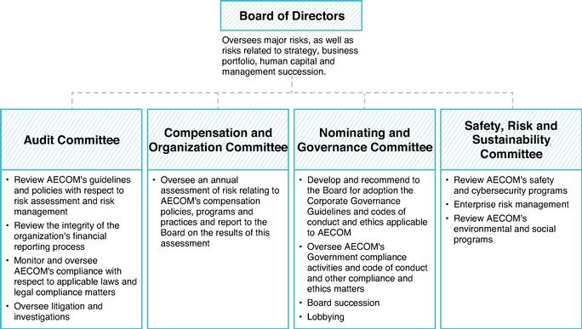

We believe the division of risk management responsibilities described above provides an effective framework for evaluating and addressing the risks facing the Company, and that our Board leadership structure supports this approach because it allows our independent directors, through the independent committee chairs, to exercise effective oversight of the actions of management. The Safety, Risk and Sustainability Committee, as well as other members of the Board, receive updates from the Company's Chief Information Security Officer on the overall cybersecurity risk environment including the Company's enterprise-wide cybersecurity risk assessment results and key initiatives.

Risk Assessment of Compensation Policies and Practices

In fiscal year 2020, the Compensation Committee's independent consultant, Exequity LLP, conducted a risk assessment of the Company's compensation policies and practices as they apply to all employees, including

32

Table of Contents

executive officers. Exequity LLP reviewed the design features and performance metrics of our cash and stock-based incentive programs, along with the approval mechanisms associated with each, to determine whether any of these policies and practices could create risks that are reasonably likely to have a material adverse effect on the Company.

As part of the review, several factors were noted that reduce the likelihood of excessive risk-taking:

- Our compensation mix is balanced among fixed components such as salary and benefits, annual incentive payments and long-term incentives, including Performance Earning Program ("PEP") awards and restricted stock units granted under our 2020 Stock Incentive Plan, which typically vest or are earned over three years.

- The Compensation Committee has ultimate authority to determine, and reduce, if appropriate and consistent with applicable arrangements, compensation provided to our executive officers, including each of the NEOs.

- The Compensation Committee, under its charter, has the authority to retain any advisor it deems necessary to fulfill its obligations and has engaged Exequity LLP as its independent consultant. Exequity performs services for the Compensation Committee as described in the "COMPENSATION DISCUSSION AND ANALYSIS" section of this Proxy Statement.

- Our annual incentive programs for employees are funded in the aggregate based on the results of key financial metrics. Individual payouts are based on a combination of financial metrics as well as qualitative factors.

- Our long-term equity incentive awards, including PEP awards and restricted stock units granted under our stockholder approved 2020 Stock Incentive Plan, are all approved by either the Compensation Committee for our executive officers or by our Chief Executive Officer for non-executive officers.

- Our NEOs are subject to stock ownership guidelines, our insider trading policy and our clawback policy.

Based on this assessment, the Company concluded that its compensation policies and practices do not create risks that are reasonably likely to have a material adverse effect on the Company.

Committees of the Board of Directors

The Board has four standing committees: the Audit Committee, the Compensation Committee, the Nominating Committee and the Safety, Risk and Sustainability Committee. In accordance with NYSE regulations, each member of the Audit Committee, the Compensation Committee, and the Nominating Committee has been determined by our Board to be "independent." The committees operate under written charters that are available for viewing on the "Corporate Governance" area of the "Investors" section of our website at www.aecom.com.

The members of each of the standing committees are as follows:

Audit Committee

Clarence T. Schmitz, Chair

Robert G. Card
Steven A. Kandarian
Douglas W. Stotlar

Compensation and Organization Committee

Steven A. Kandarian, Chair

Bradley W. Buss
Jacqueline C. Hinman
Dr. Robert J. Routs
Clarence T. Schmitz

33

Table of Contents

Nominating and Governance Committee

Douglas W. Stotlar, Chair

Bradley W. Buss
Robert G. Card
General Janet C. Wolfenbarger, USAF Retired

Safety, Risk and Sustainability Committee

Dr. Robert J. Routs, Chair

Jacqueline C. Hinman
Lydia H. Kennard
Daniel R. Tishman
General Janet C. Wolfenbarger, USAF Retired

Audit Committee. The Audit Committee, which is composed solely of independent directors as defined under Rule 10A-3(b)(1) of the rules of the U.S. Securities and Exchange Commission and the regulations of the NYSE, appoints the Company's independent auditors, reviews the results and scope of the audit of our financial statements as well as other services provided by our independent auditors, reviews and approves audit fees and all non-audit services as well as reviews and evaluates our audit and control functions, including our internal audit function. Our Audit Committee held five meetings during fiscal year 2020. Our Board has determined that Mr. Schmitz, Chair of the Audit Committee qualifies as an "audit committee financial expert" as defined by the rules under the Exchange Act. The "REPORT OF THE AUDIT COMMITTEE OF THE BOARD OF DIRECTORS" is included in this Proxy Statement.

Compensation and Organization Committee. The Compensation Committee, which is composed solely of independent directors as defined under the regulations of the NYSE, non-employee directors, as defined under Rule 16b-3 of the Exchange Act, and outside directors for purposes of grandfathering provisions under Section 162(m) of the Code, oversees our compensation plans. Such oversight includes decisions regarding executive management salaries, incentive compensation and long-term compensation plans, as well as Company-wide equity plans for our employees. This committee also reviews the Board's compensation plan for non-employee directors and determines whether independent compensation consultants should be utilized. For further information regarding the Compensation Committee's processes and procedures for determining executive and non-employee director compensation, see the "COMPENSATION DISCUSSION AND ANALYSIS" section of this Proxy Statement. Our Compensation Committee held eight meetings during fiscal year 2020. The "REPORT OF THE COMPENSATION AND ORGANIZATION COMMITTEE OF THE BOARD OF DIRECTORS" is included in this Proxy Statement.

Nominating and Governance Committee. The Nominating Committee is composed solely of independent directors as defined under the regulations of the NYSE and is responsible for recruiting and retaining qualified persons to serve on our Board, including recommending such individuals to the Board for nomination for election as directors; for evaluating director independence; and for oversight of our compliance activities. The Nominating Committee also considers written suggestions from stockholders, including potential nominees for election, and oversees other governance programs such as the Company's Corporate Governance Guidelines. This committee also conducts performance evaluations for directors being elected at each annual meeting of stockholders, and engages in succession planning for the Board and key leadership roles on the Board and its committees. Our Nominating Committee held three meetings during fiscal year 2020.

Safety, Risk and Sustainability Committee. The Safety, Risk and Sustainability Committee oversees our corporate risk management, safety and sustainability programs and reviews the Company's overall policies regarding safety, cybersecurity, enterprise risk management, and environmental and social programs. Our Safety, Risk and Sustainability Committee held three meetings during fiscal year 2020.

34

Table of Contents

Corporate Governance Guidelines

Our Board has adopted the Corporate Governance Guidelines, which set forth several important principles regarding our Board and its committees, including Board of Director membership criteria as well as other matters. Our Corporate Governance Guidelines are available for viewing on the "Corporate Governance" area of the "Investors" section of our website at www.aecom.com.

Codes of Conduct and Ethics

We have adopted a Code of Conduct that describes the professional, legal, ethical, financial and social responsibilities of all of our directors, officers and employees. We require all of our directors, officers and employees to read and acknowledge the Code of Conduct, and we provide regular compliance training to all our directors, officers and employees. Our directors, officers and employees are also encouraged to report suspected violations of the Code of Conduct through various means, including a toll-free hotline available 24 hour, 7 days a week in multiple languages, and they may do so anonymously. We do not tolerate acts of retaliation against anyone who makes an honest and sincere report of a possible violation of law or of our Code of Conduct or policies, or who participates in an investigation of possible wrongdoing. Many countries have enacted legislation to protect those who report misconduct, and we enforce any applicable protections afforded by such laws.

We also obtain year end affirmations from management personnel confirming compliance with the Code of Conduct. If we make substantive amendments to the Code of Conduct or grant any waiver, including any implicit waiver, to our principal executive, financial or accounting officer or persons performing similar functions or any director, we will disclose the nature of such amendment or waiver in a press release, on our website and/or in a report on Form 8-K in accordance with applicable rules and regulations. In addition, we have a separate Code of Ethics for Senior Financial Officers that imposes specific standards of conduct on employees with financial reporting responsibilities. We also have an Anticorruption Policy that provides specific guidance to help ensure that lawful and ethical business practices are followed while conducting international business activities. Our various policies are available for viewing on the "Ethics and Compliance" section of our website at www.aecom.com and in print to any stockholder that requests it. Any such request should be addressed to AECOM, 300 South Grand Avenue, 9th Floor, Los Angeles, California 90071, Attention: Corporate Secretary.

Communications with the Board of Directors

Our stockholders or other interested parties may communicate with our Board, a committee of our Board or one or more directors by sending a letter addressed to the Board, a committee of our Board or one or more directors to AECOM, 300 South Grand Avenue, 9th Floor, Los Angeles, California 90071, Attention: Corporate Secretary. All communications will be compiled by our Corporate Secretary and forwarded to the Board, the committee or the director, as appropriate.

Director Nominations, Board Refresh and Succession Planning

The Nominating Committee is charged with identifying, reviewing and recommending to the Board qualified individuals to become directors and regularly assessing the size and composition of the Board and recommending any changes to the Board. The Nominating Committee also engages in succession planning for the Board and key leadership roles on the Board and its committees.

The Nominating Committee reviews the appropriate skills and characteristics required of Board members in the context of the current composition of the Board, the operating requirements of the Company and the long-term interests of the Company's stockholders. In conducting this assessment, the Nominating Committee considers diversity, skills and such other factors as it deems appropriate to maintain a balance of knowledge, experience and capabilities. This periodic assessment enables the Board to update the skills and experience it seeks in the Board, as a whole and in individual directors, as the Company's needs evolve over time and to assess the effectiveness of efforts at pursuing diversity. From time to time, while identifying director candidates, the Nominating Committee may

35

Table of Contents

establish specific skills and experience that it believes the Company should seek to constitute a balanced and effective Board.
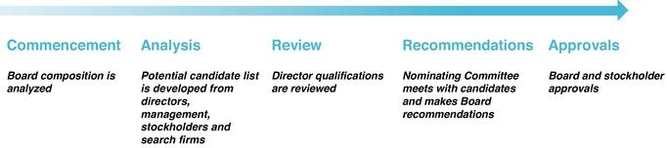

It is our belief that members of the Board should have the highest professional and personal ethics and values. We believe that the Board should be comprised of individuals who are committed to enhancing stockholder value with sufficient time to effectively carry out their duties. While all directors should possess business acumen, the Board endeavors to include an array of targeted skills and experience in its overall composition. Criteria that the Nominating Committee looks for in director candidates include business experience and skills, judgment, integrity, an understanding of such areas as finance, marketing, regulation, end markets and public policy and the absence of potential conflicts with the Company's interests. In particular, the Nominating Committee seeks candidates that have the following key skills and experience, each of which it is views as particularly important:

- senior leadership experience;

- industry experience;

- public company experience;

- financial expertise;

- government/regulatory expertise; and

- international expertise.

The Nominating Committee believes that it is essential that Board members represent diverse viewpoints and backgrounds. In identifying and selecting individuals, the Board and the Nominating Committee consider diversity, age, gender, skills, and such other factors as they deem appropriate to maintain a balance of knowledge, experience and capability. In addition, the Nominating Committee believes the Board should encompass individuals with diverse backgrounds and perspectives and representation of individuals from underrepresented communities. Diversity is an important consideration in the director nomination process because the Board believes that people of different genders, experiences, ages, races and ethnic backgrounds can contribute different, useful perspectives, while collaborating effectively to further the Company's objectives.

Our Nominating Committee will consider stockholder nominations for directors. The Nominating Committee evaluates any such nominees that are properly submitted using the same criteria it otherwise employs, as described in our Corporate Governance Guidelines. Any recommendation submitted by a stockholder must include the same information concerning the potential candidate as is required when a stockholder wishes to nominate a candidate directly. In addition, any such recommendation must be received in the same time frame as is required by our Bylaws when a stockholder wishes to nominate a candidate directly. To be timely, the notice must be received by the close of business no fewer than 90 and no more than 120 days prior to the date of the first anniversary of the preceding year's annual meeting of stockholders. However, in the event that the date of the annual meeting is advanced more than 30 days prior to such anniversary date or delayed more than 30 days after such anniversary date, or no annual meeting was held in the preceding year, notice by the stockholder to be timely must be received no more than 120 days prior to the date of the annual meeting and not less than the later of the close of business (a) 90 days prior to the date of the annual meeting and (b) on the 10th day following the day on which public announcement of the date of such meeting was first made by the Company.

To be in proper form, the notice must, as to each person whom the stockholder proposes to nominate for election or re-election as a director, set forth all information concerning such person as would be required in a proxy statement soliciting proxies for the election of directors in a contested election pursuant to Section 14 of the Exchange Act and

36

Table of Contents

all written and signed representations and all completed and signed questionnaires required pursuant to our Bylaws. In addition, as to the stockholder giving the notice and the beneficial owner, if any, on whose behalf the nomination is being made, the notice must also state the name and address, as they appear on the Company's books, of such stockholder and such beneficial owner and the class or series and number of shares of the Company that are owned of record and beneficially by such stockholder and such beneficial owner.

As to the stockholder giving the notice, or if the notice is on behalf of a beneficial owner on whose behalf the nomination is being made, as to such beneficial owner, and if such beneficial owner is an entity, as to each control person of such entity, the notice must state the class or series and number of shares of the Company that are owned of record and beneficially by such stockholder or beneficial owner and by any control person, a description of any agreement, arrangement or understanding with respect to the nomination between such stockholder or beneficial owner and any other person and by any control person, including, without limitation, any agreements that would be required to be disclosed pursuant to Item 5 or Item 6 of Schedule 13D (regardless of whether the requirement to file a Schedule 13D is applicable) of the Exchange Act, and a description of any agreement, arrangement or understanding (including, without limitation, any derivative or short positions, profit interests, options, hedging transactions, and borrowed or loaned shares) that has been entered into as of the date of the stockholder's notice by, or on behalf of, such stockholder, beneficial owner or control person, the effect or intent of which is to mitigate loss, manage risk or benefit from changes in the share price of any class or series of the Company's capital stock, or maintain, increase or decrease the voting power of the stockholder, beneficial owner or control person with respect to shares of stock of the Company. Stockholders who wish to nominate candidates for director must do so pursuant to these procedures.

Board Self-Assessment

The Nominating Committee facilitates an annual assessment of the performance of the Board and its committees and coordinates reports of the annual results to the full Board for discussions. The Nominating Committee also recommends changes to improve the Board and its committees. In 2020, the Nominating Committee engaged an outside law firm to obtain input from each director on the performance of the Board and its committees. In addition, each committee of the Board also conducted a self-evaluation discussion in executive session after the conclusion of fiscal year 2020.
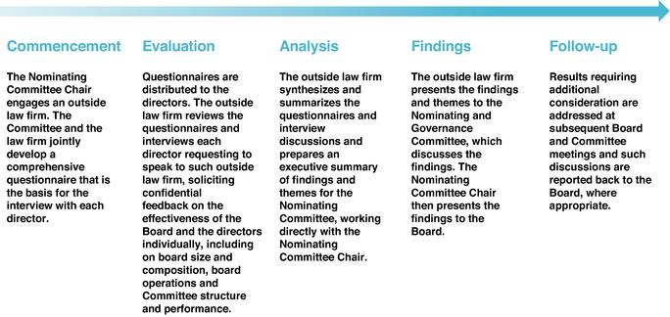

37

Table of Contents

Director Attendance at Annual Meetings

AECOM's policy is for directors to attend our annual meetings of stockholders unless there are extenuating circumstances. Eight members of our Board of Directors attended the 2020 Annual Meeting; such members attended remotely due to the Covid-19 pandemic.

Director Compensation

Information regarding the compensation of our non-employee directors is discussed below in "DIRECTORS' COMPENSATION FOR FISCAL YEAR 2020."

Director Retirement Policy

Our Corporate Governance Guidelines provide that unless otherwise recommended by the Nominating Committee and approved by the Board, directors are expected to retire from the Board at the end of the term of service during which they turn 75 years of age.

Related Party Transaction Policy

We have adopted a written related party transaction policy, which covers transactions in excess of $120,000 between the Company and our directors, executive officers, 5% or greater stockholders and parties related to the foregoing, such as immediate family members and entities they control. The policy requires that any such transaction be considered and approved by our Audit Committee, except that if the transaction is less than $1 million, the Chair of the Audit Committee may approve such transaction. In reviewing such transactions, the policy requires the Audit Committee, or the Chair, as appropriate, to consider all of the relevant facts and circumstances available to the Audit Committee, including (if applicable) but not limited to the benefits to the Company, the availability of other sources for comparable products or services, the terms of the transaction and the terms available to unrelated third parties or employees generally. The Board has also determined that certain transactions are pre-approved and do not require review by the Audit Committee. These include (i) compensation of the executive officers and Board members, which is reviewed by the Compensation Committee, (ii) a transaction with another entity in which the interested director or executive officer has an indirect interest in the transaction solely as a result of being a director or less than 10% beneficial owner of such other entity, and (iii) transactions with another corporation or charitable organization if the director's or executive officer's only interest is as a director or as a non-executive officer employee of the other corporation or organization and the amount involved does not exceed the greater of $1 million or 2% of the revenues of such other corporation or organization.

Under the policy, if we should discover related party transactions that have not been approved, the Audit Committee will be notified and will determine the appropriate action, including ratification, rescission or amendment of the transaction.

Certain Relationships and Related Transactions

Mr. Tishman, a member of our Board, owns a substantial equity interest in, and has certain management rights with respect to an unaffiliated company. The unaffiliated company associated with Mr. Tishman and our wholly owned subsidiary are parties to an Occupancy Agreement (the "Occupancy Agreement"), dated July 14, 2010, pursuant to which the unaffiliated company associated with Mr. Tishman pays our wholly owned subsidiary a portion of the rent for office space in New York City in exchange for the right to use and occupy a portion of such space. In fiscal year 2020, our wholly owned subsidiary received approximately $1,801,495 in rent from the unaffiliated company associated with Mr. Tishman per the Occupancy Agreement.

Mr. Tishman has an agreement with AECOM for reimbursement of private air travel for AECOM-related business travel to a company owned by Mr. Tishman. In fiscal year 2020, this amount was $53,035. In addition, Mr. Tishman is an indirect owner of an unaffiliated real estate development project company that engaged an AECOM affiliate to perform pre-construction and construction management services totaling $1,926,000 and an indirect owner of an

38

Table of Contents

unaffiliated hotel property company that procured $5,517,869 of risk management services and insurance coverage through an AECOM affiliated insurance captive in fiscal year 2020.

Ms. Kennard, a member of our Board, is the founder, chief executive officer and majority equity owner of KDG Construction Consulting ("KDG"), a provider of project and construction management services. KDG has previously provided certain construction consulting services to a joint venture in which the Company is a majority partner. In fiscal year 2020, KDG received approximately $2,844,996 in consulting fees from such joint venture. The aforementioned consulting services between KDG and such joint venture have concluded.

On November 27, 2019, Carla Christofferson, who served as our Executive Vice President and Chief Legal Officer during fiscal year 2019, entered into a settlement agreement with AECOM regarding certain employment-related claims, pursuant to which AECOM paid Ms. Christofferson $2,308,714. The agreement provided for a mutual release of claims.

In fiscal year 2020, pursuant to the Starboard Agreement, we reimbursed Starboard $175,000 for certain fees and expenses (including legal expenses) incurred in connection with Starboard's involvement with AECOM through the date of the Starboard Agreement.

Stock Ownership Guidelines for Non-Employee Directors

Non-employee directors are subject to stock ownership guidelines, which are intended to align their interests with those of our stockholders. Under the guidelines, our non-employee directors must maintain ownership of AECOM stock at a multiple of five times the annual retainer by the end of the fiscal year following the fifth anniversary of the director's initial appointment to the Board. The minimum number of shares guideline is updated annually based on the current cash retainer ($100,000) and the 12-month trailing average AECOM stock price. Shares owned directly or indirectly, the value of vested but unexercised stock options and unvested restricted stock are counted toward the guidelines. The table below outlines the ownership of our non-employee directors as of September 30, 2020. All directors already meet or are expected to meet guidelines within the five (5) year transition period.

 | Requirement — |  | Actual —
Non-Employee Director | Retainer Multiple |  | Retainer Multiple
Bradley W. Buss |  | 5.0 | 6.4
Robert G. Card |  | 5.0 | 2.5
Steven A. Kandarian |  | 5.0 | 3.8
Jacqueline C. Hinman |  | 5.0 | 2.5
Dr. Robert J. Routs |  | 5.0 | 13.1
Clarence T. Schmitz |  | 5.0 | 14.9
Douglas W. Stotlar |  | 5.0 | 23.2
Daniel R. Tishman |  | 5.0 | 46.3
General Janet C. Wolfenbarger |  | 5.0 | 10.4

Please see the "COMPENSATION DISCUSSION AND ANALYSIS" section for a discussion of the stock ownership guidelines applicable to our NEOs.

39

Table of Contents

EXECUTIVE OFFICERS

AECOM's current executive officers are as follows:
 | Name | Age | Position(s) Held
 | W. Troy Rudd | 56 | Chief Executive Officer
 | Gaurav Kapoor | 43 | Chief Financial Officer
 | Lara Poloni | 52 | President
 | David Gan | 48 | Chief Legal Officer
 | Todd Battley | 47 | Chief Strategy Officer
 | Shirley Adams | 61 | Chief Human Resource Officer

The following section sets forth certain background information regarding those persons currently serving as executive officers of AECOM:

W. Troy Rudd was appointed Chief Executive Officer in August 2020. He previously served as Executive Vice President and Chief Financial Officer from October 2015 to August 2020. Prior to this role, Mr. Rudd served as Chief Operating Officer, Design Consulting Services ("DCS") Americas and Chief Financial Officer, DCS Global from November 2014 to October 2015. He also served as Senior Vice President, Corporate Finance and Treasurer from 2012 until October 2015. Mr. Rudd joined AECOM in 2009 as Vice President, Financial Planning and Analysis. Prior to joining AECOM, he spent 10 years as a partner with KPMG LLP, where he held various leadership roles.

Gaurav Kapoor was appointed Chief Financial Officer in August 2020. Mr. Kapoor has extensive financial leadership experience at AECOM, having served as Chief Accounting Officer and Global Controller since December 2016 and Treasurer since October 2019. He previously served in leadership roles at the Company as Senior Vice President, Financial Planning & Analysis from January 2016 to December 2016 and Senior Vice President, Project Delivery, Americas Design Consulting Services from May 2015 to January 2016. Prior to joining the Company in May 2015, Mr. Kapoor spent 15 years at Ernst & Young LLP, where he was an audit partner and held various leadership roles.

Lara Poloni was appointed President in August 2020. She previously served as Chief Executive of Europe, Middle East, India and Africa (EMIA) in October 2017. EMIA was reorganized in October 2018 to Europe, Middle East and Africa ("EMEA"). Ms. Poloni previously served as Chief Executive of Australia New Zealand (ANZ) from July 2014 to September 2017, Managing Director of the Southern Australian Region from June 2012 to June 2014, Managing Director of Environment ANZ from 2009 to 2012 and Group Leader of Transportation VicSA from October 2006 to July 2009. Prior to joining AECOM, Ms. Poloni worked in the planning, assessment and development of major infrastructure in the transport, energy and telecommunications sectors, serving as Group Manager of Planning and Environment for civil engineering firm Maunsell from January 2002 to September 2006. She was also previously a Board Member of Infrastructure Partnerships Australia.

David Gan was appointed Chief Legal Officer in November 2019. In this role Mr. Gan is responsible for all aspects of the global legal function, including corporate governance, risk management and ethics and compliance. He previously served in legal leadership roles at AECOM most recently as Senior Vice President, Deputy General Counsel, AECOM from October 2014 to November 2019 and General Counsel, AECOM Capital, from January 2018 to November 2019. Prior to joining AECOM in 2006, Mr. Gan was a corporate and securities lawyer at Mayer Brown LLP and Wilson Sonsini Goodrich & Rosati, P.C.

Todd Battley was appointed Chief Strategy Officer in November 2020. In this role, Mr. Battley drives AECOM's growth strategy by bringing the best of the Company's enterprise capability to key clients. His areas of responsibility include digital transformation and ensuring our people have access to the digital tools and systems that will support innovation and deliver client service excellence. Previously, Mr. Battley was the Chief Executive of AECOM Australia New Zealand from September 2017 to November 2020. Mr. Battley joined AECOM in 1996.

Shirley Adams was appointed Chief Human Resources Officer in November 2020. In this role, Ms. Adams is responsible for all Human Resources services globally. Her areas of responsibility include talent acquisition, management and executive development, employee relations and training, performance management, diversity,

40

Table of Contents

organization planning and effectiveness, and the Company's performance-appraisal processes. Previously, Ms. Adams served as AECOM's Senior Vice Present of Human Resources for its Europe, Middle East and Africa geography from June 2016 to November 2020. Prior to joining AECOM in 2016, she held several roles during her tenure at Accenture, including Head of Global Geographic HR Operations, HR Managing Director of Accenture's Global Management Consulting business and Global HR Business Partner.

41

Table of Contents

COMPENSATION DISCUSSION AND ANALYSIS

Executive Summary

Why approve our Say-on-Pay proposal?


- Fiscal Year 2020 executive pay aligned with the strength of our financial performance and stock price outperformance

- Best in class shareholder outreach and responsiveness to feedback as evidenced by the decrease in CEO Annual Target Pay and enhancements to our incentive plan design and rigor of goals to address shareholder input

- Fiscal Year 2020 Financial and TSR Outperformance

Highlights

AECOM exceeded its financial guidance on every key financial metric despite headwinds from COVID-19:
- Adjusted EBITDA increased by 14%, which marked a new high for the Professional Services business and exceeded the high-end of our guidance

- Segment Adjusted Operating Margin increased by 160 basis points to 12.3% and exceeded our guidance by 60 basis points; our margins have increased by 360 basis points since fiscal 2018 and lead the industry

- Free Cash Flow of $619 million in the fourth quarter resulted in full year free cash flow of $341 million, which exceeded the high end of our guidance range

- Completed Several Strategic and Financial Initiatives as part of our transformation into a higher-margin and lower-risk Professional Services business, including the divestitures of the Management Services business in January 2020, the Power Construction business in October 2020, and the Civil Construction business in January 2021

- Transformed Balance Sheet enabled more than $600 million of stock repurchases between September 2020 and January 2021, while maintaining a gross leverage ratio below 3.0x, consistent with our objectives.

- Achieved a TSR of 18.1% in Fiscal Year 2020, outperforming the S&P 500 and Russell 3000 indices in addition to our industry peers(1), due to the above achievements and strong execution through a period of great uncertainty.

- Industry peer performance reflects the average of Jacobs Engineering Group, Tetra Tech, WSP Global, Stantec, and Arcadis

- Fiscal Year 2020 Shareholder Outreach and Responsiveness
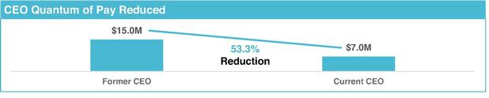

Fiscal Year 2021 Incentive Plan Design Enhancements

Short-Term Incentives: Added Operating Cash Flow as a financial metric; added ESG goals to individual key performance indicators ("KPIs")

Long-Term Incentives: Added Relative TSR and Adjusted EPS Growth as metrics; removed Free Cash Flow

Rigor of Goals: All financial targets materially align with external guidance to investors; Adjusted EPS Growth excludes impact of repurchases; Relative TSR targets 55th percentile performance

42

Table of Contents

Stockholder Engagement and Executive Compensation Design Changes

Throughout the year, we have active and on-going dialogues with stockholders which are summarized as follows for Fiscal Year 2020:

What We Heard | What We Did and Why
Engage with | ✓ The Compensation Committee directors engaged with stockholders who collectively own greater than 50% of our total outstanding shares
stockholders
CEO Quantum of Pay is | ✓ The CEO total target pay is less than 50% of his predecessor's. The decision reflected a comprehensive review of the underlying business transformation, the peer group of companies to assess competitive market data, and the
high | opportunity to recognize and reward future growth and success in the role.

Incentives should support long-term strategy

- To support long-term profitable growth and the Company's capital allocation priorities, the Compensation Committee added Operating Cash Flow to the short-term incentive program in Fiscal Year 2021.

- To focus NEOs on growing earnings to drive shareholder value, the Compensation Committee added Adjusted Earnings per Share Growth to the long-term incentive program in Fiscal Year 2021 and elected to exclude the impact of share repurchases when calculating "per Share." Earnings per Share is preferable over Net Income as it has the added benefit of factoring how executive decisions can dilute shareholder interests.

- To further align our NEO's financial interests with that of our shareholders and reward for the TSR outperformance expected if NEOs execute the Company's financial plan and capital allocation policy, the Compensation Committee added relative TSR to the long-term incentive program in Fiscal Year 2021.

- Ultimately, short-term incentives focus on key metrics that hold management responsible for performance that drive shareholder value and for commitments made to investors. Long-term incentives focus on key metrics that align pay with shareholder value creation.

Goals should be rigorous | ✓ All financial goals materially align with the financial guidance we provide to our stockholders.
 | ✓ Adjusted Earnings per Share Growth is based on underlying earnings growth from the business, excluding the impact of share repurchases.
 | ✓ Relative TSR requires 55th percentile (above-median) performance for a target payout of 100%.
Vary short-term and long- | ✓ The Compensation Committee removed Free Cash Flow from the long-term incentive program after adding Operating Cash Flow to the short-term incentive program to avoid redundant metrics. Cash Flow in the short-term better
term incentive metrics | incentivizes managing our working capital while also supporting the continued execution of our capital allocation policy.
 | 43

Table of Contents

Named Executive Officers

This Compensation Discussion and Analysis ("CD&A") section outlines the compensation philosophy and decisions for the following NEOs as of Fiscal Year 2020:

Named Executive Officer | Role as of the End of Fiscal Year 2020
W. Troy Rudd⁽¹⁾ | Chief Executive Officer
Gaurav Kapoor⁽²⁾ | Chief Financial Officer
Lara Poloni⁽³⁾ | President
Randall A. Wotring⁽⁴⁾ | Chief Operating Officer
Stephen J. Morriss⁽⁵⁾ | Group President, Design and Consulting Services—Americas
Michael S. Burke⁽⁶⁾ | Former Chairman of the Board and Chief Executive Officer

- Effective August 15, 2020, W. Troy Rudd was promoted from Executive Vice President, Chief Financial Officer to Chief Executive Officer.

- Effective August 15, 2020, Gaurav Kapoor was promoted from Chief Accounting Officer, Global Controller and Treasurer to Chief Financial Officer.

- Effective August 15, 2020, Lara Poloni was promoted from Chief Executive of Europe, Middle East and Africa to President.

- Effective October 2, 2020, Randall A. Wotring ceased serving as Chief Operating Officer, with a retirement date of December 31, 2020.

- Effective October 2, 2020, Stephen J. Morriss ceased serving as the Group President, Design and Consulting Services—Americas.

- Effective August 14, 2020, Michael S. Burke ceased serving as the Chairman of the Board and Chief Executive Officer.

Executive Pay Program and Practices

A significant majority of our NEOs' compensation is "performance based" (i.e., subject to the accomplishment of individual and Company objectives) and stock based (i.e., aligned with stockholders' interests) as follows:

CEO Annual Target Pay Other NEO Annual Target Pay
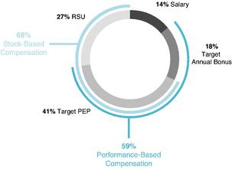
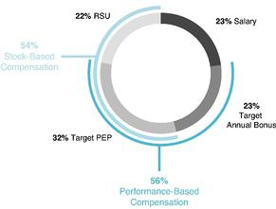

44

Table of Contents

The primary elements of our executive pay program support our executive pay philosophy and are directly linked to individual and company performance as follows:
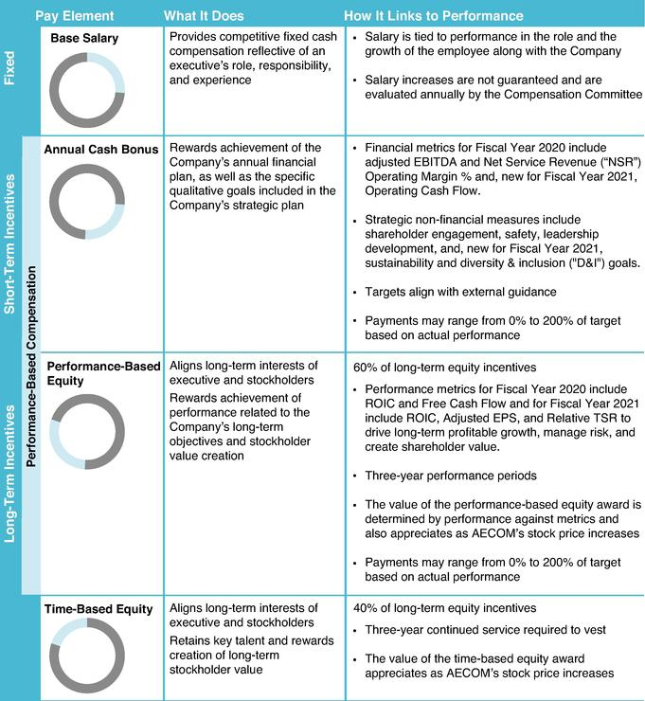

45

Table of Contents

COMPENSATION GOVERNANCE, PROCESS AND DECISIONS

Executive Pay Philosophy

Our executive pay program is designed to support our strategy to deliver industry-leading profitable growth and stockholder value creation. It is underlined by our compensation philosophy that aims to attract and retain the best and brightest in our industry and recognize and reward outstanding achievements that drive long-term profitable growth and create stockholder value.

Pillars of our Executive Pay Program

Market Competitive: Assess NEO target pay levels against market compensation benchmarks prepared by our independent compensation consultant

Pay Supports Strategy: Incentive metrics designed to drive achievement of long-term financial and strategic objectives

Performance-Based: Impose performance conditions on the majority of our NEOs' compensation

Rigorous Goal Setting: Require performance that meets investor guidance and/or outperforms our industry for target payout on incentives

Shareholder Alignment: NEO financial interests aligned with those of our shareholders with long-term equity awards comprising a majority of each NEO's total compensation

Compensation Process

Compensation decisions are made as part of a year-long review and collaborative process with the following:
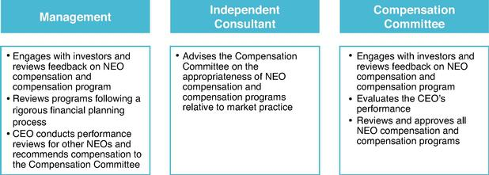

The Compensation Committee, which is composed solely of independent directors, has been authorized to determine and approve compensation for AECOM's executive officers. As part of the annual compensation planning process, the Compensation Committee reviews the NEOs' base salary, short-term and long-term incentive compensation, with a focus on the total reward package. As further described below, the Compensation Committee looks to a peer group of companies, as well as the broader market, as a baseline for compensation decisions for NEOs. However, AECOM does not target executive officer compensation at a specific level or percentage relative to compensation provided by the companies in the compensation peer group or broader market. Instead, when determining compensation for executive officers, the Compensation Committee takes into account a broad array of factors, including the experience level of the individuals in their current positions, the overall financial and strategic

46

Table of Contents

performance of the Company during the year and the performance and contribution of each executive during the year relative to individual, pre-defined goals and objectives. Differences in compensation levels for our NEOs are driven by the Compensation Committee's assessment, in its judgment, of each of our executive's responsibilities, experience and compensation levels for similar positions at peer companies. Except as otherwise noted in this CD&A, the Compensation Committee's determinations are subjective and the result of business judgment informed by members' experiences, analysis of peer company data, input from the independent consultant, and overall compensation trends.

Role of the Compensation Committee

–Reviews the Company's financial, strategic and operational metrics and goals, compensation peer group and approves the performance objectives of the CEO and other executive officers.

–Approves design changes to the executive compensation program, as applicable.

–Reviews full-year Company financial and strategic performance to understand what was accomplished relative to established objectives.

–Evaluates the CEO's performance in light of the review of Company performance.

–Discusses with the CEO his evaluation of the performance of each of the other executive officers relative to their individual performance objectives.

–Determines compensation amounts for the CEO and each of the other executive officers, taking into account:

  - Prior year's compensation;

  - Performance assessments;

  - Market considerations;

  - Individual performance and retention considerations;

  - Input from the Compensation Committee's independent compensation consultant; and

  - For the other NEOs, the CEO's recommendations.

–Reviews and approves the grants and payouts of long-term incentive equity awards.

With respect to the pool of long-term incentive equity awards, a number of factors are taken into account including but not limited to prior year grant size, growth in earnings and in employee headcount, the accounting expense, and the potential dilutive effects on stockholders. With respect to individual long-term incentive equity awards, the Compensation Committee considers individual performance, market data, including compensation for comparable positions at peer companies, and the strategic importance of the NEO's position to determine a dollar denominated long-term incentive equity value to be awarded to each NEO. The dollar value awarded by the Compensation Committee to each NEO is then converted into a specific number of units, based on the fair market value of AECOM common stock on the date of grant.

Compensation and Organization Committee's Independent Compensation Consultant

The Compensation Committee has the authority to retain the services of outside consultants to assist it in performing its responsibilities. The Compensation Committee engaged the services of the consulting firm Exequity LLP. During fiscal year 2020, the consultant provided data on the compensation and relative performance of compensation peer group companies as well as general industry data to the Compensation Committee, made presentations on regulatory and legislative matters affecting executive compensation, provided advice on the degree to which compensation arrangements are consistent with market practices, and consulted on other compensation matters as needed. Exequity LLP does not provide any services to the Company other than advising the Compensation Committee on compensation matters.

47

Table of Contents

The Compensation Committee has assessed the independence of Exequity LLP, considering the following six factors and other factors that it deemed relevant: (1) other services provided to the Company by Exequity LLP, (2) the amount of fees paid by the Company to Exequity LLP as a percentage of Exequity LLP's total revenue, (3) the policies or procedures maintained by Exequity LLP that are designed to prevent conflicts of interest, (4) any business or personal relationships between the individual employees of Exequity LLP involved in the engagement and a member of the Compensation Committee, (5) any AECOM stock owned by Exequity LLP's employees involved in the engagement and (6) any business or personal relationships between our executive officers and Exequity LLP or the employees of Exequity LLP involved in the engagement. Following such assessment, the Compensation Committee concluded that Exequity LLP is independent and that Exequity LLP's work raises no conflicts of interest.

Assessing Competitive Practice

As part of its due diligence when making compensation decisions, the Compensation Committee examines pay data for a group of comparable companies to stay current with market pay practices and trends and to understand the competitiveness of the Company's total compensation and its components of pay.

Compensation peer group data is supplemented with broader market survey data from Aon Hewitt and Willis Towers Watson. The Compensation Committee uses the compensation peer group and market survey data for informational purposes. The Company does not target a specific percentile or make significant pay decisions based on market data alone. The Compensation Committee considers Company performance as well as the level of responsibility, experience and tenure of the individual and performance in the role.

Fiscal Year 2020 Compensation Peer Group

The Compensation Committee, when developing the compensation peer group, identified the Company's competitors for talent and considered other various measures of size, scope and complexity, with a focus on revenue and enterprise value.

Cognizant Technology Solutions | Illinois Tool Works | PACCAR
Cummins | Jacobs Engineering Group | Parker-Hannifin
DXC Technology | KBR | Quanta Services
EMCOR Group | Leidos Holdings | Textron
Fluor | MasTec | Xerox

Fiscal Year 2021 Compensation Peer Group

For Fiscal Year 2021, following the sale of the Management Services business and expected sales of the Company's at-risk construction businesses, the Compensation Committee further refined the Company's compensation peer group to better align with our on-going transformation into a Professional Services business in addition to considering the other factors listed above with Net Service Revenue being a new measure included in the analysis:

Booz Allen Hamilton Corporation | Leidos Holdings | Stantec
EMCOR Group | MasTec | Tetra Tech
Fluor | Parsons | Tutor Perini
Jacobs Engineering Group | Quanta Services | WSP Global
KBR | SNC-Lavalin Group
 | 48

Table of Contents

Elements of our Named Executive Officer Compensation

The following is a discussion of the primary elements of Fiscal Year 2020 compensation for each of our NEOs.

Base Salaries

Our Compensation Committee adjusts base salaries in connection with its periodic review of the NEOs' performances, any change in responsibilities, and competitive talent market conditions. The following sets forth the fiscal year 2020 base salary increases for each NEO:

 |  |  |  | January |  | August
NEOs |  | 2019(1) |  | 2020(1) | % Change | 2020(2) | % Change
W. Troy Rudd |  | $700,000 |  | $775,000 | 10.7% | $1,000,000 | 29.0%
Gaurav Kapoor |  | $435,000 |  | $495,000 | 13.8% | $575,000 | 16.2%
Lara Poloni |  | $595,000 |  | $625,000 | 5.0% | $750,000 | 20.0%
Randall A. Wotring |  | $850,000 |  | $875,000 | 2.9%
Stephen J. Morriss |  | $640,000 |  | $660,000 | 3.1%
Michael S. Burke |  | $1,500,000 |  | $1,500,000 | 0.0%

- Salary increase, if any, effective January 2019 and 2020 with the beginning of the calendar year. Salaries disclosed in the "SUMMARY COMPENSATION TABLE" reflect actual amounts paid in the respective fiscal year.

- Salary increase, if any, effective August 15, 2020 at the time of promotion for Mr. Rudd, Ms. Poloni, and Mr. Kapoor. Salaries disclosed in the "SUMMARY COMPENSATION TABLE" reflect actual amounts paid in the respective fiscal year.

The Compensation Committee believes that our NEOs' base salary levels provide appropriate levels of fixed income based on the background, qualifications and skill set of each executive.

Compensation Actions in Response to COVID-19

Due to the COVID-19 pandemic, our Compensation Committee temporarily reduced the salaries of our NEOs, effective April 2020, by 20%. The reduced base salaries are reflected in the "Summary Compensation Table." The Compensation Committee fully restored the base salaries on a go-forward basis for all NEOs other than the CEO effective August 1, 2020, and, for the CEO, effective October 3, 2020.

Annual Incentives

Our Compensation Committee establishes a short-term incentive award opportunity to be paid to each NEO upon achieving certain annual individual and company performance goals under the Executive Incentive Plan ("EIP"). For fiscal 2020, the Compensation Committee approved the following target percentages (%) and amounts ($) for the NEOs:

Annual Target Incentives (NEOs) |  |  |  | 2019(1) | January 2020(1) |  |  | August 2020(2)
W. Troy Rudd |  |  | 100% | $700,000 | 100% | $775,000 | 125% |  | $1,250,000
Gaurav Kapoor |  |  | 60% | $261,000 | 70% | $346,500 | 100% |  | $575,000
Lara Poloni |  |  | 100% | $595,000 | 100% | $625,000 | 110% |  | $825,000
Randall A. Wotring |  |  | 100% | $850,000 | 100% | $875,000
Stephen J. Morriss |  |  | 100% | $640,000 | 100% | $660,000
Michael S. Burke |  |  | 165% | $2,475,000 | n/a | n/a

- Bonus targets reflect amounts approved as part of the annual compensation planning process for the fiscal year.

- Bonus targets reflect the increased bonus targets approved in connection with the promotions for Mr. Rudd, Mr. Kapoor, and Ms. Poloni.

49

Table of Contents

For Fiscal Year 2020, the Compensation Committee approved the following performance measures for our NEOs to support our strategy for attaining long-term profitable growth and stockholder value creation:

Corporate Leaders | Business Unit Presidents | Why Selected
 |  | Adjusted EBITDA focuses on underlying operational performance,
 |  | is responsive to stockholder feedback to align compensation
 | Pre-Variable Compensation | metrics with the metrics that investors use to evaluate
Adjusted EBITDA | Pre-Variable Compensation | performance.
Adjusted EBITDA | ("Pre-VC") EBITA
 | ("Pre-VC") EBITA | Pre-VC EBITA focuses on the "bottom-line" at the operating group
 |  | level and thus provides a strong measure of the operational
 |  | contribution to enterprise profitability.
 |  | NSR Operating Margin focuses on underlying operational
 |  | performance, including executing on restructuring and margin
 |  | enhancing initiatives while focusing business development time
 |  | and capital on the most profitable opportunities.
NSR Operating Margin % | Operating Cash Flow | Cash Flow incentivizes disciplined growth and risk management,

 | operational efficiency and working capital management. It ensures
 | working capital management is prioritized as a key contributor to
 | long-term performance and ROIC, and strong operating cash flow
 | supports the Company's capital allocation policy to return
 | substantially all cash and cash flow to stockholders through share
 | repurchases.
Key Performance Indicator ("KPI") Assessment | Encourages focus on the achievement of the Company's non-
Key Performance Indicator ("KPI") Assessment | financial strategic objectives including sustainability and ESG
Targets for the financial metrics above aligned with earnings guidance provided to our stockholders and/or our financial plan.
50

Table of Contents

Annual Incentive Calculations

For the Fiscal Year 2020 annual cash bonus, the following details the percentages earned by the following NEOs:

Mr. Rudd's bonus was calculated pro-rata based on his time as Chief Financial Officer and time as Chief Executive Officer using the same metrics.

 |  |  |  | Weighting | Threshold |  |  | Target | Maximum |  |  | Actual | Earned
 | W. Troy Rudd |  |  | Percentage | Amount($) |  | Amount($) |  | Amount($) |  |  | Amount($) | Percentage
 | Adjusted EBITDA |  |  | 35% | $ | 666.0 | $ | 740.0 | $ | 814.0 | $ | 746.1 | 37.9%
 | NSR Operating Margin % |  |  | 35% |  | 10.4% |  | 11.5% |  | 12.7% |  | 12.3% | 58.3%
 | KPIs |  |  | 30% |  |  |  |  |  |  |  |  | 45.0%
 |  | Total |  |  |  |  |  |  |  |  |  |  | 141.2%

- See Annex A, Reconciliation of Non-GAAP Items.

Mr. Kapoor's bonus was calculated pro-rata based on his time as Global Controller and Chief Financial Officer.

 |  |  |  |  | Weighting | Threshold |  |  | Target | Maximum |  |  | Actual | Earned
 |  | Gaurav Kapoor |  |  | Percentage | Amount($) |  | Amount($) |  | Amount($) |  |  | Amount($) | Percentage
 |  |  | Chief Financial Officer
 |  | Adjusted EBITDA |  |  | 35% | $ | 666.0 | $ | 740.0 | $ | 814.0 | $ | 746.1 | 37.9%
 |  | NSR Operating Margin % |  |  | 35% |  | 10.4% |  | 11.5% |  | 12.7% |  | 12.3% | 58.3%
 |  | KPIs |  |  | 30% |  |  |  |  |  |  |  |  | 30.0%
 |  |  | Total |  |  |  |  |  |  |  |  |  |  | 126.2%
 |  |  | Global Controller
 |  | Adjusted EBITDA |  |  | 80% | $ | 666.0 | $ | 740.0 | $ | 814.0 | $ | 746.1 | 86.6%
 |  | NSR Operating Margin % |  |  | 20% |  | 10.4% |  | 11.5% |  | 12.7% |  | 12.3% | 33.3%
 |  | Sub-Total |  |  |  |  |  |  |  |  |  |  |  | 119.9%
 |  |  | x Performance Modifier |  |  |  |  |  |  |  |  |  |  | 150.0%
 |  |  | Total |  |  |  |  |  |  |  |  |  |  | 179.9%
* | See Annex A, Reconciliation of Non-GAAP Items
 |  |  |  |  |  |  | 51

Table of Contents

Ms. Poloni's bonus was calculated pro-rata based on her time as Chief Executive, EMEA and time as President.

 |  |  |  | Weighting |  | Threshold |  | Target | Maximum |  |  | Actual | Earned
 | Lara Poloni |  |  | Percentage |  | Amount($) |  | Amount($) | Amount($) |  |  | Amount($) | Percentage
 |  | President
 | Adjusted EBITDA |  |  | 35% | $ | 666.0 | $ | 740.0 | $ | 814.0 | $ | 746.1 | 37.9%
 | NSR Operating Margin % |  |  | 35% |  | 10.4% |  | 11.5% |  | 12.7% |  | 12.3% | 58.3%
 | KPIs |  |  | 30% |  |  |  |  |  |  |  |  | 45.0%
 |  | Total |  |  |  |  |  |  |  |  |  |  | 141.2%
 |  | Chief Executive, EMEA
 | Pre-VC EBITA (DCS EMEA) |  |  | 42% | $ | 48.4 | $ | 53.8 | $ | 72.6 | $ | 58.4 | 52.3%
 | Op Cash Flow (DCS EMEA) |  |  | 28% | –$ | 12.3 | –$ | 11.2 | $ | 38.8 | $ | 70.5 | 56.0%
 | KPIs |  |  | 30% |  |  |  |  |  |  |  |  | 45.0%
 |  | Total |  |  |  |  |  |  |  |  |  |  | 153.3%

- See Annex A, Reconciliation of Non-GAAP Items.

Mr. Wotring's annual incentive target and metrics remained the same throughout Fiscal Year 2020. He received an award based on the earned percentage outlined below.

 |  |  |  |  | Weighting | Threshold |  |  | Target | Maximum |  |  | Actual | Earned
 |  | Randall A. Wotring |  |  | Percentage | Amount($) |  | Amount($) |  | Amount($) |  |  | Amount($) | Percentage
 |  | Adjusted EBITDA |  |  | 35% | $ | 666.0 | $ | 740.0 | $ | 814.0 | $ | 746.1 | 37.9%
 |  | NSR Operating Margin % |  |  | 35% |  | 10.4% |  | 11.5% |  | 12.7% |  | 12.3% | 58.3%
 |  | KPIs |  |  | 30% |  |  |  |  |  |  |  |  | 30.0%
 |  |  | Total |  |  |  |  |  |  |  |  |  |  | 126.2%
* | See Annex A, Reconciliation of Non-GAAP Items

Key Performance Indicator ("KPI") Assessment

With respect to each of our NEOs, the KPI assessment focuses on the individual's contributions to strategic objectives that are part of the Company's strategic plan.

52

Table of Contents

NEOs | Achievements
W. Troy Rudd | Delivery of Company Financial Plan: Adjusted EBITDA and Free Cash Flow exceeded the high-end of the Company's guidance, and NSR Adjusted Operating Margin exceeded the
 | midpoint of the Company's guidance. This financial success was driven by our transformation into a higher-margin and lower-risk professional services organization.


Execution of the Capital Allocation Policy:

– Repurchased $455 million or 10.4 million shares through November 2020

– The Company's Board of Directors increased the existing repurchase authorization by $695 million to $1 billion in November 2020.

– Substantially reduced our debt and leverage with proceeds from the sale of our Management Services business

Safety:

– Lowest recordable injuries and lost workdays since 2015

– Effective management and mitigation of the COVID-19 pandemic (including scenario planning, preemptive impact mitigations, and health and safety planning)

New Leadership Team and Enterprise Strategy:

– Implemented a cultural shift that places Equity, Diversity & Inclusion and Environment, Social and Governance (ESG) efforts at forefront of enterprise strategy

– Development, recruitment, and launch of new Executive Leadership Team globally, including restructuring of the DCS business into a single operating group that enhances collaboration, creates direct lines of accountability, and simplifies the organization to enhance agility.
Lara Poloni | Led the restructuring of the EMEA business to focus on higher margin and higher growth markets, including market penetration in the Middle East. Oversaw year over year margin
 | improvement in EMEA despite impacts of the pandemic, laying down a strong foundation with a trajectory for continued improvements regardless of market challenges. Successfully
 | restored transportation market positions in the UK that had been previously lost. Developed a strong EMEA leadership team and a culture of collaboration. Developed and began
 | implementation of a restructuring of the entire DCS business.
Gaurav Kapoor | Successfully executed $455M of share repurchases through November 2020, delivering on Fiscal Year 2020 capital allocation commitments made to investors. Oversaw the Global
 | Business Services' transformation to achieve all key financial metrics at the high end of the range for Fiscal Year 2020. Eliminated $53M of stranded costs following the Management
 | Services transaction. Executed the Fiscal Year 2020 global real estate consolidation resulting in over 1.1 million square feet of real estate offices being restructured.
Randall A. Wotring | Led year over year improvement in employee engagement score as well as total retention and retention outstanding ratings. Exceeded Fiscal Year 2020 plan for hours and cost
 | benefit of the Global Delivery Services strategy and vision. Supported two-year planning cycle by driving best-in-class margin across operating groups, meeting plan margin
 | percentage and stranded cost targets. Provided critical leadership in connection with the exit of our at-risk construction businesses.
 | 53

Table of Contents

Fiscal Year 2021 Annual Incentives Design

In response to stockholder feedback and efforts to align our incentives with our long-term strategy, the Compensation Committee adopted the following Fiscal Year 2021 performance metrics for our NEOs:

 | 2020 |  | 2021 | Rationale
Corporate Performance Metrics | Professional Services¹ Adjusted |  | Professional Services¹ Adjusted | – Responsive to stockholder feedback to focus incentives on the metrics
 | EBITDA² |  | EBITDA² | on which investors measure short term financial performance
 | Professional Services¹ Adjusted NSR |  | Professional Services¹ Adjusted NSR | – Measures are critical to long-term profitable growth
 | Operating Margin Percent³ |  | Operating Margin Percent³ | – Cash flow supports the Company's capital allocation policy
 |  |  | AECOM Operating Cash Flow (New
 |  |  | for 2021)
Individual KPI Performance Goals | See Prior Page |  | ESG (Environmental, Social and | – ESG added to the Company's long-term strategic plan to become the
 |  |  | Governance) goals such as, for the | ESG leader in our industry
 |  |  | CEO, Safety; Ethics & Compliance;
 |  |  | Percentage of Women in Leadership;
 |  |  | and overall improved ESG ratings
 |  |  | from independent ESG research firms

- Defined as AECOM Enterprise less the at-risk, self-perform construction businesses to be sold, which are reported in discontinued operations.

- Defined as Net Income attributable to AECOM before income tax expense (benefit), interest expense, interest income, depreciation and amortization expense, excluding acquisition and integration-related items, transaction-related expenses, financial impacts associated with expected and actual dispositions of non-core businesses and assets, and transformational restructuring related expenses.

- Defined as Adjusted Operating Income divided by Net Service Revenue. Adjusted Operating Income is defined as income from operations excluding acquisition and integration-related items, transaction-related expenses, financial impacts associated with expected and actual dispositions of non-core businesses and assets, amortization of intangible assets, and transformational restructuring related expenses. Net Service Revenue is defined as revenue less other direct costs.

Long-Term Incentives

Long-term incentive equity awards not only serve to retain our NEOs but also align our NEOs' interests with those of our stockholders by linking the final value to AECOM's stock price and, for PEP awards, being subject to performance metrics that drive our long-term strategy to build sustainable profitable growth and stockholder value.

54

Table of Contents

Long-Term Incentive Award

As part of its review of Fiscal Year 2020 performance, the Compensation Committee analyzed the role and responsibilities of each NEO, including their past and current performance history, and prevailing market practices with respect to our compensation peer group and across industries. Based on these factors (as well as taking into consideration the Compensation Committee's collective experience regarding appropriate annual equity grant levels), the Compensation Committee approved the following equity awards in Fiscal Year 2020:

NEOs |  |  | 2019 |  | 2020 | % Change
W. Troy Rudd |  | $ | 2,200,000 | $ | 2,500,000 | 13.6%
Gaurav Kapoor |  | $ | 475,000 | $ | 600,000 | 26.3%
Lara Poloni |  | $ | 700,000 | $ | 1,000,000 | 42.9%
Randall A. Wotring |  | $ | 2,750,000 | $ | 2,750,000 | 0.0%
Stephen J. Morriss |  | $ | 1,000,000 | $ | 1,000,000 | 0.0%
Michael S. Burke |  | $ | 11,000,000 |  | — | –100%

For fiscal year 2020, each NEO's long-term incentive equity award was comprised of the following:

Type

PEP

RSU

Weighting

Percentage Performance Measures and Vesting Requirements
60% Metrics:
– 50% to vest based on 3-year average ROIC achievements

– 50% to vest based on 3-year cumulative attributable Free Cash Flow achievements

40% | Continued service over 3-years (except in the case of certain qualifying terminations)

As to each PEP metric, because pre-established targets are competitively sensitive, they have not been disclosed; however, we note that the applicable targets aligned with guidance to shareholders.

55

Table of Contents

Fiscal Year 2021 Long-Term Incentive Design Changes

In response to stockholder feedback and a continuous focus on aligning our incentives with our long-term strategy, the Compensation Committee adopted the following Fiscal Year 2021 performance metrics for our

NEOs, each weighted equally:

2020 | 2021 | Rationale
Professional Services¹ ROIC² | Professional Services¹ | – Critical to achieving long-term profitable growth
 | ROIC²
Professional Services¹ |  | – Removing cash flow avoids duplicative metrics in short- and long-term incentives.
Attributable FCF
 | Professional Services¹ | – Adding EPS aligns with how our stockholders will measure our performance in the
 | Adjusted EPS³ Growth | long-term. Stockholders had commented that they will increasingly value the
 |  | Company on an EPS basis following the sales of our Management Services and at-
 |  | risk businesses.
 |  | – Excluding share repurchases from EPS growth results focuses NEOs on delivering
 |  | underlying business growth.
 |  | – EPS is preferable over Net Income as it also considers how executive decisions can
 |  | dilute shareholder interests.
 | Relative TSR | – Rewards execution of the capital allocation policy which is expected to create
 |  | shareholder value above and beyond achieving our long-term strategic objectives
 |  | – Encourages outperformance with target TSR payout set above the median of peers
 |  | at 55th percentile

- Defined as AECOM Enterprise less at-risk, self-perform construction businesses to be sold.

- Defined as the 3-Year Average Annual Adjusted NOPAT divided by the 3-Year Average Quarterly Invested Capital. Adjusted NOPAT is Adjusted Attributable Net Income plus Adjusted Interest Expense net of Interest Income (tax effected at a normalized 28.5% rate). Adjusted Attributable Net Income is defined as Net Income Available to Common Stockholders excluding foreign exchange gains/losses on forward contracts related to financing, acquisition and integration related expenses, transaction related expenses, transformational restructuring related expenses, financing charges in interest expense, the amortization of intangible assets, and financial impacts associated with expected and actual dispositions of non-core businesses and assets. Adjusted Interest Expense excludes financing charges in interest expense. Invested Capital is Attributable Shareholders Equity plus Total Debt less Cash and Cash Equivalents (all per balance sheet). Quarterly Invested Capital is defined as the beginning and ending balance of each respective quarter excluding (1) any balance with respect to all at-risk businesses to be sold and (2) changes to Accumulated Other Comprehensive Loss (i.e., held flat at Q4 FY2020 ending actuals).

- Adjusted EPS is calculated as (a) Adjusted Attributable Net Income (as defined in footnote 2) divided by (b) the Weighted Average Number of Common Shares Outstanding, on a diluted basis, for a fiscal year.

FY2021 RSU Grants for CEO and President

In conjunction with their promotions to CEO and President, respectively, Mr. Rudd and Ms. Poloni received the RSU portion of their annual Fiscal Year 2021 long-term incentive awards on August 15, 2020. These awards will fully vest on the third anniversary of the grant date and are included in the "Grants of Plan-Based Awards for Fiscal Year 2020" table. The PEP portions of their award were granted in December 2020, along with the FY2021 annual grants for all other NEOs and AECOM employees.

56

Table of Contents

Performance Stock Option for CEO

In addition to the FY2021 RSU grant, Mr. Rudd received a $3,000,000 performance stock option award upon his promotion to CEO. The performance stock option is subject to both service and stock price vesting conditions, which must each be satisfied for the option to be vested as to the underlying shares. The service vesting requirement is satisfied in five (5) equal installments on each anniversary of the grant date, subject to continued employment. The performance vesting requirement is also satisfied in five (5) equal installments, upon our volume-weighted average price during a twenty-consecutive trading day period achieving each of the following AECOM stock price hurdles:

Target Stock Price | Percentage
Exercise Price plus 20% ($46.46) | 20%
Exercise Price plus 40% ($54.21) | 40%
Exercise Price plus 60% ($61.95) | 60%
Exercise Price plus 80% ($69.70) | 80%
Exercise Price plus 100% ($77.44) | 100%

In order to fully vest, AECOM's stock price needs to double compared to the grant date closing stock price (i.e., the Exercise Price), creating over $6.2 billion in market capitalization. Full vesting will also require outperforming our highest stock price from the last six (6) years by over 150% as both service and performance requirements must be met in order to become exercisable.

57

Table of Contents

PERFORMANCE EARNINGS PROGRAM — 2020 ACHIEVEMENTS AND PAYOUTS

Fiscal Years 2017-2019 (PEP2017)

The number of units eligible to be earned was based on the Company's achievement of certain financial metrics, weighted 75%, and Relative TSR, weighted 25%. The financial metrics were measured over three

- one-year performance periods with a 37.5% weighting for Adjusted EPS and a 37.5% weighting for Free Cash Flow Per Share. The Relative TSR metric was measured over a cumulative three-year performance period ending on December 14, 2019. PEP2017 earned 84.3% of target based on prior Fiscal Year 2017, 2018 and 2019 results and the below Relative TSR performance results.

December 15, 2016 – December 14, 2019 Threshold Target Maximum Actual Payout (%)

Relative TSR

25%' ile

50%'ile

75%'ile

17.6%'ile

0%

In Fiscal Year 2019, executive management made a strategic decision to restructure the Company to deliver long-term value to stockholders, which resulted in $95.4 million of transformational restructuring costs. As a result of the impact of the cost of restructuring, Fiscal Year Adjusted EPS earned 0% as the target levels were burdened by the cost of these investments. The final payout percentage above reflects this detriment taken by management for the benefit of the Company and its shareholders in the long-term.

Fiscal Years 2018-2020 (PEP2018)

PEP2018 has the same design as PEP2017. PEP2018 achieved 108.5% based on the Company's financial performance for Fiscal Years 2018 - 2020 and Relative TSR performance from December 15, 2017 to December 14, 2020. The table below details the final Fiscal Year 2020 financial performance and Relative TSR performance.

Year 3 (Fiscal Year 2020) Threshold Target Maximum Actual % Payout (%)

Adjusted EPS Growth

FCF Per Share Growth

(5.0)% | 2.0%-5.0% | 10.0% | (7.5%)
(5.0)% | 2.0%-5.0% | 10.0% | 23.0%

0%

200%

December 15, 2017 – December 14, 2020 Threshold Target Maximum Actual Payout (%)

Relative TSR

25%' ile

50%'ile

75%'ile

46.7%'ile

86.7%

Similar to the results of PEP2017, for PEP2018, Adjusted EPS was negatively impacted by executive management's strategic decision to restructure the Company to deliver long term value to stockholders. The estimated payout percentage above reflects this detriment resulting from unplanned restructuring actions taken for the benefit of the Company and its shareholders in the long-term.

Fiscal Years 2019-2022 (PEP2019) and Fiscal Years 2020-2023 (PEP2020)

PEP2019 and PEP2020 have three-year performance periods to measure Return on Invested Capital and Free Cash Flow Per Share for PEP2019, and Attributable Free Cash Flow for PEP2020. Actual performance results will not be available until after the three-year performance period ends for both awards. Because pre-established targets are competitively sensitive, they have not been disclosed; however, we note that the applicable targets aligned with guidance to shareholders.

58

Table of Contents

OTHER PROGRAMS, POLICIES AND GUIDELINES

Stock Ownership Guidelines for Named Executive Officers

NEOs are subject to stock ownership guidelines, which helps to ensure that their interests are aligned with those of stockholders. Under the guidelines, AECOM's CEO is required to maintain ownership of AECOM stock at six times base salary and the other NEOs at three times base salary. The minimum number of shares required to meet the guideline is updated annually based on each executive's salary and the 12-month trailing average AECOM stock price. Shares owned directly and indirectly, restricted stock units and vested stock options/shares are counted toward the guidelines. NEOs have five full fiscal years, starting from the date an executive is first subject to the guidelines, to comply.

In Fiscal Year 2020, the Compensation Committee increased the rigor of the stock ownership guidelines by removing unvested PEP units from shares counted toward meeting the applicable salary multiple requirements. As a result, our NEOs are required to hold a greater number of AECOM shares in the future to satisfy the requirements of our stock ownership guidelines.

The table below outlines the stock ownership of AECOM's NEOs as of October 2, 2020. Mr. Burke ceased serving as an officer on August 14, 2020. Messrs. Wotring and Morriss ceased serving as officers on October 2, 2020. Some of the continuing NEOs do not currently meet the stock ownership guidelines, however, each continuing NEO is expected to meet the guidelines by the end of his/her respective five-year transition period.

 | Guideline — |  | Actual —
Named Executive Officers | Salary Multiple |  | Salary Multiple
W. Troy Rudd |  | 6.0 | 8.0
Gaurav Kapoor |  | 3.0 | 2.4
Lara Poloni |  | 3.0 | 2.8
Randall A. Wotring |  | 3.0 | n/a
Stephen J. Morriss |  | 3.0 | n/a
Michael S. Burke |  | n/a | n/a

Benefit, Retirement and Perquisite Programs

To protect the Company's executives' health and well-being, facilitate the operation of the business, assist in the retention of current executives and aid in the recruitment of new executives, AECOM's NEOs are eligible to participate in benefit plans that are available to a substantial amount of all employees, including participation in retirement plans, medical insurance, dental insurance, life insurance and disability insurance programs. Further, the Company offers certain additional benefits only to executive officers and other senior officers, where applicable, which consist of the following:

- Executive Life Insurance. AECOM provides life insurance coverage with a benefit of up to $2 million for each NEO.

- Executive Disability Program. AECOM provides an Executive Disability Program, which offers salary replacement of up to 60% of salary in the event of an executive's disability (maximum $25,000 per month).

- Executive Health Program. Mr. Burke is the only remaining participant of this program that has been frozen to new participants. This plan provides up to 100% reimbursement for specified medical, prescription, dental and vision expenses.

- AECOM Executive Deferred Compensation Plan. A non-qualified deferred compensation plan that enables highly compensated U.S. employees to defer income tax on components of their compensation.

59

Table of Contents

- Perquisites. The Company believes that offering certain limited perquisites, including an executive allowance to offset normal business expenses incurred by the executive in service to the Company, facilitates the operation of AECOM's business and assists in executive retention.

Employment Agreements, Severance Benefits and Change in Control Provisions

The Company has entered into a letter agreement with Mr. Burke dated March 6, 2014 and amended May 8, 2018 to add certain post-employment health insurance benefits; a letter agreement with Mr. Rudd dated June 20, 2020; and an employment agreement with Ms. Poloni dated October 19, 2020. Details of these agreements along with benefits provided to our NEOs under the AECOM Senior Leadership Severance Plan and AECOM Technology Corporation Change in Control Severance Policy for Key Executives can be found under the "PAYMENTS AND BENEFITS UPON TERMINATION OR CHANGE IN CONTROL" section of this Proxy Statement.

Clawback Provisions

The Compensation Committee maintains a clawback policy applicable to all current and former Section 16 officers that will apply if there is an accounting restatement due to material noncompliance with any financial reporting requirement under the securities laws. The Company is authorized to recover a portion of any short-term cash and long-term equity incentive awards paid to current or former executive officers during the three full fiscal years prior to the date of the covered event.

Hedging and Anti-Pledging

The Company's insider trading policy prohibits all directors, executive officers (as defined by Section 16 of the Exchange Act) and certain other employees designated as insiders from engaging in any hedging or monetization transactions, such as zero-cost collars and forward-sale contracts, involving Company securities.

In addition, the policy prohibits buying shares on margin and the pledging of Company securities by NEOs except in certain limited circumstances subject to Company approval and demonstration of the NEO's ability to repay the applicable loan without selling such securities.

60

Table of Contents

REPORT OF THE COMPENSATION AND ORGANIZATION COMMITTEE OF THE BOARD OF DIRECTORS

The Compensation Committee has reviewed and discussed with management the Compensation Discussion and Analysis and, based on such review and discussions, recommended to the Board that the Compensation Discussion and Analysis be included in the Company's Annual Report on Form 10-K and this Proxy Statement.

Respectfully submitted,

Steven A. Kandarian, Chair

Bradley W. Buss
Jacqueline C. Hinman
Dr. Robert J. Routs
Clarence T. Schmitz

61

Table of Contents

EXECUTIVE COMPENSATION TABLES

The following tables provide information regarding the compensation awarded to or earned during the fiscal years ended September 30, 2020, 2019 and 2018 by our NEOs.

Summary Compensation Table for Fiscal Years 2020, 2019 and 2018

 |  |  |  |  |  |  | Change in
 |  |  |  |  |  |  | Pension
 |  |  |  |  |  |  | Value and
 |  |  |  |  |  | Non-Equity | Nonqualified
 |  |  |  | Stock |  | Incentive Plan | Deferred
Name and Principal |  | Salary |  | Awards | Option | Compensation | Compensation | All Other
Position | Year | (1) | Bonus | (2) | Awards | (3) | Earnings | Compensation | Total
W. Troy Rudd | 2020 | $701,058 | $0 | $4,400,064 | $3,000,003(4) | $1,177,143 | $7,536 | $35,084(5) | $9,320,888
CEO | 2019 | $682,395 | $0 | $2,200,000 | $0 | $1,150,000 | $4,667 | $45,228 | $4,082,290
 | 2018 | $625,295 | $0 | $2,055,908 | $0 | $700,000 | $3,124 | $54,016 | $3,438,343
Gaurav Kapoor | 2020 | $478,558 | $0 | $600,084 | $0 | $635,954 | $0 | $17,448(6) | $1,732,044
CFO
Lara Poloni | 2020 | $588,043 | $0 | $1,690,087 | $0 | $983,508 | $0 | $220,337(7) | $3,481,976
President
Randall A. Wotring | 2020 | $811,059 | $0 | $2,750,027 | $0 | $1,104,412 | $0 | $1,123,217(8) | $5,788,715
Chief Operating Officer | 2019 | $836,543 | $0 | $2,750,000 | $0 | $1,150,000 | $188,698 | $22,384 | $4,947,625
 | 2018 | $783,854 | $0 | $2,569,914 | $0 | $1,000,000 | $0 | $22,979 | $4,376,747
Stephen J. Morriss | 2020 | $631,771 | $0 | $1,000,069 | $0 | $660,000 | $0 | $821,865(9) | $3,113,705
Group President, DCSA | 2019 | $635,962 | $175,000 | $1,000,038 | $0 | $815,000 | $0 | $52,231 | $2,678,231
Michael S. Burke | 2020 | $1,228,857 | $0 | $0 | $0 | $1,111,275 | $0 | $15,107,930(10) | $17,448,062
Former Chairman & CEO | 2019 | $1,500,013 | $0 | $11,000,000 | $0 | $3,037,500 | $0 | $372,728 | $15,910,241
 | 2018 | $1,466,357 | $0 | $11,307,440 | $0 | $2,475,000 | $0 | $417,522 | $15,666,319

- Includes any amounts deferred to AECOM's qualified defined contribution plan and our non-qualified deferred compensation plan. For more information regarding amounts deferred into the non-qualified deferred compensation plan, please refer to the "EXECUTIVE NONQUALIFIED DEFERRED COMPENSATION FOR FISCAL YEAR 2020" table. The Fiscal Year 2020 compensation amounts are for a 53 week fiscal year while the Fiscal Year 2019 and Fiscal Year 2018 compensation amounts are for a 52 week fiscal year.

- These amounts represent the grant date fair value of the stock awards granted during the applicable fiscal year. With respect to the PEP awards, these amounts represent the value based on the target performance as of the grant date. The value of the PEP2020 awards based on maximum performance is as follows: Mr. Rudd — $3,000,0000 ($1,500,000× 200%), Mr. Kapoor — $720,000 ($360,000 × 200%), Ms. Poloni — $1,200,000 ($600,000 × 200%), Mr. Wotring — $3,300,000 ($1,650,000 × 200%), and Mr. Morriss — $1,200,000 ($600,000 × 200%). PEP2020 awards cliff vest after a three-year performance period based on cumulative performance against performance goals and continued employment over that period (except in the case of certain qualifying terminations). RSU awards cliff vest on the third anniversary of the grant date, subject to continued employment through the applicable vesting date (except in the case of certain qualifying terminations).

The "GRANTS OF PLAN-BASED AWARDS FOR FISCAL YEAR 2020," "OUTSTANDING EQUITY AWARDS FOR FISCAL YEAR END 2020" and the "OPTION EXERCISES AND STOCK VESTED FOR FISCAL YEAR 2020" tables include additional information with respect to all awards outstanding as of September 30, 2020.

- These amounts represent the annual bonus/short-term incentive compensation earned by the NEOs in their respective fiscal years. See "COMPENSATION DISCUSSION AND ANALYSIS

— 2020 ELEMENTS OF OUR NAMED EXECUTIVE COMPENSATION" for a description of this short-term incentive program. These figures include any amounts deferred to the Company's qualified defined contribution and non-qualified deferred compensation plan.

- This amount represents the one-time performance stock option award granted to Mr. Rudd upon his promotion to CEO. The performance stock option is subject to both service and stock price vesting conditions, which must each be satisfied for the option to be vested as to the underlying shares.

62

Table of Contents

- This amount includes a Company match in the AECOM Retirement and Savings Plan ("RSP"), executive life and disability insurance premiums, membership dues, and Company-paid charitable match.

- This amount includes executive life insurance premiums, membership dues and Company-paid parking.

- This amount includes an auto allowance, executive health and welfare benefit premium, relocation expenses, $102,138 housing allowance while in the UK (ceasing upon her return to Australia), $57,454 gross-up on the housing allowance, and $33,341 pension allowance.

- This amount includes a Company match in the RSP, executive life insurance premiums, other medical costs and a $1,101,928 severance payment.

- This amount includes a Company match in the RSP, executive life insurance premiums, other medical costs, Company-paid parking, entertainment and a $719,359 severance payment, which includes $47,650 in relocation benefits.

- This amount includes a Company match in the RSP, executive life insurance premiums, health and welfare benefit premiums and other medical costs, membership dues, an executive allowance, entertainment, Company-paid charitable match, and $332,849 per the Security Arrangement as described below. It also includes the following in connection with Mr. Burke's termination as the Company's Chairman of the Board and CEO:

Item | Amount | Source
Cash Severance | $8,895,210 | Amounts provided under the letter agreement dated March 6, 2014
Cash Incentive Retention Award | $4,516,129 | Amounts provided under an Extension Letter dated March 11, 2020 (the "Extension
 |  | Letter"): (a) to retain Mr. Burke until his replacement could be found; (b) to recognize
 |  | his contributions fiscal year to-date; (c) in lieu of any short-term incentives for the
 |  | extension period; and (d) in recognition that Mr. Burke did not receive a Fiscal Year
 |  | 2020 equity grant due to his scheduled separation from the Company
Post-Employment medical benefit | $817,905 | Provided under the amended letter agreement dated May 8, 2018
Accrued Personal Time Off (PTO) | $342,241 | As required under California law
Reimbursement for Documented Legal | $65,000
Fees |  | Amounts provided under the Extension Letter

Security Arrangement. The Company maintained a comprehensive security program for Mr. Burke that included ground and air executive protection deemed necessary to address the Company's security requirements. In selecting the level and form of protection, the arrangement considered the security risks faced by those in the Company's industry in general and security risks specific to the Company itself and its individuals. Pursuant to this Security Arrangement, the Board required that the CEO use private air travel for purposes of security, rapid availability and communications connectivity. This program was not designed to provide a personal benefit (other than the intended security).

63

Table of Contents

Grants of Plan Based Awards for Fiscal Year 2020

The Compensation Committee typically considers and approves non-equity incentive targets and long-term incentive equity awards in the first quarter of each fiscal year at regular meetings. The following table sets forth information with respect to non-equity incentive targets and long-term incentive equity awards granted to NEOs during fiscal year ended September 30, 2020.

 |  |  |  |  |  |  |  |  |  |  | All Other
 |  |  |  |  |  |  |  |  |  |  | Stock
 |  |  |  |  |  |  |  |  |  |  | Awards: | All Other
 |  |  |  |  |  |  |  |  |  |  | Number | Option | Exercise | Grant Date
 |  |  | Estimated Future Payouts |  |  |  | Estimated Future Payouts |  |  |  | of | Awards: | of Base | Fair Value
 |  |  | Under Non-Equity Incentive |  |  |  | Under Equity Incentive |  |  |  | Shares | Number of | Price of | of
 |  |  |  | Plan Awards(1) |  |  | Plan Awards(2) |  |  |  | or | Securities | Option | Stock and
 | Grant | Grant | Threshold | Target | Max. |  | Threshold | Target | Max. |  | Stock/ | Underlying | Awards | Option
Name | Type | Date | ($) | ($) | ($) |  | (#) | (#) | (#) |  | Units | Options | ($/Sh) | Awards(3)
W. Troy Rudd | STI |  | $0 | $775,000 | $1,550,000 |  | — | — | — |  | — |  |  | $0
 | PEP | 12/16/2019 | $0 | $0 | $0 |  | 0 | 34,836 | 69,672 |  | — |  |  | $1,500,038
 | RSU | 12/16/2019 | $0 | $0 | $0 |  | — | — | — |  | 23,224 |  |  | $1,000,025
 | RSU | 8/15/2020 | $0 | $0 | $0 |  | — | — | — |  | 49,071 |  |  | $1,900,000
 | NQ | 8/15/2020 | $0 | $0 | $0 |  | — | — | — |  | — | 265,487 | 38.72 | $3,000,003
Gaurav Kapoor | STI |  | $0 | $346,500 | $693,000 |  | — | — | — |  | — |  |  | $0
 | PEP | 12/16/2019 | $0 | $0 | $0 |  | 0 | 6,968 | 13,936 |  | — |  |  | $300,042
 | RSU | 12/16/2019 | $0 | $0 | $0 |  | — | — | — |  | 6,968 |  |  | $300,042
Lara Poloni | STI |  | $0 | $625,000 | $1,250,000 |  | — | — | — |  | — |  |  | $0
 | PEP | 12/16/2019 | $0 | $0 | $0 |  | 0 | 13,935 | 27,870 |  | — |  |  | $600,041
 | RSU | 12/16/2019 | $0 | $0 | $0 |  | — | — | — |  | 9,290 |  |  | $400,027
 | RSU | 8/15/2020 | $0 | $0 | $0 |  | — | — | — |  | 17,821 |  |  | $690,019
Randall A. Wotring | STI |  | $0 | $875,000 | $1,750,000 |  | — | — | — |  | — |  |  | $0
 | PEP | 12/16/2019 | $0 | $0 | $0 |  | 0 | 38,319 | 76,638 |  | — |  |  | $1,650,016
 | RSU | 12/16/2019 | $0 | $0 | $0 |  | — | — | — |  | 25,546 |  |  | $1,100,011
Stephen J. Morriss | STI |  | $0 | $660,000 | $1,320,000 |  | — | — | — |  | — |  |  | $0
 | PEP | 12/16/2019 | $0 | $0 | $0 |  | 0 | 13,935 | 27,870 |  | — |  |  | $600,041
 | RSU | 12/16/2019 | $0 | $0 | $0 |  | — | — | — |  | 9,290 |  |  | $400,027
Michael S. Burke | STI |  | $0 | $2,250,000 | $4,500,000 |  | — | — | — |  | — |  |  | $0

- See "COMPENSATION DISCUSSION AND ANALYSIS — 2020 ELEMENTS OF OUR NAMED EXECUTIVE Compensation" for a description of this short-term incentive program.

- The target for the PEP2020 awards was 100% of the granted PEP units. The maximum for the PEP2020 awards was 200% of the granted PEP units.

- The grant date fair value amounts in this column are based on the following calculations:

  - All of the PEP awards subject to financial performance vesting conditions are calculated based upon the number of target PEP units granted multiplied by the closing common stock price of $43.06 on the grant date. These PEP awards will cliff vest 100% on December 16, 2022, following the close of the three-year vesting period, provided the performance conditions are achieved and subject to continued employment through the vesting date (except in the case of certain qualifying terminations).

  - The annual RSU awards granted on December 16, 2019 are calculated based upon the number of restricted stock units granted multiplied by the closing common stock price of $43.06 on the grant date. These annual restricted stock unit awards will cliff vest 100% on December 16, 2022, subject to continued employment through the vesting date (except in the case of certain qualifying terminations).

  - The RSU awards granted on August 15, 2020 to Mr. Rudd and Ms. Poloni in connection with their promotions are calculated based upon the number of RSUs granted multiplied by the closing common stock price of $38.72 immediately before the grant date, which fell on a weekend. These RSU awards will cliff vest 100% on August 15, 2023.

  - Options awards issued on August 15, 2020, are calculated based upon the number of options granted multiplied by the Financial Accounting Standards Board ("FASB") Accounting Standards Codification ("ASC") 718 grant date fair value of $11.30, determined using a Monte Carlo valuation model. These special performance stock options will vest equal installments over a five-year vesting period subject to the achievement of certain stock price performance goals and satisfaction of applicable continued employment requirements.

64

Table of Contents

Outstanding Equity Awards at Fiscal Year-End 2020

The following table sets forth information with respect to all outstanding equity awards held by the NEOs as of September 30, 2020.

 |  |  | Option Award |  |  |  |  |  | Stock Award
 |  |  | Equity
 |  |  | Incentive
 |  |  | Plan
 |  |  | Awards:
 |  | Number of | Number of |  |  |  |  |  |  |  | Equity Incentive Plan Awards:
 |  | Securities | Securities |  |  |  | Shares or Units of Stock |  |  |  | Unearned Shares or Units
 |  | Underlying | Underlying |  |  |  | That Have Not Vested |  |  |  | That Have Not Vested
 |  | Unexercised | Unexercised | Option |  |  |  |  |  |  |  |  | Market or
 |  | Options | Unearned | Exercise | Option |  |  |  | Market |  |  |  | Payout
 |  | Exercisable | Options | Price | Expiration |  |  | Number | Value |  |  | Number | Value
Name |  | (#) | (#) | ($) | Date |  |  | (#)(1) | ($)(2) |  |  | (#)(3) | ($)(4)
W. Troy Rudd |  |  | 265,487(5) | $38.72 | 8/15/2027 |  | RSU2021 | 49,071 | $2,053,131
 |  |  |  |  |  |  | RSU2020 | 23,224 | $971,692 |  | PEP2020 | 34,836 | $1,457,538
 |  |  |  |  |  |  | RSU2019 | 32,000 | $1,338,880 |  | PEP2019 | 48,000 | $2,008,320
 |  |  |  |  |  |  | RSU2018 | 21,663 | $906,380 |  | PEP2018 | 35,256 | $1,475,111
Gaurav Kapoor |  | N/A |  | N/A | N/A |  | RSU2020 | 6,968 | $291,541 |  | PEP2020 | 6,968 | $291,541
 |  |  |  |  |  |  | RSU2019 | 8,637 | $361,372 |  | PEP2019 | 8,637 | $361,372
 |  |  |  |  |  |  | RSU2018 | 5,416 | $226,605 |  | PEP2018 | 5,877 | $245,894
Lara Poloni |  | N/A |  | N/A | N/A |  | RSU2021 | 17,821 | $745,631
 |  |  |  |  |  |  | RSU2020 | 9,290 | $388,694 |  | PEP2020 | 13,935 | $583,040
 |  |  |  |  |  |  | RSU2019 | 10,182 | $426,015 |  | PEP2019 | 15,273 | $639,022
 |  |  |  |  |  |  | RSU2018 | 5,416 | $226,605 |  | PEP2018 | 8,815 | $368,820
Randall A. Wotring |  | N/A |  | N/A | N/A |  | RSU2020 | 25,546 | $1,068,845 |  | PEP2020 | 38,319 | $1,603,267
 |  |  |  |  |  |  | RSU2019 | 40,000 | $1,673,600 |  | PEP2019 | 60,000 | $2,510,400
 |  |  |  |  |  |  | RSU2018 | 27,079 | $1,132,985 |  | PEP2018 | 44,071 | $1,843,931
Stephen J. Morriss |  | N/A |  | N/A | N/A |  | RSU2020 | 9,290 | $388,694 |  | PEP2020 | 13,935 | $583,040
 |  |  |  |  |  |  | RSU2019 | 14,546 | $608,605 |  | PEP2019 | 21,819 | $912,907
 |  |  |  |  |  |  | RSU2018 | 10,832 | $453,211 |  | PEP2018 | 17,628 | $737,556
Michael S. Burke |  | 127,714 |  | $31.62 | 8/15/2021 |  |  |  |  |  | PEP2019 | 240,000 | $10,041,600
 |  |  |  |  |  |  |  |  |  |  | PEP2018 | 193,908 | $8,113,111

- This column represents the aggregate number of shares subject to RSU2021, RSU2020, RSU2019, and RSU2018 awards that were not vested as of September 30, 2020.

- This column represents the aggregate number of shares subject to RSU2021, RSU2020, RSU2019, and RSU2018 awards that were not vested as of September 30, 2020, multiplied by the September 30, 2020, common stock price of $41.84 per share.

- This column represents the number of shares subject to PEP2020, PEP2019, and PEP2018 units that were not vested as of September 30, 2020. For PEP2018, the number of PEP units is based on the actual performance of 108.5%. For PEP2019 and PEP2020, the number of PEP units is based on estimated performance at target. In addition to performance, the vesting of PEP awards is contingent on continuous employment by the NEOs through the end of the applicable vesting period (except in the case of certain qualifying terminations).

- This column represents the number of PEP2020, PEP2019, and PEP2018 units that were not vested as of September 30, 2020, adjusted for actual PEP performance of 108.5% for PEP2018 and estimated PEP performance at target for PEP2019 and PEP2020, multiplied by the September 30, 2020, common stock price of $41.84 per share.

- This reflects the special performance stock option award granted on August 15, 2020 to Mr. Rudd in connection with his appointment to the position of CEO. The performance stock option is subject to both service and stock price vesting conditions, which must each be satisfied for the option to vest as to the underlying shares. The service vesting requirement is satisfied in five (5) equal installments on each anniversary of the grant date, subject to continued employment through the applicable vesting date. The performance vesting requirement is

65

Table of Contents

also satisfied in five (5) equal installments, upon our volume-weighted average stock price during a 20-day consecutive trading day period achieving each of the following stock price hurdles:

Target Stock Price |  | Percentage
Exercise Price plus 20% ($46.46) |  | 20%
 | Exercise Price plus 40% ($54.21) | 40%
 | Exercise Price plus 60% ($61.95) | 60%
 | Exercise Price plus 80% ($69.70) | 80%
 | Exercise Price plus 100% ($77.44) | 100%

The following table below provides information on the vesting schedules associated with the outstanding long-term incentive equity awards listed above:

Award Type | Expiration Date | Vesting Schedule
Option | 8/15/2027 | The option vests over five (5) years subject to continued employment and achievement of certain stock price performance goals.
Option | 8/15/2021 | This option is fully vested
RSU2021 | — | The RSUs cliff vest 100% on August 15, 2023.
RSU2020 | — | The RSUs cliff vest 100% on December 16, 2022.
RSU2019 | — | The RSUs cliff vest 100% on December 17, 2021.
RSU2018 | — | The RSUs cliff vest 100% on December 15, 2020.
PEP2020 | — | The PEPs cliff vest 100% on December 16, 2022, subject to satisfaction of performance conditions.
PEP2019 | — | The PEPs cliff vest 100% on December 17, 2021, subject to satisfaction of performance conditions.
PEP2018 | — | The PEPs cliff vest 100% on December 15, 2020, subject to satisfaction of performance conditions.

The vesting of the RSU awards and PEP awards is subject to continued employment through the applicable vesting date (except in the case of certain qualifying terminations).

Option Exercises and Stock Vested for Fiscal Year 2020

None of our NEOs exercised any options during Fiscal Year 2020. The following table sets forth information about the value realized by the NEOs on stock awards that vested during the fiscal year ended September 30, 2020.

 |  | Stock Awards
 |  | Number of Shares
 |  | Acquired on | Value Realized
Name |  | Vesting(#) | on Vesting($)(1)
W. Troy Rudd |  | 35,607 | $1,526,828
Gaurav Kapoor |  | 9,741 | $417,694
Lara Poloni |  | 5,011 | $214,872
Randall A. Wotring |  | 42,727 | $1,832,134
Stephen J. Morriss |  | 15,431 | $661,681
Michael S. Burke |  | 591,676 | $21,182,936

- Except for Mr. Burke, the values in this column reflect amounts vested from the PEP2017 and RSU2017 awards granted on December 15, 2016. The value of the PEP2017 units is based on units earned at 84.3% of target for those with a relative TSR component (Mr. Rudd, Mr. Burke, Mr. Wotring, and Mr. Morriss) and 112.4% of target for those without the relative TSR component (Mr. Kapoor and Ms. Poloni) and the common stock price of $42.88 immediately before December 15, 2019, which fell on a weekend. The value of the RSU2017 units is also based on the common stock price of $42.88. For Mr. Burke only, the values in this column include amounts vested from the RSU2015 awards granted on November 19, 2014 in connection with his promotion to CEO, as well as from the annual equity RSU2018 and RSU2019 awards granted respectively on December 15, 2017 and December 17, 2018 that vested on March 17, 2020 as provided under Mr. Burke's severance agreement. The value of the RSU2015 units is based on the November 19, 2019 closing stock price of $42.59. The values of the RSU2018 and RSU2019 units are based on the March 17, 2020 closing stock price of $27.93.

66

Table of Contents

Executive Nonqualified Deferred Compensation for Fiscal Year 2020

The following table sets forth information with respect to activity in the AECOM Executive Deferred Compensation Plan ("EDCP") during fiscal year ended September 30, 2020. The EDCP is a non-qualified plan that enables eligible employees to defer compensation in excess of amounts that may be contributed to the tax qualified RSP. Participants are allowed to defer the same elements of base salary into the EDCP as may be deferred under the RSP. The EDCP also permits deferral of sign on bonuses and annual incentive bonuses. Up to 50% of base salary and 100% of any eligible bonus may be deferred into the EDCP. The EDCP offers a fixed rate of return, which is determined each year.

 | Executive | Registrant | Aggregate | Aggregate | Aggregate
 | Contributions | Contributions | Earnings | Withdrawals/ | Balance
 | in Last FY | in Last FY | in Last FY | Distributions | at Last FY
Name | ($) | ($) | ($)(1) | ($) | ($)(2)
W. Troy Rudd | $0 | $0 | $16,103 | $0 | $326,867

- Earnings were calculated using the rate of 5.00% and, to the extent exceeding 120% of the Applicable Federal Rate, were included in the Nonqualified Deferred Compensation Earnings column of the "SUMMARY COMPENSATION TABLE".

- $11,603 of this amount was reported as an executive contribution or earnings above the Applicable Federal Rate in the "SUMMARY COMPENSATION TABLE" in prior year proxy statements. The information in this footnote is provided to clarify the extent to which amounts payable as deferred compensation represent compensation reported in our prior proxy statements, rather than new deferrals of compensation.

Payments and Benefits Upon Termination or Change in Control

Payments and benefits that would be provided to each NEO in addition to those received by all employees (such as payout of 401(k) balances and paid time off) as a result of certain termination events are set forth in the table below. The amounts shown assume a qualifying termination of employment effective as of the last day of our fiscal year ended September 30, 2020.

Senior Leadership Severance Plan

In June 2020, the Compensation Committee approved the AECOM Senior Leadership Severance Plan (the "Severance Plan"). Each named executive officer currently employed by the Company is an eligible employee under the Severance Plan. The Severance Plan provides that, upon the termination of employment of an eligible employee by the Company other than for Cause (as defined in the Severance Plan) or due to death or disability (other than a termination in connection with a change in control of the Company), in addition to the payment of accrued obligations, the eligible employee will receive the following compensation and benefits: (i) a lump sum payment equal to one (1) times the eligible employee's base salary (except with respect to W. Troy Rudd, whose multiple is two (2) times base salary); (ii) a prorated target bonus for the fiscal year in which the termination occurred based on the number of days of service in the fiscal year; (iii) additional service vesting credit for purposes of outstanding equity awards based on the eligible employee's years of service with the Company (12 months of credit for five to ten years of service and 24 months of credit for more than ten years of service); and (iv) a lump sum payment in respect of the monthly employer portion of healthcare premiums multiplied by 12 (except with respect to Mr. Rudd, whose premiums are multiplied by 24). The receipt of the foregoing severance payments and benefits will be subject to the eligible employee's execution of a separation and release agreement that contains customary restrictive covenants, including obligations with respect to confidentiality and restrictions on soliciting the Company's employees and customers.

Change in Control Severance Policy for Key Executives

Pursuant to the AECOM Technology Corporation Change in Control Severance Policy for Key Executives (the "CIC Plan"), the NEOs in the table below will receive the following benefits in connection with a Change in Control (as defined in the CIC Plan):

- Upon a Change in Control only ("single trigger"): (i) full-vesting acceleration of equity awards only if the surviving entity does not continue or substitute such awards post-closing and (ii) deemed satisfaction of PEP Award targets based on actual performance through the change in control date and conversion of the earned PEPs to unvested restricted stock units that will continue to vest based on continued employment through the time-based vesting period for the PEPs (generally through December 15 following the end of the PEP performance cycle).

67

Table of Contents

- Upon a termination without Cause (as defined in the CIC Plan) or with Good Reason (as defined in the CIC Plan) within the period that begins 90 days prior to a Change in Control and ends 24 months following a Change in Control ("double trigger"): (i) full vesting acceleration of all unvested PEP (but based on actual performance through the change in control date), stock option, restricted stock units and other equity awards; (ii) a lump sum cash severance payment equal to a multiple (two times for our CEO and 1.5 times for other NEOs) of the NEO's base salary and average bonus earned over the three years prior to the year of termination (but including only those years in which the NEO was employed as a Key Executive of the Company); (iii) a pro-rata annual bonus payment, under the annual incentive compensation plan applicable to the executive, for the year in which the double trigger occurs, based upon the number of full months between the beginning of the applicable annual performance period and the executive's last date of employment, based upon the target level of performance and payable when bonuses are otherwise payable to the Company's executives; and (iv) continued health coverage for a number of years equal to the severance multiple (i.e., two years for our CEO and 1.5 years for other NEOs).

Michael S. Burke Letter Agreements

Pursuant to a letter agreement dated March 6, 2014 between the Company and Mr. Burke, in addition to Mr. Burke's participation in the Company's Change in Control Severance Policy for Key Executives, in the event that his employment had been terminated (i) by the Company for any reason other than "Cause" (as defined in the policy) or his death or disability or (ii) by Mr. Burke for "Good Reason" (as defined in the policy), and such termination did not occur within the "protection period" (as defined in the policy) then, the Company would have paid to Mr. Burke his accrued compensation through the termination date, a pro rata portion of the annual cash incentive award he would have received for the fiscal year in which employment terminated (based on the Company's actual performance over the entire year and Mr. Burke's number of full months of actual service during such fiscal year), a lump sum cash payment equal to two times the sum of his base salary plus the average annual cash incentive award he earned for the three fiscal years preceding the fiscal year in which such termination occurred, twenty four months of COBRA coverage premiums, and additional vesting of then outstanding equity awards as follows:

- any then-outstanding PEP awards would have remained outstanding and continued to be eligible to vest in accordance with their existing terms (as if he had remained employed and based on actual performance through the end of the applicable performance period);

- any then-outstanding unvested time based restricted stock units would have vested in full upon termination; and

- all other outstanding equity based compensation awards would have been treated as set forth in the applicable award agreements.

In addition, had Mr. Burke retired, notwithstanding anything to the contrary in an award agreement, Mr. Burke would have been entitled to full vesting of the then unvested portion of any outstanding award, as if he had remained employed through the end of each applicable vesting period (and based on actual performance). Any and all severance payments or benefits provided under the letter agreement would have been contingent upon the execution of a general release.

On May 8, 2018, the Company entered into an agreement to allow Mr. Burke and his eligible dependents to receive certain post-employment health insurance benefits (the "Amended Letter Agreement"). The Amended Letter Agreement, which updated the terms and conditions of Mr. Burke's post-employment insurance benefits as set forth in the 2014 letter agreement, provided that in the event Mr. Burke was terminated by AECOM for any reason other than Cause, or by Mr. Burke for Good Reason, Retirement or Total and Permanent Disablement (each a "Status Change"), then AECOM would extend health plan coverage and pay insurance premiums for a period of 24 months to Mr. Burke and his eligible dependents (the "Eligible Dependents"). Health plan coverage would have been provided at the expense of Mr. Burke and/or the Eligible Dependents commencing twenty five months after a Status Change. AECOM's obligation to provide health plan coverage to Mr. Burke and any of the Eligible Dependents would have ceased when Mr. Burke or any of the Eligible Dependents became eligible for comparable health insurance coverage at another employer or any of the Eligible Dependents becomes ineligible for coverage under the Company's health insurance plans.

On November 22, 2019, in connection with the previously announced CEO succession plan, the Company entered into a letter agreement that clarified that at the time a new CEO was appointed (or, if earlier, the day before the 2020

68

Table of Contents

Annual Meeting), Mr. Burke would cease serving as CEO and resign from all other positions at the Company. Mr. Burke ceased serving as CEO on August 14, 2020. At such time, in accordance with such letter agreement, Mr. Burke was entitled to the separation payments and benefits payable upon on a termination other than for Cause, consistent with the letter agreements entered into between the Company and Mr. Burke dated March 6, 2014 and May 8, 2018, although the pro rata bonus for the 2020 fiscal year was based on target bonus opportunity. The form of separation and release agreement that Mr. Burke was required to sign as a condition to receipt of the severance payments and benefits contains certain restrictive covenants, including a prohibition on Mr. Burke soliciting the Company's employees for one year following his date of separation.

Separation Agreement — Randall S. Wotring

On October 2, 2020, the Company and Randall A. Wotring mutually agreed that Mr. Wotring would resign from his position as Chief Operating Officer of the Company immediately, after which time he would serve in a non-executive officer capacity as Senior Advisor to the Chief Executive Officer until his retirement from the Company on December 31, 2020. Mr. Wotring and the Company entered into a separation and release agreement (the "Wotring Separation Agreement"), pursuant to which Mr. Wotring became entitled to receive the following compensation and benefits in accordance with the Company's Senior Leadership Severance Plan: (i) a lump sum payment equal to his annual base salary; (ii) a prorated annual incentive award payment for fiscal year 2021; (iii) a lump sum payment in respect of the monthly employer portion of healthcare premiums multiplied by 12; and (iv) 12 months of additional service vesting credit for purposes of his outstanding equity awards. The Wotring Separation Agreement also includes a general release of claims in favor of the Company as well as customary restrictive covenants, including obligations with respect to confidentiality and restrictions on soliciting the Company's employees and customers.

Separation Agreement — Stephen J. Morriss

On October 2, 2020, the Company and Stephen J. Morriss mutually agreed that Mr. Morriss would resign from his position as Group President, Design and Consulting Services—Americas of the Company effective immediately, after which time Mr. Morriss may continue to provide transition-related services to the Company under a short-term consulting arrangement on a month-to-month retainer at a pro rata monthly rate calculated based on his current base salary. Mr. Morriss and the Company entered into a separation and release agreement (the "Morriss Separation Agreement"), pursuant to which Mr. Morriss became entitled to receive the following compensation and benefits in accordance with the Company's Senior Leadership Severance Plan: (i) a lump sum payment equal to his annual base salary; (ii) an annual incentive award payment for fiscal year 2020; (iii) a lump sum payment in respect of the monthly employer portion of healthcare premiums multiplied by 12; and (iv) 12 months of additional service vesting credit for purposes of his outstanding equity awards. In addition, Mr. Morriss would receive $47,650 in relocation benefits. The Morriss Separation Agreement also includes a general release of claims in favor of the Company as well as customary restrictive covenants, including obligations with respect to confidentiality and restrictions on soliciting the Company's employees and customers.

Long-Term Incentive Equity Award Agreements

Pursuant to the terms of each of the restricted stock unit and PEP awards ("Long-Term Incentive Equity" in the tables below) held by our NEOs, upon the date of a termination of the executive's employment as a result of death or disability, all unvested restricted stock units and PEP awards will vest in full. Upon the date of a termination of the executive's employment as a result of Retirement, a pro rata vesting portion of then unvested restricted stock unit and PEP awards will vest. The proration will be calculated as a percentage where the denominator is the number of months in the performance cycle of the relevant award and the numerator is the number of whole months from the beginning date of the performance cycle through the date of the executive's termination.

69

Table of Contents

Estimated Potential Payments

 |  |  |  |  |  |  |  |  | Involuntary
 |  |  |  |  |  |  |  | Involuntary | Termination
 |  |  |  |  |  |  | Involuntary | Termination | Upon
Name and |  |  |  |  | Voluntary |  | Termination | Without | Change of
Principal Position | Plan Name |  | Death | Disability | Termination | Retirement | for Cause | Cause | Control(1)
W. Troy Rudd | Long-Term Incentive(2) |  | $11,215,212 | $11,215,212 | $0 | $0 | $0 | $6,732,851 | $11,215,212
 | Severance Payment |  | $0 | $0 | $0 | $0 | $0 | $2,775,000 | $3,700,000
 | Health and Welfare Benefit |  | $0 | $0 | $0 | $0 | $0 | $20,618 | $20,618
Gaurav Kapoor | Long-Term Incentive(2) |  | $1,958,985 | $1,958,985 | $0 | $0 | $0 | $472,472 | $1,958,985
 | Severance Payment |  | $0 | $0 | $0 | $0 | $0 | $921,500 | $1,302,500
 | Health and Welfare Benefit |  | $0 | $0 | $0 | $0 | $0 | $10,856 | $16,285
Lara Poloni | Long-Term Incentive(2) |  | $3,697,319 | $3,697,319 | $0 | $0 | $0 | $1,979,954 | $3,697,319
 | Severance Payment |  | $0 | $0 | $0 | $0 | $0 | $1,375,000 | $1,805,000
 | Health and Welfare Benefit |  | $0 | $0 | $0 | $0 | $0 | $948 | $1,422
Randall A. Wotring | Long-Term Incentive(2) |  | — | — | — | — | — | $2,976,896 | —
 | Severance Payment |  | — | — | — | — | — | $1,750,000 | —
 | Health and Welfare Benefit |  | — | — | — | — | — | $11,175 | —
Stephen J. Morriss | Long-Term Incentive(2) |  | — | — | — | — | — | $1,190,766 | —
 | Severance Payment |  | — | — | — | — | — | $1,367,650 | —
 | Health and Welfare Benefit |  | — | — | — | — | — | $11,709 | —
Michael S. Burke | Long-Term Incentive(3) |  | — | — | — | — | — | $30,972,028 | —
 | Severance Payment |  | — | — | — | — | — | $8,895,210 | —
 | Health and Welfare Benefit(4) |  | — | — | — | — | — | $817,905 | —

- Under the Change in Control Severance Policy in the event that any benefit payable constitutes a "parachute payment" within the meaning of Internal Revenue Code Section 280G and would be subject to excise tax imposed by Section 4999 of the Internal Revenue Code, then payments shall be provided either in full or reduced to an amount in which no portion of the benefits would be subject to excise tax, whichever provides the greatest after-tax benefit to the executive. The amounts in the table represent the benefits without consideration of reduction to avoid excise tax and based on assumption of a double-trigger event.

- All calculations in this row are based on the AECOM common stock closing price as of September 30, 2020, which was $41.84 per share.

- All calculations for RSU awards in this row are based on a $27.93 AECOM common stock closing price as of March 17, 2020, the date such awards were actually accelerated and paid following Mr. Burke's original scheduled separation date from the Company. All calculations for PEP awards in this row are otherwise based on the AECOM common stock closing price as of September 30, 2020, which was $41.84 per share, because these awards remained outstanding following Mr. Burke's separation from the Company, still subject to Company performance vesting conditions for periods after Fiscal Year 2020.

- Reflects the Present Value of Accumulated Benefits as calculated by a third party actuarial & valuation specialist

70

Table of Contents

CEO PAY RATIO

Pay Ratio

Pursuant to Section 953(b) of the Dodd-Frank Wall Street Reform and Consumer Protection Act, below we provide disclosure of the ratio of our CEO's annual total compensation to that of our median compensated employee.

 | Total Compensation
CEO (combined total for Mr. Rudd and Mr. Burke) | $22,661,131
Median Employee | $67,221
Ratio | 337.1

CEO Pay

The CEO pay ratio above for Fiscal Year 2020 is not representative of future years. The CEO pay reflects the combined total compensation paid to Mr. Rudd and Mr. Burke in Fiscal Year 2020 for their time served as CEO. For Mr. Burke, this reflects his total pay (including his severance and benefits payable upon his termination) as reported in the Summary Compensation Table. For Mr. Rudd, this reflects the portion of his base salary actually received on and after his promotion to CEO on August 15, 2020, a pro-rata of his Fiscal Year 2020 annual bonus, all of his equity awards granted upon his promotion, a pro-rata of his non-qualified deferred compensation earnings, and the portion of his All Other Compensation attributable to his time as CEO.

The CEO pay ratio below, however, is a better representation of future fiscal years as it reflects Mr. Rudd's total target pay package as CEO and excludes the severance and other benefits payable upon Mr. Burke's termination from the Company:

 | Total Compensation
CEO (Target Total Annual Pay) | $7,000,000
Median Employee | $67,221
Ratio | 104.1

Global Employee Data Set

To derive our global employee data set, we employed the following methodology and assumptions:

- Data Source: We used our global human resource system of record to aggregate employee information from our various systems worldwide.

- Determination Date: We selected Monday, August 31, 2020, which falls within the last three months of our most recently completed fiscal year, as the determination date for identifying our median employee.

Consistently Applied Compensation Measure & Selection of Median Employee

To determine our median compensated employee, we used a Consistently Applied Compensation Measure (CACM). As our CACM, we used Annual Base Compensation, defined as base salary rate taking into
account the employee's full-time or part-time status and the employee's scheduled hours of employment, plus any guaranteed 13th or 14th month period pay, as of the Determination Date. We exchanged non-U.S.
compensation to US dollars applying the same fixed annual exchange rate used in our filed periodic reports.

The SEC's rules for identifying the median compensated employee and calculating the pay ratio based on that employee's annual total compensation allow companies to adopt a variety of methodologies, to apply certain exclusions, and to make reasonable estimates and assumptions that reflect their employee populations and compensation practices. As a result, the pay ratio reported by other companies may not be comparable to the pay ratio reported above, as other companies have different employee populations and compensation practices and may utilize different methodologies, exclusions, estimates and assumptions in calculating their own pay ratios.

71

Table of Contents

DIRECTORS' COMPENSATION

The following table sets forth information with respect to the compensation that certain members of the AECOM Board received in fiscal year 2020. Mr. Burke did not receive separate compensation for Board member activities. Generally, the annual aggregate dollar value of equity-based and cash compensation granted under our 2020 Stock Incentive Plan or otherwise to any non-employee director may not exceed $600,000.

All non-employee directors are paid a retainer of $100,000 per year. In addition, these non-employee directors receive the following retainers for their service on the Board:

- Chairman of the Board — Annual retainer of $150,000 (approved November 2020 by the Board, retroactive to Fiscal Year 2020; for Fiscal Year 2020, the annual retainer for Lead Director was $35,000)

- Chair of the Audit Committee — Annual retainer of $25,000

- Chair of the Compensation Committee — Annual retainer of $25,000

- Chair of the Other Committees — Annual retainer of $20,000

- Members of the Audit Committee — Annual retainer of $12,000

- Members of the Other Committees — Annual retainer of $9,500

- Board/Committee Meeting Fees — $1,500 or $1,000 for each meeting attended in-person or by telephone, respectively, is paid when the number of meetings during the year has exceeded five (5) for the Board or each Committee

Each non-employee director also receives a $1,000 fee per day, plus reimbursement for travel for attendance at other qualifying Board-related functions in his or her capacity as a Director.

Each non-employee director receives an annual long-term equity award of $160,000 composed 100% of time-vested restricted stock units. Each non-employee director who joins our Board receives an annual long-term equity award pro-rated for the number of quarters he or she serves. In November 2019, Exequity presented a report to the Compensation Committee concluding that the total compensation for non-employee directors approximated the median of our compensation peer group and the broader market (S&P 500).

 |  |  | Nonqualified
 |  |  | Deferred
 |  | Stock | Compensation | All Other
 | Fees Earned or | Awards | Earnings | Compensation
Name | Paid in Cash ($)(1) | ($)(2) | ($)(3) | ($)(4) | Total($)
Bradley W. Buss | $15,866 | $120,016 | $0 | $0 | $135,882
Robert G. Card | $99,767 | $160,014 | $0 | $0 | $259,781
Peter A. Feld | $79,333 | $0 | $411 | $0 | $79,744
James H. Fordyce | $42,375 | $0 | $7,090 | $0 | $49,465
Senator William H. Frist | $60,750 | $0 | $8,207 | $0 | $68,957
Linda Griego | $32,375 | $0 | $0 | $5,000 | $37,375
Jacqueline C. Hinman | $89,275 | $160,014 | $0 | $0 | $249,289
Steven A. Kandarian | $166,375 | $160,014 | $0 | $0 | $326,389
Dr. Robert J. Routs | $128,625 | $160,014 | $0 | $0 | $288,639
Clarence T. Schmitz | $133,375 | $160,014 | $0 | $1,000 | $294,389
Douglas W. Stotlar | $153,141 | $160,014 | $0 | $10,000 | $323,155
Daniel R. Tishman | $107,225 | $160,014 | $0 | $0 | $267,239
General Janet C. Wolfenbarger | $116,250 | $160,014 | $0 | $0 | $276,264

- These amounts include annual retainer fees and any Board and Committee meeting fees earned in fiscal year 2020.

- All of these restricted stock units will become 100% vested and be settled, in shares of AECOM stock, on the earlier of the first anniversary of the grant date or the date of the Company's 2021 Annual Meeting.

- Reflects earnings on EDCP deferrals above 120% of the Applicable Federal Rate (AFR).

72

Table of Contents

- The amounts for non-employee directors include Company matching contributions to charitable organizations for Ms. Griego, and Messrs. Schmitz, and Stotlar. The non-employee directors as of September 30, 2020 had the following number of unvested RSUs and PEPs units outstanding as of such date:
 |  | Additional | Additional
 | Unvested | Unvested | Unvested
Director | RSUs | RSUs* | PEPs*
Bradley W. Buss | 3,090 | — | —
Robert G. Card | 4,396 | — | —
Jacqueline C. Hinman | 4,396 | — | —
Steven A. Kandarian | 4,396 | — | —
Dr. Robert J. Routs | 4,396 | — | —
Clarence T. Schmitz | 4,396 | — | —
Douglas W. Stotlar | 4,396 | — | —
Daniel R. Tishman | 4,396 | 3,791 | 5,687
General Janet C. Wolfenbarger | 4,396 | — | —

- For Mr. Tishman, reflects unvested RSUs and PEPs from previous grants received as an employee of the Company. 73

Table of Contents

COMPENSATION COMMITTEE INTERLOCKS AND INSIDER PARTICIPATION

The members of the Compensation Committee of our Board in fiscal year 2020 were Steven A. Kandarian (Chair), Bradley W. Buss, Jacqueline C. Hinman, Dr. Robert J. Routs and Clarence T. Schmitz. James H. Fordyce and Linda Griego also served for the portion of fiscal year 2020. None of the current or former members of the Compensation Committee of our Board during fiscal year 2020 were or currently are a current or former officer or employee of the Company, or have had any relationships requiring disclosure under Item 404(a) of Regulation S-K. No executive officer of the Company serves or served during fiscal year 2020 as a member of the Board or Compensation Committee of any entity that has one or more executive officers serving on our Compensation Committee.

74

Table of Contents

REPORT OF THE AUDIT COMMITTEE OF THE BOARD OF DIRECTORS

The Audit Committee is comprised of non-employee directors, all of whom are "independent" under the applicable listing standards of the NYSE and the applicable rules of the SEC. The Audit Committee is governed by a written charter, as amended and restated, which has been adopted by the Board. A copy of the current Audit Committee Charter is available for viewing on the "Corporate Governance" area of the "Investors" section of our website at www.aecom.com

Management of the Company is responsible for the preparation, presentation, and integrity of the consolidated financial statements, maintaining a system of internal controls and having appropriate accounting and financial reporting principles and policies. The independent registered public accounting firm is responsible for planning and carrying out an audit of the consolidated financial statements and an audit of internal control over financial reporting in accordance with the rules of the Public Company Accounting Oversight Board (United States) and expressing an opinion as to the consolidated financial statements' conformity with U.S. generally accepted accounting principles ("GAAP") and as to internal control over financial reporting. The Audit Committee monitors and oversees these processes and is responsible for selecting and overseeing the Company's independent registered public accounting firm.

As part of the oversight process, the Audit Committee met five times during fiscal year 2020. Throughout the year, the Audit Committee met with the Company's independent registered public accounting firm, management and internal auditors, both together and separately in closed sessions, to review accounting, auditing, internal controls and financial reporting matters. In the course of fulfilling its responsibilities, the Audit Committee did, among other things, the following:

- reviewed and evaluated the performance and quality of Ernst & Young LLP, the Company's independent registered public accounting firm, and its lead audit partner in its determination to recommend the retention of Ernst & Young LLP, including by assessing the performance of Ernst & Young LLP from within the Audit Committee and from the perspective of senior management and the internal auditor;

- considered whether the provision of non-audit services by Ernst & Young LLP to the Company is compatible with maintaining the registered public accounting firm's independence;

- reviewed and discussed with management and Ernst & Young LLP the audited consolidated financial statements for the year ended September 30, 2020 and unaudited consolidated financial statements for the quarters ended December 31, 2019, March 31, 2020, and June 30, 2020;

- reviewed management's representations that the Company's consolidated financial statements were prepared in accordance with GAAP and present fairly the results of operations and financial position of the Company;

- discussed with Ernst & Young LLP the matters required to be discussed by PCAOB Auditing Standard No. 16, Communications with Audit Committees, as modified or supplemented and the overall scope and plans for the annual audit, the results of their examinations, their evaluation of the Company's internal controls and the overall quality of the Company's financial reporting;

- received the written disclosures and letter from Ernst & Young LLP required by the applicable requirements of the Public Company Accounting Oversight Board regarding Ernst & Young LLP's communication with the Audit Committee concerning independence, and discussed with Ernst & Young LLP its independence;

- monitored the reporting system implemented to provide an anonymous complaint reporting procedure;

- reviewed the scope of and overall plans for the annual audit and the internal audit program;

- reviewed new accounting standards applicable to the Company with the Company's Chief Financial Officer, internal audit department and Ernst & Young LLP;

- consulted with management and Ernst & Young LLP with respect to the Company's processes for risk assessment and risk mitigation;

75

Table of Contents

- reviewed the Company's cybersecurity and data privacy risks and the Company's policies and controls designed to mitigate these risks; and

- reviewed the implementation and effectiveness of the Company's ethics and compliance program, including processes for monitoring compliance with the law, Company policies and the Code of Business Conduct and Ethics.

The Audit Committee also met with representatives of management, the internal auditors, legal counsel and the Ernst & Young LLP on a regular basis throughout the year to discuss the progress of management's testing and evaluation of the Company's system of internal control over financial reporting in response to the applicable requirements of the Sarbanes-Oxley Act of 2002 and related U.S. Securities and Exchange Commission regulations. At the conclusion of this process, the Audit Committee received from management its assessment and report on the effectiveness of the Company's internal controls over financial reporting. In addition, the Audit Committee received from Ernst & Young LLP its attestation report on the Company's internal control over financial reporting. These assessments and reports are as of September 30, 2020. The Audit Committee reviewed and discussed the results of management's assessment and Ernst & Young LLP's attestation.

In reliance on the reviews and discussions referred to above, the Audit Committee recommended to the Board of Directors, and the Board has approved, that the audited consolidated financial statements be included in the Company's Annual Report on Form 10-K for the fiscal year ended September 30, 2020, for filing with the U.S. Securities and Exchange Commission. The Audit Committee also approved the appointment of Ernst & Young LLP as the Company's independent registered public accountants for the fiscal year ending September 30, 2021, and recommended that the Board submit this appointment to the Company's stockholders for ratification at the 2021 Annual Meeting.

Respectfully submitted,

Clarence T. Schmitz, Chairman

Robert G. Card
Steven A. Kandarian
Douglas W. Stotlar

76

Table of Contents

AUDIT FEES

Independent Registered Public Accounting Firm and Fees

The following table summarizes the fees for professional audit services provided by Ernst & Young LLP for the audit of the Company's annual consolidated financial statements for the fiscal years ended

September 30, 2020, and September 30, 2019, as well as fees billed for all other services provided by Ernst & Young LLP during those same periods:

(in millions) |  | 2019 |  |  | 2020
Audit Fees | $ | 9.9 | $ |  | 8.4
Audit Related Fees |  | 2.0 |  |  | 0.7
Tax Fees |  | 2.9 |  |  | 3.2
Total | $ | 14.8 |  | $ | 12.3

Audit Fees. The fees identified under this caption were for professional services rendered by Ernst & Young LLP for fiscal years 2020 and 2019 in connection with the audit of our annual financial statements and review of the financial statements included in our quarterly reports on Form 10-Q. The amounts also include fees for services that are normally provided by the independent public registered accounting firm in connection with statutory and regulatory filings and engagements for the years identified.

Audit-Related Fees. The fees identified under this caption were for assurance and related services that were related to the performance of the audit or review of our financial statements and were not reported under the caption "Audit Fees." This category may include fees related to the performance of audits and attestation services not required by statute or regulations, due-diligence activities related to acquisitions, contractor's license compliance procedures and accounting consultations about the application of generally accepted accounting principles to proposed transactions.

Tax Fees. The fees identified under this caption were for tax compliance of $1.3 million, tax planning, tax advice and corporate tax services. Corporate tax services may encompass a variety of permissible services, including technical tax advice related to U.S. and international tax matters, assistance with foreign income and withholding tax matters, assistance with sales tax, value-added tax and equivalent tax-related matters in local jurisdictions, preparation of reports to comply with local tax authority transfer pricing documentation requirements and assistance with tax audits.

Approval Policy. Except for requests for preapproval made between Audit Committee meetings, the Company's Audit Committee approves in advance all services provided by our independent registered public accounting firm. The Chair of our Audit Committee approves in advance all services requested between Audit Committee meetings. All such interim approvals are reported to and approved by the full Audit Committee at the next meeting. All engagements of our independent registered public accounting firm in fiscal years 2020 and 2019 were pre-approved by the Audit Committee or Chair of the Audit Committee in accordance with this policy.

77

Table of Contents

SECURITY OWNERSHIP OF CERTAIN BENEFICIAL OWNERS AND MANAGEMENT

The following table sets forth information regarding the beneficial ownership of our common stock as of January 11, 2021, by:

- Each person or group of affiliated persons who we know beneficially owns more than 5% of our common stock;

- Each of our directors and nominees;

- Each of our NEOs; and

- All of our directors and executive officers as a group.

Except as indicated in the footnotes to this table, the persons named in the table have sole voting and investment power with respect to all shares of common stock shown as beneficially owned by them, subject to community property laws. The table includes the number of shares underlying options and warrants that are exercisable within, and the number of shares of restricted stock units that settle within 60 days from January 11, 2021.

 |  |  |  | Amount and Nature of
 | Name and Address of Beneficial Owner(1) |  |  | Beneficial Ownership(2) | Percent(%) of Class(2)
 | PRIMECAP Management Company(3) |  |  | 22,135,684 | 14.98%
 |  | 171 E. Colorado Blvd., 11th Floor
 |  | Pasadena, CA 91105
 | FMR LLC(4) |  |  | 18,587,199 | 12.58%
 |  | 245 Summer Street
 |  | Boston, MA 02210
 | Blackrock, Inc.(5) |  |  | 13,901,989 | 9.41%
 |  | 55 East 52nd Street
 |  | New York, NY 10022
 | The Vanguard Group(6) |  |  | 13,850,240 | 9.37%
 |  | 100 Vanguard Boulevard
 |  | Malvern, PA 19355
 | Starboard Value LP (7) |  |  | 7,771,992 | 5.26%
 |  | 777 Third Avenue, 18th Floor
 |  | New York, NY 10017
 | Bradley W. Buss(8) |  |  | 16,090 | *
 | Robert G. Card(9) |  |  | 6,272 | *
 | Diane C. Creel |  |  | 0 | *
 | Jacqueline C. Hinman(9) |  |  | 6,254 | *
 | Lydia H. Kennard(10) |  |  | 9,157 | *
 | Steven A. Kandarian(9) |  |  | 9,641 | *
 | Dr. Robert J. Routs(9) |  |  | 33,129 | *
 | Clarence T. Schmitz(9) |  |  | 37,546 | *
 | Douglas W. Stotlar(9) |  |  | 58,740 | *
 | Daniel R. Tishman(9) |  |  | 119,735 | *
 | Sander van't Noordende |  |  | 2,255 | *
 | General Janet C. Wolfenbarger, USAF Retired(9) |  |  | 26,399 | *
 | Michael S. Burke(11) |  |  | 975,420 | *
 | W. Troy Rudd(12) |  |  | 104,390 | *
 | Gaurav Kapoor |  |  | 19,028 | *
 | Lara Poloni |  |  | 18,003 | *
 | Randall A. Wotring(13) |  |  | 222,912 | *
 | Stephen J. Morriss(14) |  |  | 389 | *
 | All directors and executive officers as a group (18 persons) |  |  | 482,851 | *
* |  | Indicates less than one percent.
 |  |  |  | 78

Table of Contents

- Unless otherwise indicated, the address of each person in this table is c/o AECOM, 300 South Grand Avenue, 9th Floor, Los Angeles, California 90071, Attention: Corporate Secretary.

- Calculated pursuant to Rule 13d-3(d) under the Exchange Act. Shares not outstanding that are subject to options or warrants exercisable by the holder thereof and the number of shares of restricted stock units that settle within 60 days of January 11, 2021, are deemed outstanding for the purposes of calculating the number and percentage owned by such stockholder, but not deemed outstanding for the purpose of calculating the percentage of any other person. Unless otherwise noted, all shares listed as beneficially owned by a stockholder are actually outstanding.

- Based solely on the information set forth in a Schedule 13G/A filed by PRIMECAP Management Company with the SEC on February 12, 2020. Based on such filing, PRIMECAP Management has sole power to vote or to direct the vote with respect to 20,913,533 shares, sole power to dispose or to direct the disposition of 22,135,684 shares.

- Based solely on the information set forth in a Schedule 13G/A filed by FMR LLC with the SEC on February 7, 2020. Based on such filing, FMR LLC has sole power to vote or to direct the vote with respect to 862,209 shares and sole power to dispose or to direct the disposition of 18,587,199 shares.

- Based solely on the information set forth in a Schedule 13G/A filed by Blackrock Inc. with the SEC on February 5, 2020. Based on such filing, Blackrock Inc. has sole power to vote or to direct the vote with respect to 13,282,328 shares and sole power to dispose or to direct the disposition of 13,901,989 shares.

- Based solely on the information set forth in a Schedule 13G/A filed by The Vanguard Group with the SEC on February 12, 2020. Based on such filing, The Vanguard Group has sole power to vote or to direct the vote with respect to 81,042 shares, shared power to vote or to direct the vote with respect to 31,831 shares, sole power to dispose or to direct the disposition of 13,758,808 shares, and shared power to dispose or to direct the disposition of 91,432 shares.

- Based solely on the information set forth in a Schedule 13D/A filed by Starboard Value LP with the SEC on December 9, 2020. Based on such filing, Starboard Value LP has sole power to vote or to direct the vote with respect to 7,771,992 shares and sole power to dispose or to direct the disposition of 7,771,992 shares.

- Common stock includes 3,090 shares that will be acquired as settlement of restricted stock units prior to March 12, 2021.

- Common stock includes 4,396 shares that will be acquired as settlement of restricted stock units prior to March 12, 2021.

- Common stock includes 1,710 shares that will be acquired as settlement of restricted stock units prior to March 12, 2021.

- Common stock is as of August 14, 2020, when Michael S. Burke ceased serving as the Chairman of the Board and Chief Executive Officer with the Company and includes 127,714 shares underlying options that are exercisable prior to March 12, 2021 and 41,222 shares held in the Company's RSP.

- Common stock includes 1,077 shares held in the Company's RSP.

- Common stock includes 626 shares held in the Company's RSP.

- Common stock includes 389 shares held in the Company's RSP.

79

Table of Contents

OTHER INFORMATION

Stockholders Sharing the Same Address

Stockholders who have more than one account holding AECOM stock but who share the same address may request to receive only a single set of annual meeting materials. Such requests should be submitted in writing to AECOM, 300 South Grand Avenue, 9th Floor, Los Angeles, California 90071, Attention: Corporate Secretary; online through the Information Request page in the "Investors" section of our website: www.aecom.com; or by calling Investor Relations at (212) 973-2982, and we will promptly make the changes that you have requested. Stockholders who choose to receive only one copy of the annual meeting materials will continue to have access to and utilize separate proxy voting instructions.

If you want to receive a paper proxy or voting instruction form, or other proxy materials for purposes of the 2021 Annual Meeting, follow the instructions included in the Notice of Internet Availability of Proxy Materials that was sent to you.

Annual Report on Form 10-K

Printed copies of our most recent Annual Report on Form 10-K (including our financial statements) are available upon request without charge by calling Investor Relations at (212) 973-2982; writing to AECOM, 300 South Grand Avenue, 9th Floor, Los Angeles, California 90071, Attention: Corporate Secretary; or soft copies may be obtained from the Investor section of www.aecom.com.

Stockholder Proposals

2022 Annual Meeting Proposals:

Stockholders who wish to have proposals considered for inclusion in the Proxy Statement and form of proxy for our 2022 Annual Meeting of Stockholders pursuant to Rule 14a-8 under the Exchange Act must cause their proposals to be received in writing by our Corporate Secretary at the address first set forth on the first page of this Proxy Statement no later than September 17, 2021. Any proposal should be addressed to our Corporate Secretary and may be included in next year's proxy materials only if such proposal complies with our Bylaws and the rules and regulations promulgated by the Securities and Exchange Commission. Nothing in this section shall be deemed to require us to include in our Proxy Statement or our proxy relating to any annual meeting any stockholder proposal that does not meet all of the requirements for inclusion established by the Securities and Exchange Commission.

In addition, the Company's Bylaws require that the Company be given advance written notice of nominations for election to the Board and other matters that stockholders wish to present for action at an annual meeting of stockholders (other than matters included in the Company's proxy materials in accordance with Rule 14a-8(e) under the Exchange Act). The Corporate Secretary must receive such notice not later than November 26, 2021, and no earlier than October 27, 2021, for matters to be presented at the 2022 Annual Meeting of Stockholders. However, in the event that the date of the 2022 Annual Meeting of Stockholders is held before January 25, 2022, or after March 26, 2022, for notice by the stockholder to be timely it must be received no more than 120 days prior to the date of the 2022 Annual Meeting of Stockholders and not less than the later of the close of business (a) 90 days prior to the date of the 2022 Annual Meeting of Stockholders and (b) the 10th day following the day on which public announcement of such meeting was first made by the Company. If timely notice is not received by the Company, then the Company may exercise discretionary voting authority under proxies it solicits to vote in accordance with its best judgment on any such stockholder proposal or nomination.

Pursuant to the proxy access provisions in the Company's Bylaws, a stockholder or group of up to 20 stockholders owning in the aggregate 3% or more of the Company's outstanding common stock continuously for at least three years to nominate and include in our proxy materials director nominees constituting up to 20% of the number of directors in office or two nominees, whichever is greater, provided the stockholder(s) and nominee(s) satisfy the requirements in the Company's Bylaws. If a stockholder or group of stockholders wishes to nominate one or more director candidates to be included in the Company's proxy statement for the 2022 Annual Meeting of Stockholders,

80

Table of Contents

the Corporate Secretary must receive proper written notice of the nomination no later than the close of business on September 17, 2021, and no earlier than August 18, 2021, and the nomination must otherwise comply with our Bylaws. However, in the event that the date of the 2022 Annual Meeting of Stockholders is held before January 25, 2022, or after March 26, 2022, for notice by the stockholder(s) to be timely it must be received no more than 150 days prior to the date of the 2022 Annual Meeting of Stockholders and not less than the later of the close of business (a) 120 days prior to the date of the 2022 Annual Meeting of Stockholders and (b) the 10th day following the day on which public announcement of such meeting was first made by the Company.

Incorporation by Reference

In our filings with the Securities and Exchange Commission, information is sometimes "incorporated by reference." This means that we are referring you to information that has previously been filed with the Securities and Exchange Commission, information that should be considered as part of the filing that you are reading. Our Annual Report on Form 10-K, filed with the Securities and Exchange Commission on November 19, 2020, is incorporated by reference herein. Printed copies of our most recent Annual Report on Form 10-K and other reports incorporated herein by reference are available upon request without charge by calling Investor Relations at (212) 973-2982; writing to AECOM, 300 South Grand Avenue, 9th Floor, Los Angeles, California 90071, Attention: Corporate Secretary; or requesting online through the Information Request page in the "Investors" section of our website: www.aecom.com. Such materials will be provided by first class mail or other equally prompt means. Based on Securities and Exchange Commission regulations, the reports of the Compensation Committee and Audit Committee, included above, are not specifically incorporated by reference into any other filings that we make with the Securities and Exchange Commission. This Proxy Statement is sent to you as part of the proxy materials for the 2021 Annual Meeting. You may not consider this Proxy Statement as material for soliciting the purchase or sale of our common stock.

Other Matters

Our Board knows of no other matters that will be presented for consideration at the 2021 Annual Meeting. If any other matters are properly brought before the 2021 Annual Meeting, it is the intention of the persons named in the accompanying proxy to vote on such matters in accordance with their best judgment. It is important that the proxies be returned promptly and that your shares be represented. Stockholders are urged to vote promptly by either electronically submitting a proxy or voting instruction card over the Internet, by telephone, or by delivering to us or your broker a signed and dated proxy card.

By order of the Board of Directors,
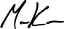

Manav Kumar

Corporate Secretary

Los Angeles, California

January 15, 2021

81

Table of Contents

ANNEX A

Reconciliation of Non-GAAP Items

Our proxy contains financial information calculated other than in accordance with U.S. generally accepted accounting principles ("GAAP"). In particular, the Company believes that non-GAAP financial measures such as adjusted EBITDA, adjusted EPS and free cash flow provide a meaningful perspective on its business results as the Company utilizes this information to evaluate and manage the business. We use adjusted EBITDA and adjusted EPS to exclude the impact of non-operating items, such as certain amortization expense, certain depreciation expense, restructuring costs and non-core operating losses, to aid investors in better understanding our core performance results. We use free cash flow to represent the cash generated after capital expenditures to maintain our business. Our non-GAAP disclosure has limitations as an analytical tool, should not be viewed as a substitute for financial information determined in accordance with GAAP, and should not be considered in isolation or as a substitute for analysis of our results as reported under GAAP, nor is it necessarily comparable to non-GAAP performance measures that may be presented by other companies.

Reconciliation of Net Income Attributable to AECOM From Continuing Operations to EBITDA to Adjusted EBITDA

 |  |  | Twelve
 |  |  | Months
 |  |  | Ended
 |  |  | Sep 30
Net Income attributable to AECOM from continuing operations |  |  | 2020
 |  |  | $170.4
Income tax expense (benefit) |  |  | 45.8
Income attributable to AECOM |  |  | 216.2
Depreciation and amortization expense(1) |  |  | 192.7
Interest income(2) |  |  | (10.4)
Interest expense |  |  | 159.8
Amortized bank fees included in interest expense |  |  | (6.2)
EBITDA |  |  | 552.1
Noncore operating losses & transaction-related expenses |  |  | 5.6
Impairment of long-lived assets |  |  | —
Restructuring costs |  |  | 188.4
Gain on disposal activities |  |  | —
Depreciation expense included in above adjustments |  |  | —
Adjusted EBITDA |  |  | $746.1
(1) | Excludes depreciation from noncore operating losses and accelerated depreciation of project management tool
(2) | Included in other income
Note: Variances within tables are due to rounding.
 |  | A-1

Table of Contents
Reconciliation of Adjusted EPS
 |  |  |  |  |  | Twelve
 |  |  |  |  |  | Months
 |  |  |  |  |  | Ended
 |  |  |  |  |  | Sept 30
Net income (loss) attributable to AECOM—per diluted share |  |  |  |  | 2020
Net income (loss) attributable to AECOM—per diluted share |  |  |  |  |  | $1.06
Per diluted share adjustments:
Non-core operating losses |  |  |  |  | 0.03
Accelerated depreciation of project management tool |  |  |  |  | 0.18
Restructuring Costs |  |  |  |  | 1.17
Amortization of intangible assets |  |  |  |  | 0.15
Financing charges in interest expense |  |  |  |  | 0.14
Tax effect of the above adjustments |  |  |  |  | (0.43)
Valuation allowances and other tax items |  |  |  |  | (0.15)
Adjusted net income attributable to AECOM—per diluted share |  |  |  |  |  | $2.15
Reconciliation of Net Cash Provided By Operating Activities to Free Cash Flow
 |  | Three |  |  |  | Twelve
 |  | Months |  |  |  | Months
 |  | Ended |  |  |  | Ended
 |  | Sept 30 |  |  |  | Sept 30
Net cash provided by operating activities | 2020 |  |  |  | 2020
Net cash provided by operating activities |  | $649.3 |  |  |  | $329.6
Capital expenditures, net | (30.0) |  |  |  | (110.8)
Working capital adjustment from sale of Management Services business |  | — |  |  | 122.0
Free cash flow |  | $619.3 |  |  |  | $340.8
Reconciliation of Adjusted Margin Calculation for Annual Incentives
 |  |  |  |  |  | Three
 |  |  |  |  |  | Months
 |  |  |  |  |  | Ended
 |  |  |  |  |  | Sept 30
Revenue Americas Segment |  |  |  |  | 2020
Revenue Americas Segment |  |  |  |  | $10,131.5
Revenue International Segment |  |  |  |  | 3,101.7
Less: subcontractor and other direct costs Americas Segment |  |  |  |  | 6,440.6
Less: subcontractor and other direct costs International Segment |  |  |  |  | 622.5
NSR (Revenue, net of subcontractor and other direct costs) |  |  |  |  | $6,170.1
Income from Operations Americas Segment |  |  |  |  | $600.3
Income from Operations International Segment |  |  |  |  | 136.5
Noncore operating losses & transaction related expenses |  |  |  |  | (0.1)
Amortization of intangible assets |  |  |  |  | 24.0
Adjusted income from operations |  |  |  |  | $760.7
NSR Operating Margin |  |  |  |  | 12.3%
 | A-2





